# Ansible - Introduction

**Ansible** is simple open source IT engine which automates application deployment, intra service orchestration, cloud provisioning and many other IT tools.

Ansible is easy to deploy because it does not use any agents or custom security infrastructure.

Ansible uses playbook to describe automation jobs, and playbook uses very simple language i.e. **YAML** (It’s a human-readable data serialization language & is commonly used for configuration files, but could be used in many applications where data is being stored)which is very easy for humans to understand, read and write. Hence the advantage is that even the IT infrastructure support guys can read and understand the playbook and debug if needed (YAML – It is in human readable form).

Ansible is designed for multi-tier deployment. Ansible does not manage one system at time, it models IT infrastructure by describing all of your systems are interrelated. Ansible is completely agentless which means Ansible works by connecting your nodes through ssh(by default). But if you want other method for connection like Kerberos, Ansible gives that option to you.

After connecting to your nodes, Ansible pushes small programs called as “Ansible Modules”. Ansible runs that modules on your nodes and removes them when finished. Ansible manages your inventory in simple text files (These are the hosts file). Ansible uses the hosts file where one can group the hosts and can control the actions on a specific group in the playbooks.

### **Sample Hosts File**

This is the content of hosts file −

#File name: hosts

#Description: Inventory file for your application. Defines machine type abc

node to deploy specific artifacts

# Defines machine type def node to upload

metadata.

[abc-node]

#server1 ansible_host = <target machine for DU deployment> ansible_user = <Ansible

user> ansible_connection = ssh

server1 ansible_host = <your host name> ansible_user = <your unix user>

ansible_connection = ssh

[def-node]

#server2 ansible_host = <target machine for artifact upload>

ansible_user = <Ansible user> ansible_connection = ssh

server2 ansible_host = <host> ansible_user = <user> ansible_connection = ssh

## **What is Configuration Management**

Configuration management in terms of Ansible means that it maintains configuration of the product performance by keeping a record and updating detailed information which describes an enterprise’s hardware and software.

Such information typically includes the exact versions and updates that have been applied to installed software packages and the locations and network addresses of hardware devices. For e.g. If you want to install the new version of **WebLogic/WebSphere** server on all of the machines present in your enterprise, it is not feasible for you to manually go and update each and every machine.

You can install WebLogic/WebSphere in one go on all of your machines with Ansible playbooks and inventory written in the most simple way. All you have to do is list out the IP addresses of your nodes in the inventory and write a playbook to install WebLogic/WebSphere. Run the playbook from your control machine & it will be installed on all your nodes.

AD

## **How Ansible Works?**

The picture given below shows the working of Ansible.

**Ansible works** by connecting to your nodes and pushing out small programs, called "**Ansible** modules" to them. **Ansible** then executes these modules (over SSH by default), and removes them when finished. Your library of modules can reside on any machine, and there are no servers, daemons, or databases required.

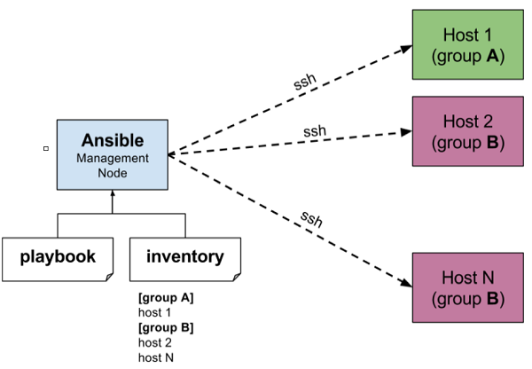

The management node in the above picture is the controlling node (managing node) which controls the entire execution of the playbook. It’s the node from which you are running the installation. The inventory file provides the list of hosts where the Ansible modules needs to be run and the management node does a SSH connection and executes the small modules on the hosts machine and installs the product/software.

**Beauty** of Ansible is that it removes the modules once those are installed so effectively it connects to host machine , executes the instructions and if it’s successfully installed removes the code which was copied on the host machine which was executed.

# Ansible - Environment Setup

In this chapter, we will learn about the environment setup of Ansible.

## **Installation Process**

Mainly, there are two types of machines when we talk about deployment −

* **Control machine** − Machine from where we can manage other machines.
* **Remote machine** − Machines which are handled/controlled by control machine.

There can be multiple remote machines which are handled by one control machine. So, for managing remote machines we have to install Ansible on control machine.

### **Control Machine Requirements**

Ansible can be run from any machine with Python 2 (versions 2.6 or 2.7) or Python 3 (versions 3.5 and higher) installed.

**Note** − Windows does not support control machine.

By default, Ansible uses **ssh** to manage remote machine.

Ansible does not add any database. It does not require any daemons to start or keep it running. While managing remote machines, Ansible **does not** leave any software installed or running on them. Hence, there is no question of how to upgrade it when moving to a new version.

Ansible can be installed on control machine which have above mentioned requirements in different ways. You can install the latest release through Apt, yum, pkg, pip, OpenCSW, pacman, etc.

### **Installation through Apt on Ubuntu Machine**

For installing Ansible you have to configure PPA on your machine. For this, you have to run the following line of code −

$ sudo apt-get update

$ sudo apt-get install software-properties-common

$ sudo apt-add-repository ppa:ansible/ansible $ sudo apt-get update

$ sudo apt-get install ansible

After running the above line of code, you are ready to manage remote machines through Ansible. Just run Ansible–version to check the version and just to check whether Ansible was installed properly or not.

# Ansible - YAML Basics

Ansible uses YAML syntax for expressing Ansible playbooks. This chapter provides an overview of YAML. Ansible uses YAML because it is very easy for humans to understand, read and write when compared to other data formats like XML and JSON.

Every **YAML** file optionally starts with “---” and ends with “...”.

AD

## **Understanding YAML**

In this section, we will learn the different ways in which the YAML data is represented.

### **key-value pair**

YAML uses simple key-value pair to represent the data. The dictionary is represented in key: value pair.

**Note** − There should be space between : and value.

### **Example: A student record**

--- #Optional YAML start syntax

james:

name: james john

rollNo: 34

div: B

sex: male

… #Optional YAML end syntax

### **Abbreviation**

You can also use abbreviation to represent dictionaries.

### **Example**

James: {name: james john, rollNo: 34, div: B, sex: male}

## **Representing List**

We can also represent List in YAML. Every element(member) of list should be written in a new line with same indentation starting with “- “ (- and space).

### **Example**

---

countries:

- America

- China

- Canada

- Iceland

…

### **Abbreviation**

You can also use abbreviation to represent lists.

### **Example**

Countries: [‘America’, ‘China’, ‘Canada’, ‘Iceland’]

### **List inside Dictionaries**

We can use list inside dictionaries, i.e., value of key is list.

### **Example**

---

james:

name: james john

rollNo: 34

div: B

sex: male

likes:

- maths

- physics

- english

…

### **List of Dictionaries**

We can also make list of dictionaries.

### **Example**

---

- james:

name: james john

rollNo: 34

div: B

sex: male

likes:

- maths

- physics

- english

- robert:

name: robert richardson

rollNo: 53

div: B

sex: male

likes:

- biology

- chemistry

…

YAML uses “|” to include newlines while showing multiple lines and “>” to suppress newlines while showing multiple lines. Due to this we can read and edit large lines. In both the cases intendentation will be ignored.

We can also represent **Boolean** (True/false) values in YAML. where **boolean** values can be case insensitive.

### **Example**

---

- james:

name: james john

rollNo: 34

div: B

sex: male

likes:

- maths

- physics

- english

result:

maths: 87

chemistry: 45

biology: 56

physics: 70

english: 80

passed: TRUE

messageIncludeNewLines: |

Congratulation!!

You passed with 79%

messageExcludeNewLines: >

Congratulation!!

You passed with 79%

## **Some common words related to Ansible.**

**Service/Server** − A process on the machine that provides the service.

**Machine** − A physical server, vm(virtual machine) or a container.

**Target machine** − A machine we are about to configure with Ansible.

**Task** − An action(run this, delete that) etc managed by Ansible.

**Playbook** − The yml file where Ansible commands are written and yml is executed on a machine.

# Ansible - Ad hoc Commands

Ad hoc commands are commands which can be run individually to perform quick functions. These commands need not be performed later.

For example, you have to reboot all your company servers. For this, you will run the Adhoc commands from ‘**/usr/bin/ansible**’.

These ad-hoc commands are not used for configuration management and deployment, because these commands are of one time usage.

ansible-playbook is used for configuration management and deployment.

## **Parallelism and Shell Commands**

Reboot your company server in 12 parallel forks at time. For this, we need to set up SSHagent for connection.

$ ssh-agent bash

$ ssh-add ~/.ssh/id_rsa

To run reboot for all your company servers in a group, 'abc', in 12 parallel forks −

$ Ansible abc -a "/sbin/reboot" -f 12

By default, Ansible will run the above Ad-hoc commands form current user account. If you want to change this behavior, you will have to pass the username in Ad-hoc commands as follows −

$ Ansible abc -a "/sbin/reboot" -f 12 -u username

## **File Transfer**

You can use the Ad-hoc commands for doing **SCP** (Secure Copy Protocol) lots of files in parallel on multiple machines.

### **Transferring file to many servers/machines**

$ Ansible abc -m copy -a "src = /etc/yum.conf dest = /tmp/yum.conf"

### **Creating new directory**

$ Ansible abc -m file -a "dest = /path/user1/new mode = 777 owner = user1 group = user1 state = directory"

### **Deleting whole directory and files**

$ Ansible abc -m file -a "dest = /path/user1/new state = absent"

## **Managing Packages**

The Ad-hoc commands are available for yum and apt. Following are some Ad-hoc commands using yum.

The following command checks if yum package is installed or not, but does not update it.

$ Ansible abc -m yum -a "name = demo-tomcat-1 state = present"

The following command check the package is not installed.

$ Ansible abc -m yum -a "name = demo-tomcat-1 state = absent"

The following command checks the latest version of package is installed.

$ Ansible abc -m yum -a "name = demo-tomcat-1 state = latest"

## **Gathering Facts**

Facts can be used for implementing conditional statements in playbook. You can find adhoc information of all your facts through the following Ad-hoc command −

$ Ansible all -m setup

# Ansible - Playbooks

In this chapter, we will learn about Playbooks in Ansible.

Playbooks are the files where Ansible code is written. Playbooks are written in YAML format. YAML stands for Yet Another Markup Language. **Playbooks** are one of the core features of Ansible and tell Ansible what to execute. They are like a to-do list for Ansible that contains a list of tasks.

Playbooks contain the steps which the user wants to execute on a particular machine. Playbooks are run sequentially. Playbooks are the building blocks for all the use cases of Ansible.

## **Playbook Structure**

Each playbook is an aggregation of one or more plays in it. Playbooks are structured using Plays. There can be more than one play inside a playbook.

The function of a play is to map a set of instructions defined against a particular host.

YAML is a strict typed language; so, extra care needs to be taken while writing the YAML files. There are different YAML editors but we will prefer to use a simple editor like notepad++. Just open notepad++ and copy and paste the below yaml and change the language to YAML (Language → YAML).

A YAML starts with --- (3 hyphens)

## **Create a Playbook**

Let us start by writing a sample YAML file. We will walk through each section written in a yaml file.

---

name: install and configure DB

hosts: testServer

become: yes

vars:

oracle_db_port_value : 1521

tasks:

-name: Install the Oracle DB

yum: <code to install the DB>

-name: Ensure the installed service is enabled and running

service:

name: <your service name>

The above is a sample Playbook where we are trying to cover the basic syntax of a playbook. Save the above content in a file as **test.yml**. A YAML syntax needs to follow the correct indentation and one needs to be a little careful while writing the syntax.

## **The Different YAML Tags**

Let us now go through the different YAML tags. The different tags are described below −

### **name**

This tag specifies the name of the Ansible playbook. As in what this playbook will be doing. Any logical name can be given to the playbook.

### **hosts**

This tag specifies the lists of hosts or host group against which we want to run the task. The hosts field/tag is mandatory. It tells Ansible on which hosts to run the listed tasks. The tasks can be run on the same machine or on a remote machine. One can run the tasks on multiple machines and hence hosts tag can have a group of hosts’ entry as well.

### **vars**

Vars tag lets you define the variables which you can use in your playbook. Usage is similar to variables in any programming language.

### **tasks**

All playbooks should contain tasks or a list of tasks to be executed. Tasks are a list of actions one needs to perform. A tasks field contains the name of the task. This works as the help text for the user. It is not mandatory but proves useful in debugging the playbook. Each task internally links to a piece of code called a module. A module that should be executed, and arguments that are required for the module you want to execute.

# Ansible - Roles

Roles provide a framework for fully independent, or interdependent collections of variables, tasks, files, templates, and modules.

In Ansible, the role is the primary mechanism for breaking a playbook into multiple files. This simplifies writing **complex playbooks**, and it makes them easier to reuse. The breaking of playbook allows you to logically break the playbook into reusable components.

Each role is basically limited to a particular functionality or desired output, with all the necessary steps to provide that result either within that role itself or in other roles listed as dependencies.

Roles are not playbooks. Roles are small functionality which can be independently used but have to be used within playbooks. There is no way to directly execute a role. Roles have no explicit setting for which host the role will apply to.

Top-level playbooks are the bridge holding the hosts from your inventory file to roles that should be applied to those hosts.

## **Creating a New Role**

The directory structure for roles is essential to create a new role.

### **Role Structure**

Roles have a structured layout on the file system. The default structure can be changed but for now let us stick to defaults.

Each role is a directory tree in itself. The role name is the directory name within the /roles directory.

$ ansible-galaxy -h

### **Usage**

ansible-galaxy [delete|import|info|init|install|list|login|remove|search|setup] [--help] [options] ...

### **Options**

* **-h, --help** − Show this help message and exit.
* **-v, --verbose** − Verbose mode (-vvv for more, -vvvv to enable connection debugging)
* **--version** − Show program's version number and exit.

### **Creating a Role Directory**

The above command has created the role directories.

$ ansible-galaxy init vivekrole

ERROR! The API server (https://galaxy.ansible.com/api/) is not responding, please try again later.

$ ansible-galaxy init --force --offline vivekrole

- vivekrole was created successfully

$ tree vivekrole/

vivekrole/

├── defaults

│ └── main.yml

├── files ├── handlers

│ └── main.yml

├── meta

│ └── main.yml

├── README.md ├── tasks

│ └── main.yml

├── templates ├── tests │ ├── inventory

│ └── test.yml

└── vars

└── main.yml

8 directories, 8 files

Not all the directories will be used in the example and we will show the use of some of them in the example.

## **Utilizing Roles in Playbook**

This is the code of the playbook we have written for demo purpose. This code is of the playbook vivek_orchestrate.yml. We have defined the hosts: **tomcat-node** and called the two roles – **install-tomcat** and **start-tomcat**.

The problem statement is that we have a war which we need to deploy on a machine via Ansible.

---

- hosts: tomcat-node

roles:

- {role: install-tomcat}

- {role: start-tomcat}

Contents of our directory structure from where we are running the playbook.

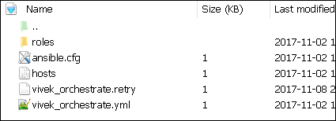

$ ls

ansible.cfg hosts roles vivek_orchestrate.retry vivek_orchestrate.yml

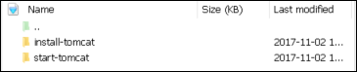

There is a tasks directory under each directory and it contains a main.yml. The main.yml contents of install-tomcat are −

---

#Install vivek artifacts

-

block:

- name: Install Tomcat artifacts

action: >

yum name = "demo-tomcat-1" state = present

register: Output

always:

- debug:

msg:

- "Install Tomcat artifacts task ended with message: {{Output}}"

- "Installed Tomcat artifacts - {{Output.changed}}"

The contents of main.yml of the start tomcat are −

#Start Tomcat

-

block:

- name: Start Tomcat

command: <path of tomcat>/bin/startup.sh"

register: output

become: true

always:

- debug:

msg:

- "Start Tomcat task ended with message: {{output}}"

- "Tomcat started - {{output.changed}}"

The advantage of breaking the playbook into roles is that anyone who wants to use the Install tomcat feature can call the Install Tomcat role.

## **Breaking a Playbook into a Role**

If not for the roles, the content of the main.yml of the respective role can be copied in the playbook **yml** file. But to have modularity, roles were created.

Any logical entity which can be reused as a reusable function, that entity can be moved to role. The example for this is shown above

Ran the command to run the playbook.

-vvv option for verbose output – verbose output

$ cd vivek-playbook/

This is the command to run the playbook

$ sudo ansible-playbook -i hosts vivek_orchestrate.yml –vvv

-----------------------------------------------------------------

-----------------------------------------------------------------------

### **Output**

The generated output is as seen on the screen −

Using **/users/demo/vivek-playbook/ansible.cfg** as config file.

PLAYBOOK: vivek_orchestrate.yml *********************************************************

***********************************************************

1 plays in vivek_orchestrate.yml

PLAY [tomcat-node] **********************************************************************

******** *************************************************

TASK [Gathering Facts] *************************************************

****************************** *********************************************

Tuesday 21 November 2017 13:02:05 +0530 (0:00:00.056) 0:00:00.056 ******

Using module file /usr/lib/python2.7/sitepackages/ansible/modules/system/setup.py

<localhost> ESTABLISH LOCAL CONNECTION FOR USER: root

<localhost> EXEC /bin/sh -c 'echo ~ && sleep 0'

<localhost> EXEC /bin/sh -c '( umask 77 && mkdir -p "` echo

/root/.ansible/tmp/ansible-tmp-1511249525.88-259535494116870 `" &&

echo ansible-tmp-1511249525.88-259535494116870="`

echo /root/.ansible/tmp/ansibletmp-1511249525.88-259535494116870 `" ) && sleep 0'

<localhost> PUT /tmp/tmpPEPrkd TO

/root/.ansible/tmp/ansible-tmp-1511249525.88259535494116870/setup.py

<localhost> EXEC /bin/sh -c 'chmod u+x

/root/.ansible/tmp/ansible-tmp1511249525.88-259535494116870/

/root/.ansible/tmp/ansible-tmp-1511249525.88259535494116870/setup.py && sleep 0'

<localhost> EXEC /bin/sh -c '/usr/bin/python

/root/.ansible/tmp/ansible-tmp1511249525.88-259535494116870/setup.py; rm -rf

"/root/.ansible/tmp/ansible-tmp1511249525.88-259535494116870/" > /dev/null 2>&1 && sleep 0'

ok: [server1]

META: ran handlers

TASK [install-tomcat : Install Tomcat artifacts] ***********************************

***************************************************************

task path: /users/demo/vivek-playbook/roles/install-tomcat/tasks/main.yml:5

Tuesday 21 November 2017 13:02:07 +0530 (0:00:01.515) 0:00:01.572 ******

Using module file /usr/lib/python2.7/sitepackages/ansible/modules/packaging/os/yum.py

<localhost> ESTABLISH LOCAL CONNECTION FOR USER: root

<localhost> EXEC /bin/sh -c 'echo ~ && sleep 0'

<localhost> EXEC /bin/sh -c '( umask 77 && mkdir -p "` echo

/root/.ansible/tmp/ansible-tmp-1511249527.34-40247177825302 `" && echo

ansibletmp-1511249527.34-40247177825302="` echo

/root/.ansible/tmp/ansible-tmp1511249527.34-40247177825302 `" ) && sleep 0'

<localhost> PUT /tmp/tmpu83chg TO

/root/.ansible/tmp/ansible-tmp-1511249527.3440247177825302/yum.py

<localhost> EXEC /bin/sh -c 'chmod u+x

/root/.ansible/tmp/ansible-tmp1511249527.34-40247177825302/

/root/.ansible/tmp/ansible-tmp-1511249527.3440247177825302/yum.py && sleep 0'

<localhost> EXEC /bin/sh -c '/usr/bin/python

/root/.ansible/tmp/ansible-tmp1511249527.34-40247177825302/yum.py; rm -rf

"/root/.ansible/tmp/ansible-tmp1511249527.34-40247177825302/" > /dev/null 2>

&1 && sleep 0'

changed: [server1] => {

"changed": true,

"invocation": {

"module_args": {

"conf_file": null,

"disable_gpg_check": false,

"disablerepo": null,

"enablerepo": null,

"exclude": null,

"install_repoquery": true,

"installroot": "/",

"list": null,

"name": ["demo-tomcat-1"],

"skip_broken": false,

"state": "present",

"update_cache": false,

"validate_certs": true

}

},

"msg": "",

"rc": 0,

"results": [

"Loaded plugins: product-id,

search-disabled-repos,

subscriptionmanager\nThis system is not registered to Red Hat Subscription Management.

You can use subscription-manager to register.\nResolving Dependencies\n-->

Running transaction check\n--->

Package demo-tomcat-1.noarch 0:SNAPSHOT-1 will be installed\n--> Finished Dependency

Resolution\n\nDependencies Resolved\n

\n================================================================================\n

Package Arch Version Repository

Size\n==================================================================\nInstalling:\n

demo-tomcat-1 noarch SNAPSHOT-1 demo-repo1 7.1 M\n\nTransaction

Summary\n==================================================================\nInstall 1

Package\n\nTotal download size: 7.1 M\nInstalled size: 7.9 M\nDownloading

packages:\nRunning transaction

check\nRunning transaction test\nTransaction test succeeded\nRunning transaction\n Installing :

demotomcat-1-SNAPSHOT-1.noarch 1/1 \n Verifying :

demo-tomcat-1-SNAPSHOT-1.noarch 1/1 \n\nInstalled:\n

demo-tomcat-1.noarch 0:SNAPSHOT-1 \n\nComplete!\n"

]

}

TASK [install-tomcat : debug] **********************************************************

***************************************************************************

task path: /users/demo/vivek-playbook/roles/install-tomcat/tasks/main.yml:11

Tuesday 21 November 2017 13:02:13 +0530 (0:00:06.757) 0:00:08.329 ******

ok: [server1] => {

"changed": false,

"msg": [

"Install Tomcat artifacts task ended with message: {

u'msg': u'', u'changed': True, u'results':

[u'Loaded plugins: product-id,

search-disabledrepos,

subscription-manager\\nThis system is not registered to Red Hat Subscription Management.

You can use subscription-manager to register.\\nResolving Dependencies\\n-->

Running transaction check\\n--->

Package demo-tomcat-1.noarch 0:SNAPSHOT-1 will be installed\\n-->

Finished Dependency Resolution\\n

\\nDependencies

Resolved\\n\\n==================================================================\\n

Package Arch Version Repository

Size\\n========================================================================

=====\\nInstalling:\\n demo-tomcat-1 noarch SNAPSHOT-1 demo-repo1 7.1 M\\n\\nTransaction

Summary\\n=========================================================\\nInstall 1

Package\\n\\nTotal download size: 7.1 M\\nInstalled size: 7.9 M\\nDownloading

packages:\\nRunning

transaction check\\nRunning transaction test\\nTransaction test succeeded\\nRunning

transaction\\n

Installing : demo-tomcat-1-SNAPSHOT-1.noarch 1/1 \\n Verifying :

demo-tomcat-1-SNAPSHOT-1.noarch

1/1 \\n\\nInstalled:\\n demo-tomcat-1.noarch 0:SNAPSHOT-1 \\n\\nComplete!\\n'], u'rc': 0

}",

"Installed Tomcat artifacts - True"

]

}

TASK [install-tomcat : Clean DEMO environment] ****************************************

************************************************************

task path: /users/demo/vivek-playbook/roles/install-tomcat/tasks/main.yml:19

Tuesday 21 November 2017 13:02:13 +0530 (0:00:00.057) 0:00:08.387 ******

[WARNING]: when statements should not include jinja2 templating delimiters such as {{ }} or

{% %}. Found: {{installationOutput.changed}}

Using module file /usr/lib/python2.7/sitepackages/ansible/modules/files/file.py

<localhost> ESTABLISH LOCAL CONNECTION FOR USER: root

<localhost> EXEC /bin/sh -c 'echo ~ && sleep 0'

<localhost> EXEC /bin/sh -c '( umask 77 && mkdir -p "` echo

/root/.ansible/tmp/ansible-tmp-1511249534.13-128345805983963 `" && echo

ansible-tmp-1511249534.13-128345805983963="` echo

/root/.ansible/tmp/ansibletmp-1511249534.13-128345805983963 `" ) && sleep 0'

<localhost> PUT /tmp/tmp0aXel7 TO

/root/.ansible/tmp/ansible-tmp-1511249534.13128345805983963/file.py

<localhost> EXEC /bin/sh -c 'chmod u+x

/root/.ansible/tmp/ansible-tmp1511249534.13-128345805983963/

/root/.ansible/tmp/ansible-tmp-1511249534.13128345805983963/file.py && sleep 0'

<localhost> EXEC /bin/sh -c '/usr/bin/python

/root/.ansible/tmp/ansible-tmp1511249534.13-128345805983963/file.py; rm -rf

"/root/.ansible/tmp/ansible-tmp1511249534.13-128345805983963/" > /dev/null 2>&1

&& sleep 0'

changed: [server1] => {

"changed": true,

"diff": {

"after": {

"path": "/users/demo/DEMO",

"state": "absent"

},

"before": {

"path": "/users/demo/DEMO",

"state": "directory"

}

},

"invocation": {

"module_args": {

"attributes": null,

"backup": null,

"content": null,

"delimiter": null,

"diff_peek": null,

"directory_mode": null,

"follow": false,

"force": false,

"group": null,

"mode": null,

"original_basename": null,

"owner": null,

"path": "/users/demo/DEMO",

"recurse": false,

"regexp": null,

"remote_src": null,

"selevel": null,

"serole": null,

"setype": null,

"seuser": null,

"src": null,

"state": "absent",

"unsafe_writes": null,

"validate": null

}

},

"path": "/users/demo/DEMO",

"state": "absent"

}

TASK [install-tomcat : debug] ********************************************************

*************************************************************

task path: /users/demo/vivek-playbook/roles/install-tomcat/tasks/main.yml:29

Tuesday 21 November 2017 13:02:14 +0530 (0:00:00.257) 0:00:08.645 ******

ok: [server1] => {

"changed": false,

"msg": [

"Clean DEMO environment task ended with message:{u'diff': {u'after': {u'path':

u'/users/demo/DEMO', u'state': u'absent'},

u'before': {u'path': u'/users/demo/DEMO', u'state': u'directory'}}, u'state': u'absent',

u'changed': True, u'path': u'/users/demo/DEMO'}",

"check value :True"

]

}

TASK [install-tomcat : Copy Tomcat to user home] *************************************

********************************************************

task path: /users/demo/vivek-playbook/roles/install-tomcat/tasks/main.yml:37

Tuesday 21 November 2017 13:02:14 +0530 (0:00:00.055) 0:00:08.701 ******

[WARNING]: when statements should not include jinja2 templating delimiters such as {{ }} or

{% %}. Found: {{installationOutput.changed}}

Using module file /usr/lib/python2.7/sitepackages/ansible/modules/commands/command.py

<localhost> ESTABLISH LOCAL CONNECTION FOR USER: root

<localhost> EXEC /bin/sh -c 'echo ~ && sleep 0'

<localhost> EXEC /bin/sh -c '( umask 77 && mkdir -p "` echo

/root/.ansible/tmp/ansible-tmp-1511249534.43-41077200718443 `" && echo

ansibletmp-1511249534.43-41077200718443="` echo

/root/.ansible/tmp/ansible-tmp1511249534.43-41077200718443 `" ) && sleep 0'

<localhost> PUT /tmp/tmp25deWs TO

/root/.ansible/tmp/ansible-tmp-1511249534.4341077200718443/command.py

<localhost> EXEC /bin/sh -c 'chmod u+x

/root/.ansible/tmp/ansible-tmp1511249534.43-41077200718443/

/root/.ansible/tmp/ansible-tmp-1511249534.4341077200718443/command.py && sleep 0'

<localhost> EXEC /bin/sh -c '/usr/bin/python

/root/.ansible/tmp/ansible-tmp1511249534.43-41077200718443/command.py; rm -rf

"/root/.ansible/tmp/ansibletmp-1511249534.43-41077200718443/" > /dev/null 2>&1

&& sleep 0'

changed: [server1] => {

"changed": true,

"cmd": [

"cp",

"-r",

"/opt/ansible/tomcat/demo",

"/users/demo/DEMO/"

],

"delta": "0:00:00.017923",

"end": "2017-11-21 13:02:14.547633",

"invocation": {

"module_args": {

"_raw_params": "cp -r /opt/ansible/tomcat/demo /users/demo/DEMO/",

"_uses_shell": false,

"chdir": null,

"creates": null,

"executable": null,

"removes": null,

"warn": true

}

},

"rc": 0,

"start": "2017-11-21 13:02:14.529710",

"stderr": "",

"stderr_lines": [],

"stdout": "",

"stdout_lines": []

}

TASK [install-tomcat : debug] ********************************************************

**********************************************************

task path: /users/demo/vivek-playbook/roles/install-tomcat/tasks/main.yml:47

Tuesday 21 November 2017 13:02:14 +0530 (0:00:00.260) 0:00:08.961 ******

ok: [server1] => {

"changed": false,

"msg": "Copy Tomcat to user home task ended with message {

'stderr_lines': [], u'changed': True, u'end': u'2017-11-21 13:02:14.547633', u'stdout':

u'', u'cmd': [u'cp', u'-r', u'/opt/ansible/tomcat/demo', u'/users/demo/DEMO/'], u'rc': 0,

u'start': u'2017-11-21 13:02:14.529710', u'stderr': u'', u'delta': u'0:00:00.017923',

'stdout_lines': []}"

}

TASK [start-tomcat : Start Tomcat] **************************************************

**********************************************************

task path: /users/demo/vivek-playbook/roles/start-tomcat/tasks/main.yml:5

Tuesday 21 November 2017 13:02:14 +0530 (0:00:00.044) 0:00:09.006 ******

Using module file /usr/lib/python2.7/sitepackages/ansible/modules/commands/command.py

<localhost> ESTABLISH LOCAL CONNECTION FOR USER: root

<localhost> EXEC /bin/sh -c 'echo ~ && sleep 0'

<localhost> EXEC /bin/sh -c '( umask 77 && mkdir -p "` echo

/root/.ansible/tmp/ansible-tmp-1511249534.63-46501211251197 `" && echo

ansibletmp-1511249534.63-46501211251197="` echo

/root/.ansible/tmp/ansible-tmp1511249534.63-46501211251197 `" ) && sleep 0'

<localhost> PUT /tmp/tmp9f06MQ TO

/root/.ansible/tmp/ansible-tmp-1511249534.6346501211251197/command.py

<localhost> EXEC /bin/sh -c 'chmod u+x

/root/.ansible/tmp/ansible-tmp1511249534.63-46501211251197/

/root/.ansible/tmp/ansible-tmp-1511249534.6346501211251197/command.py && sleep 0'

<localhost> EXEC /bin/sh -c '/usr/bin/python

/root/.ansible/tmp/ansible-tmp1511249534.63-46501211251197/command.py; rm -rf

"/root/.ansible/tmp/ansibletmp-1511249534.63-46501211251197/" > /dev/null 2>&1

&& sleep 0'

changed: [server1] => {

"changed": true,

"cmd": [ "/users/demo/DEMO/bin/startup.sh" ],

"delta": "0:00:00.020024",

"end": "2017-11-21 13:02:14.741649",

"invocation": {

"module_args": {

"_raw_params": "/users/demo/DEMO/bin/startup.sh",

"_uses_shell": false,

"chdir": null,

"creates": null,

"executable": null,

"removes": null,

"warn": true

}

},

"rc": 0,

"start": "2017-11-21 13:02:14.721625",

"stderr": "",

"stderr_lines": [],

"stdout": "Tomcat started.",

"stdout_lines": [ "Tomcat started." ]

}

TASK [start-tomcat : debug] *************************************************

**********************************************************************

task path: /users/demo/vivek-playbook/roles/start-tomcat/tasks/main.yml:10

Tuesday 21 November 2017 13:02:14 +0530 (0:00:00.150) 0:00:09.156 ******

ok: [server1] => {

"changed": false,

"msg": [

"Start Tomcat task ended with message: {'

stderr_lines': [], u'changed': True, u'end': u'2017-11-21 13:02:14.741649', u'stdout':

u'Tomcat started.', u'cmd': [u'/users/demo/DEMO/bin/startup.sh'], u'rc': 0, u'start':

u'2017-11-21 13:02:14.721625', u'stderr': u'', u'delta': u'0:00:00.020024',

'stdout_lines': [u'Tomcat started.']}",

"Tomcat started - True"

]

}

META: ran handlers

META: ran handlers

PLAY RECAP *******************************************************************************

*********************************************************

server1 : ok = 9 changed = 4 unreachable = 0 failed = 0

Tuesday 21 November 2017 13:02:14 +0530 (0:00:00.042) 0:00:09.198 ******

===============================================================================

install-tomcat : Install Tomcat artifacts ------------------------------- 6.76s

/users/demo/vivek-playbook/roles/install-tomcat/tasks/main.yml:5 --------------

Gathering Facts --------------------------------------------------------- 1.52s

------------------------------------------------------------------------------

install-tomcat : Copy Tomcat to user home ------------------------------- 0.26s

/users/demo/vivek-playbook/roles/install-tomcat/tasks/main.yml:37 -------------

install-tomcat : Clean DEMO environment --------------------------------- 0.26s

/users/demo/vivek-playbook/roles/install-tomcat/tasks/main.yml:19 -------------

start-tomcat : Start Tomcat --------------------------------------------- 0.15s

/users/demo/vivek-playbook/roles/start-tomcat/tasks/main.yml:5 ----------------

install-tomcat : debug -------------------------------------------------- 0.06s

/users/demo/vivek-playbook/roles/install-tomcat/tasks/main.yml:11 -------------

install-tomcat : debug -------------------------------------------------- 0.06s

/users/demo/vivek-playbook/roles/install-tomcat/tasks/main.yml:29 -------------

install-tomcat : debug -------------------------------------------------- 0.04s

/users/demo/vivek-playbook/roles/install-tomcat/tasks/main.yml:47 -------------

start-tomcat : debug ---------------------------------------------------- 0.04s

/users/demo/vivek-playbook/roles/start-tomcat/tasks/main.yml:10 ---------------

Hit the following URL and you will be directed to a page as shown below − **http://10.76.0.134:11677/HelloWorld/HelloWorld**

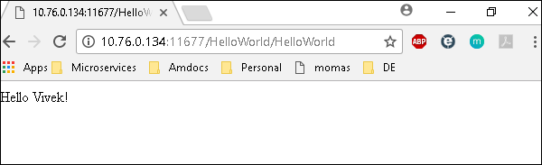

The deployed war just has a servlet which displays “Hello World”. The detailed output shows the time taken by each and every task because of the entry added in ansible.cfg file −

[defaults]

callback_whitelist = profile_tasks

# Ansible - Variables

Variable in playbooks are **very similar** to using variables in any programming language. It helps you to use and assign a value to a variable and use that anywhere in the playbook. One can put conditions around the value of the variables and accordingly use them in the playbook.

### **Example**

- hosts : <your hosts>

vars:

tomcat_port : 8080

In the above example, we have defined a variable name **tomcat_port** and assigned the value 8080 to that variable and can use that in your playbook wherever needed.

Now taking a reference from the example shared. The following code is from one of the roles (install-tomcat) −

block:

- name: Install Tomcat artifacts

action: >

yum name = "demo-tomcat-1" state = present

register: Output

always:

- debug:

msg:

- "Install Tomcat artifacts task ended with message: {{Output}}"

- "Installed Tomcat artifacts - {{Output.changed}}"

Here, the output is the variable used.

Let us walk through all the keywords used in the above code −

* **block** − Ansible syntax to execute a given block.
* **name** − Relevant name of the block - this is used in logging and helps in debugging that which all blocks were successfully executed.
* **action** − The code next to action tag is the task to be executed. The action again is a Ansible keyword used in yaml.
* **register** − The output of the action is registered using the register keyword and Output is the variable name which holds the action output.
* **always** − Again a Ansible keyword , it states that below will always be executed.
* **msg** − Displays the message.

### **Usage of variable - {{Output}} -->**

This will read the value of variable Output. Also as it is used in the msg tab, it will print the value of the output variable.

Additionally, you can use the sub properties of the variable as well. Like in the case checking {{Output.changed}} whether the output got changed and accordingly use it.

## **Exception Handling in Playbooks**

Exception handling in Ansible is similar to exception handling in any programming language. An example of the exception handling in playbook is shown below.

tasks:

- name: Name of the task to be executed

block:

- debug: msg = 'Just a debug message , relevant for logging'

- command: <the command to execute>

rescue:

- debug: msg = 'There was an exception.. '

- command: <Rescue mechanism for the above exception occurred)

always:

- debug: msg = "this will execute in all scenarios. Always will get logged"

Following is the syntax for exception handling.

* **rescue** and **always** are the keywords specific to exception handling.
* Block is where the code is written (anything to be executed on the Unix machine).
* If the command written inside the block feature fails, then the execution reaches rescue block and it gets executed. In case there is no error in the command under block feature, then rescue will not be executed.
* **Always** gets executed in all cases.
* So if we compare the same with java, then it is similar to try, catch and finally block.
* Here, **Block** is similar to **try block** where you write the code to be executed and **rescue** is similar to **catch block** and **always** is similar to **finally**.

## **Loops**

Below is the example to demonstrate the usage of Loops in Ansible.

The tasks is to copy the set of all the war files from one directory to tomcat webapps folder.

Most of the commands used in the example below are already covered before. Here, we will concentrate on the usage of loops.

Initially in the 'shell' command we have done ls *.war. So, it will list all the war files in the directory.

Output of that command is taken in a variable named output.

To loop, the 'with_items' syntax is being used.

with_items: "{{output.stdout_lines}}" --> output.stdout_lines gives us the line by line output and then we loop on the output with the with_items command of Ansible.

Attaching the example output just to make one understand how we used the stdout_lines in the with_items command.

---

#Tsting

- hosts: tomcat-node

tasks:

- name: Install Apache

shell: "ls *.war"

register: output

args:

chdir: /opt/ansible/tomcat/demo/webapps

- file:

src: '/opt/ansible/tomcat/demo/webapps/{{ item }}'

dest: '/users/demo/vivek/{{ item }}'

state: link

with_items: "{{output.stdout_lines}}"

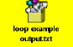

## **Blocks**

The playbook in totality is broken into blocks. The smallest piece of steps to execute is written in block. Writing the specific instruction in blocks helps to segregate functionality and handle it with exception handling if needed.

Example of blocks is covered in variable usage,exception handling and loops above.

## **Conditionals**

Conditionals are used where one needs to run a specific step based on a condition.

---

#Tsting

- hosts: all

vars:

test1: "Hello Vivek"

tasks:

- name: Testing Ansible variable

debug:

msg: "Equals"

when: test1 == "Hello Vivek"

In this case, Equals will be printed as the test1 variable is equal as mentioned in the when condition. **when** can be used with a logical OR and logical AND condition as in all the programming languages.

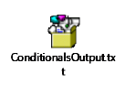

Just change the value of test1 variable from Hello Vivek to say Hello World and see the output.

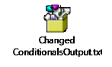

# Ansible - Advanced Execution

In this chapter, we will learn what is advanced execution with Ansible.

## **How to Limit Execution by Tasks**

This is a very important execution strategy where one needs to execute only one execution and not the entire playbook. **For example**, suppose you only want to stop a server (in case a production issue comes) and then post applying a patch you would like to only start the server.

Here in original playbook stop and start were a part of different roles in the same playbook but this can be handled with the usage of tags. We can provide different tags to different roles (which in turn will have tasks) and hence based on the tags provided by the executor only that specified role/task gets executed. So for the above example provided, we can add tags like the following −

- {role: start-tomcat, tags: ['install']}}

The following command helps in using tags −

ansible-playbook -i hosts <your yaml> --tags "install" -vvv

With the above command, only the start-tomcat role will be called. The tag provided is case-sensitive. Ensure exact match is being passed to the command.

## **How to Limit Execution by Hosts**

There are two ways to achieve the execution of specific steps on specific hosts. For a specific role, one defines the hosts - as to which specific hosts that specific role should be run.

### **Example**

- hosts: <A>

environment: "{{your env}}"

pre_tasks:

- debug: msg = "Started deployment.

Current time is {{ansible_date_time.date}} {{ansible_date_time.time}} "

roles:

- {role: <your role>, tags: ['<respective tag>']}

post_tasks:

- debug: msg = "Completed deployment.

Current time is {{ansible_date_time.date}} {{ansible_date_time.time}}"

- hosts: <B>

pre_tasks:

- debug: msg = "started....

Current time is {{ansible_date_time.date}} {{ansible_date_time.time}} "

roles:

- {role: <your role>, tags: ['<respective tag>']}

post_tasks:

- debug: msg = "Completed the task..

Current time is {{ansible_date_time.date}} {{ansible_date_time.time}}"

As per the above example, depending on the hosts provided, the respective roles will only be called. Now my hosts A and B are defined in the hosts (inventory file).

### **Alternate Solution**

A different solution might be defining the playbook's hosts using a variable, then passing in a specific host address via **--extra-vars** −

# file: user.yml (playbook)

---

- hosts: '{{ target }}'

user: ...

playbook contd….

### **Running the Playbook**

ansible-playbook user.yml --extra-vars "target = "<your host variable>"

If {{ target }} isn't defined, the playbook does nothing. A group from the hosts file can also be passed through if need be. This does not harm if the extra vars is not provided.

### **Playbook targeting a single host**

$ ansible-playbook user.yml --extra-vars "target = <your hosts variable>" --listhosts

# Ansible - Troubleshooting

The most common strategies for debugging Ansible playbooks are using the modules given below −

### **Debug and Register**

These two are the modules available in Ansible. For debugging purpose, we need to use the two modules judiciously. Examples are demonstrated below.

### **Use Verbosity**

With the Ansible command, one can provide the verbosity level. You can run the commands with verbosity level one (-v) or two (-vv).

## **Important Points**

In this section, we will go through a few examples to understand a few concepts.

If you are not quoting an argument that starts with a variable. For example,

vars:

age_path: {{vivek.name}}/demo/

{{vivek.name}}

This will throw an error.

### **Solution**

vars:

age_path: "{{vivek.name}}/demo/" – marked in yellow is the fix.

How to use register -> Copy this code into a yml file say test.yml and run it

---

#Tsting

- hosts: tomcat-node

tasks:

- shell: /usr/bin/uptime

register: myvar

- name: Just debugging usage

debug: var = myvar

When I run this code via the command Ansible-playbook -i hosts test.yml, I get the output as shown below.

If you see the yaml , we have registered the output of a command into a variable – **myvar** and just printed the output.

The text marked yellow, tells us about property of the variable –myvar that can be used for further flow control. This way we can find out about the properties that are exposed of a particular variable. The following debug command helps in this.

$ ansible-playbook -i hosts test.yml

PLAY [tomcat-node] ***************************************************************

**************** ****************************************************************

*************** ******************************

TASK [Gathering Facts] *****************************************************************

************** *****************************************************************

************** **************************

Monday 05 February 2018 17:33:14 +0530 (0:00:00.051) 0:00:00.051 *******

ok: [server1]

TASK [command] ******************************************************************

************* ******************************************************************

************* **********************************

Monday 05 February 2018 17:33:16 +0530 (0:00:01.697) 0:00:01.748 *******

changed: [server1]

TASK [Just debugging usage] ******************************************************************

************* ******************************************************************

************* *********************

Monday 05 February 2018 17:33:16 +0530 (0:00:00.226) 0:00:01.974 *******

ok: [server1] => {

"myvar": {

"changed": true,

"cmd": "/usr/bin/uptime",

"delta": "0:00:00.011306",

"end": "2018-02-05 17:33:16.424647",

"rc": 0,

"start": "2018-02-05 17:33:16.413341",

"stderr": "",

"stderr_lines": [],

"stdout": " 17:33:16 up 7 days, 35 min, 1 user, load average: 0.18, 0.15, 0.14",

"stdout_lines": [

" 17:33:16 up 7 days, 35 min, 1 user, load average: 0.18, 0.15, 0.14"

]

}

}

PLAY RECAP ****************************************************************************

**********************************************************************************

**************************************

server1 : ok = 3 changed = 1 unreachable = 0 failed = 0

## **Common Playbook Issues**

In this section, we will learn about the a few common playbook issues. The issues are −

* Quoting
* Indentation

Playbook is written in yaml format and the above two are the most common issues in yaml/playbook.

Yaml does not support tab based indentation and supports space based indentation, so one needs to be careful about the same.

**Note** − once you are done with writing the yaml , open this site(<https://editor.swagger.io/>) and copy paste your yaml on the left hand side to ensure that the yaml compiles properly. This is just a tip.

Swagger qualifies errors in warning as well as error.

# Docker - Overview

Docker is a container management service. The keywords of Docker are **develop, ship** and **run** anywhere. The whole idea of Docker is for developers to easily develop applications, ship them into containers which can then be deployed anywhere.

The initial release of Docker was in March 2013 and since then, it has become the buzzword for modern world development, especially in the face of Agile-based projects.

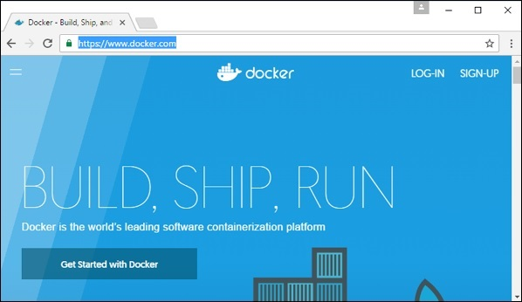

## **Features of Docker**

* Docker has the ability to reduce the size of development by providing a smaller footprint of the operating system via containers.
* With containers, it becomes easier for teams across different units, such as development, QA and Operations to work seamlessly across applications.
* You can deploy Docker containers anywhere, on any physical and virtual machines and even on the cloud.
* Since Docker containers are pretty lightweight, they are very easily scalable.

AD

## **Components of Docker**

Docker has the following components

* **Docker for Mac** − It allows one to run Docker containers on the Mac OS.
* **Docker for Linux** − It allows one to run Docker containers on the Linux OS.
* **Docker for Windows** − It allows one to run Docker containers on the Windows OS.
* **Docker Engine** − It is used for building Docker images and creating Docker containers.
* **Docker Hub** − This is the registry which is used to host various Docker images.
* **Docker Compose** − This is used to define applications using multiple Docker containers.

We will discuss all these components in detail in the subsequent chapters.

The official site for Docker is <https://www.docker.com/> The site has all information and documentation about the Docker software. It also has the download links for various operating systems.

# Installing Docker on Linux

To start the installation of Docker, we are going to use an Ubuntu instance. You can use Oracle Virtual Box to setup a virtual Linux instance, in case you don’t have it already.

The following screenshot shows a simple Ubuntu server which has been installed on Oracle Virtual Box. There is an OS user named **demo** which has been defined on the system having entire root access to the sever.

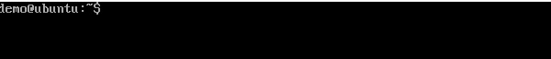

To install Docker, we need to follow the steps given below.

**Step 1** − Before installing Docker, you first have to ensure that you have the right Linux kernel version running. Docker is only designed to run on Linux kernel version 3.8 and higher. We can do this by running the following command.

### **uname**

This method returns the system information about the Linux system.

### **Syntax**

uname -a

### **Options**

**a** − This is used to ensure that the system information is returned.

### **Return Value**

This method returns the following information on the Linux system −

* kernel name
* node name
* kernel release
* kernel version
* machine
* processor
* hardware platform
* operating system

### **Example**

uname –a

### **Output**

When we run above command, we will get the following result −

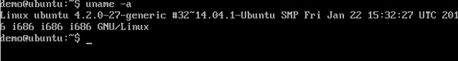

From the output, we can see that the Linux kernel version is 4.2.0-27 which is higher than version 3.8, so we are good to go.

**Step 2** − You need to update the OS with the latest packages, which can be done via the following command −

apt-get

This method installs packages from the Internet on to the Linux system.

### **Syntax**

sudo apt-get update

### **Options**

* **sudo** − The **sudo** command is used to ensure that the command runs with root access.
* **update** − The **update** option is used ensure that all packages are updated on the Linux system.

### **Return Value**

None

### **Example**

sudo apt-get update

### **Output**

When we run the above command, we will get the following result −

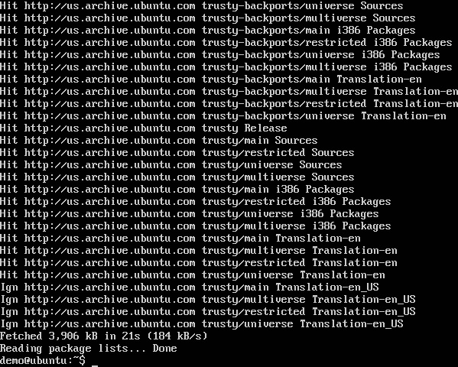

This command will connect to the internet and download the latest system packages for Ubuntu.

**Step 3** − The next step is to install the necessary certificates that will be required to work with the Docker site later on to download the necessary Docker packages. It can be done with the following command.

sudo apt-get install apt-transport-https ca-certificates

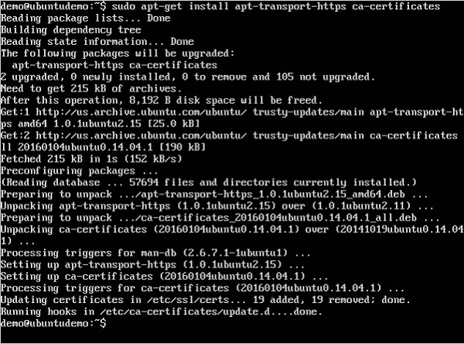

**Step 4** − The next step is to add the new GPG key. This key is required to ensure that all data is encrypted when downloading the necessary packages for Docker.

The following command will download the key with the ID 58118E89F3A912897C070ADBF76221572C52609D from the **keyserver** hkp://ha.pool.sks-keyservers.net:80 and adds it to the **adv** keychain. Please note that this particular key is required to download the necessary Docker packages.

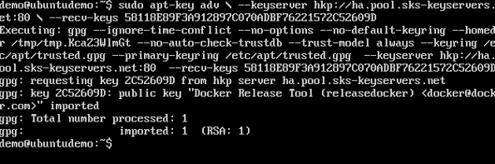

**Step 5** − Next, depending on the version of Ubuntu you have, you will need to add the relevant site to the **docker.list** for the **apt package manager**, so that it will be able to detect the Docker packages from the Docker site and download them accordingly.

* Precise 12.04 (LTS) ─ deb [https://apt.dockerproject.org/repo](https://apt.dockerproject.org/repo/)ubuntu-precise main
* Trusty 14.04 (LTS) ─ deb <https://apt.dockerproject.org/repo/> ubuntu-trusty main
* Wily 15.10 ─ deb [https://apt.dockerproject.org/repo](https://apt.dockerproject.org/repo/) ubuntu-wily main
* Xenial 16.04 (LTS) - [https://apt.dockerproject.org/repo](https://apt.dockerproject.org/repo/) ubuntu-xenial main

Since our OS is Ubuntu 14.04, we will use the Repository name as “deb [https://apt.dockerproject.org/repo](https://apt.dockerproject.org/repo/)ubuntu-trusty main”.

And then, we will need to add this repository to the **docker.list** as mentioned above.

echo "deb https://apt.dockerproject.org/repo ubuntu-trusty main”

| sudo tee /etc/apt/sources.list.d/docker.list

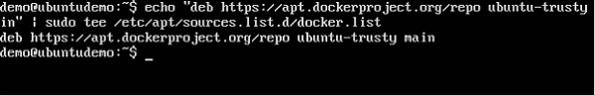

**Step 6** − Next, we issue the **apt-get update command** to update the packages on the Ubuntu system.

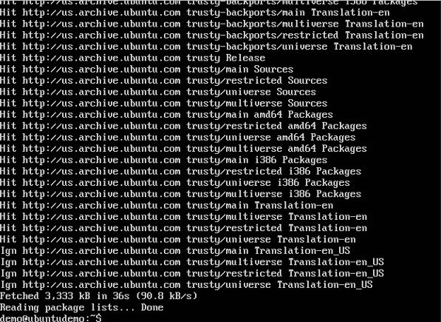

**Step 7** − If you want to verify that the package manager is pointing to the right repository, you can do it by issuing the **apt-cache command**.

apt-cache policy docker-engine

In the output, you will get the link to <https://apt.dockerproject.org/repo/>



**Step 8** − Issue the **apt-get update command** to ensure all the packages on the local system are up to date.

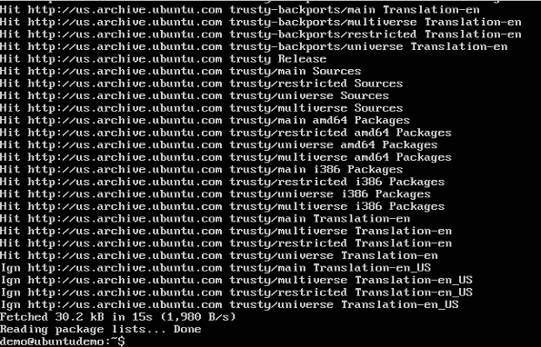

**Step 9** − For Ubuntu Trusty, Wily, and Xenial, we have to install the linux-image-extra-* kernel packages, which allows one to use the **aufs storage driver**. This driver is used by the newer versions of Docker.

It can be done by using the following command.

sudo apt-get install linux-image-extra-$(uname -r)

linux-image-extra-virtual

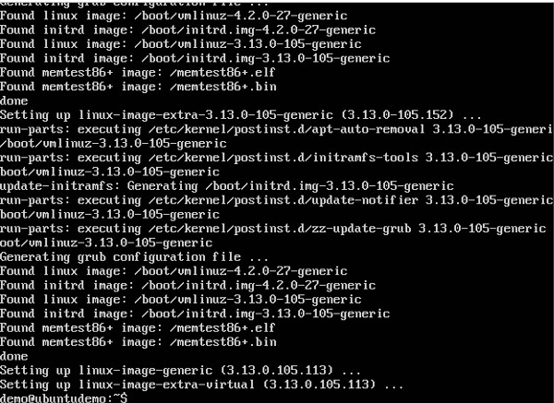

**Step 10** − The final step is to install Docker and we can do this with the following command −

sudo apt-get install –y docker-engine

Here, **apt-get** uses the install option to download the Docker-engine image from the Docker website and get Docker installed.

The Docker-engine is the official package from the Docker Corporation for Ubuntu-based systems.

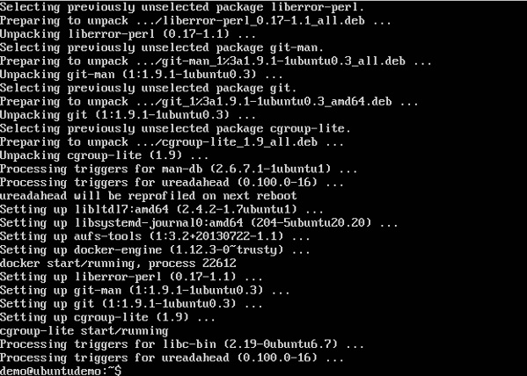

In the next section, we will see how to check for the version of Docker that was installed.

## **Docker Version**

To see the version of Docker running, you can issue the following command −

### **Syntax**

docker version

### **Options**

* **version** − It is used to ensure the Docker command returns the Docker version installed.

### **Return Value**

The output will provide the various details of the Docker version installed on the system.

### **Example**

sudo docker version

### **Output**

When we run the above program, we will get the following result −

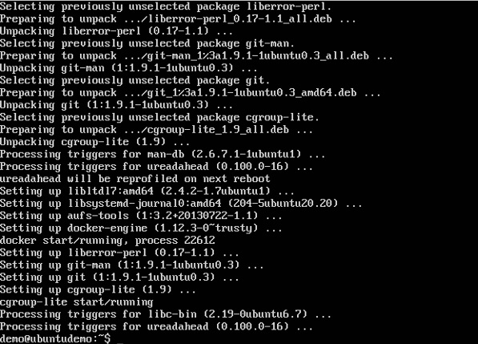

AD

## **Docker Info**

To see more information on the Docker running on the system, you can issue the following command −

### **Syntax**

docker info

### **Options**

* **info** − It is used to ensure that the Docker command returns the detailed information on the Docker service installed.

### **Return Value**

The output will provide the various details of the Docker installed on the system such as −

* Number of containers
* Number of images
* The storage driver used by Docker
* The root directory used by Docker
* The execution driver used by Docker

### **Example**

sudo docker info

### **Output**

When we run the above command, we will get the following result −

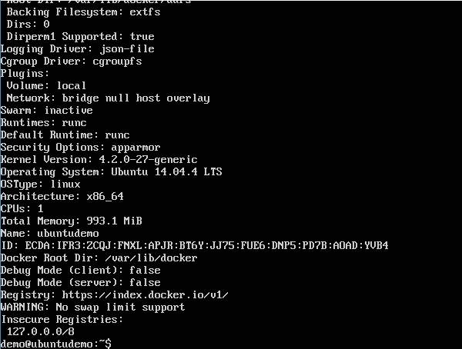

## **Docker for Windows**

Docker has out-of-the-box support for Windows, but you need to have the following configuration in order to install Docker for Windows.

### **System Requirements**

|  |  |
| --- | --- |
| Windows OS | Windows 10 64 bit |
| Memory | 2 GB RAM (recommended) |

You can download Docker for Windows from − <https://docs.docker.com/docker-for-windows/>

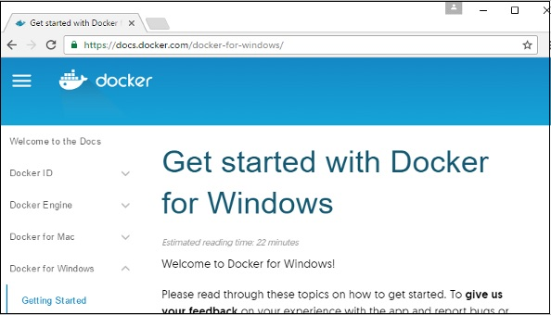

## **Docker ToolBox**

Docker ToolBox has been designed for older versions of Windows, such as Windows 8.1 and Windows 7. You need to have the following configuration in order to install Docker for Windows.

### **System Requirements**

|  |  |
| --- | --- |
| Windows OS | Windows 7 , 8, 8.1 |
| Memory | 2 GB RAM (recommended) |
| Virtualization | This should be enabled. |

You can download Docker ToolBox from − <https://www.docker.com/products/docker-toolbox>

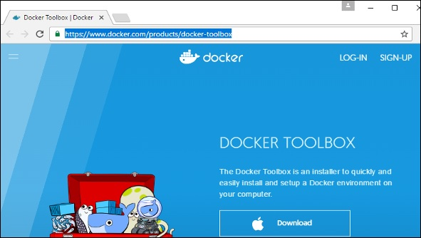

# Docker - Installation

Let’s go through the installation of each product.

## **Docker for Windows**

Once the installer has been downloaded, double-click it to start the installer and then follow the steps given below.

**Step 1** − Click on the Agreement terms and then the Install button to proceed ahead with the installation.

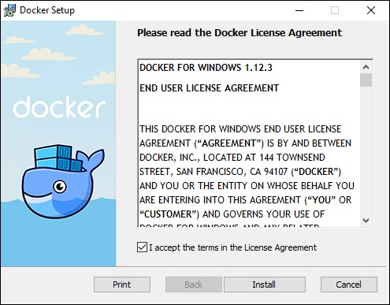

**Step 2** − Once complete, click the Finish button to complete the installation.

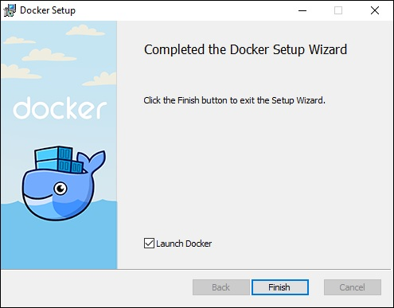

## **Docker ToolBox**

Once the installer has been downloaded, double-click it to start the installer and then follow the steps given below.

**Step 1** − Click the Next button on the start screen.

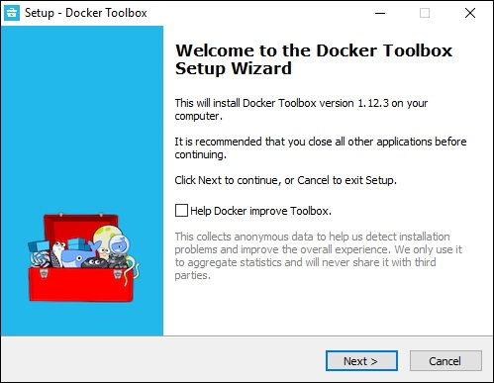

**Step 2** − Keep the default location on the next screen and click the Next button.

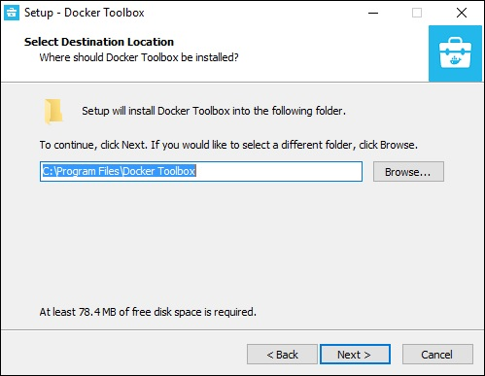

**Step 3** − Keep the default components and click the Next button to proceed.

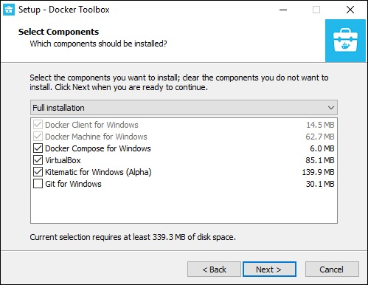

**Step 4** − Keep the Additional Tasks as they are and then click the Next button.

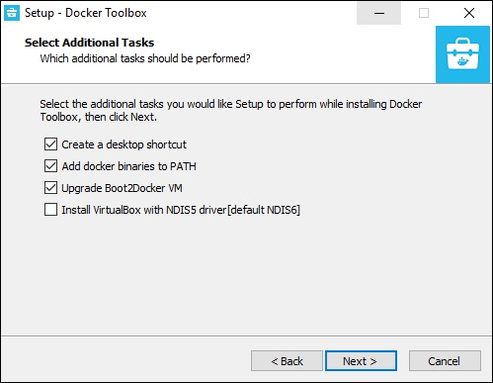

**Step 5** − On the final screen, click the Install button.

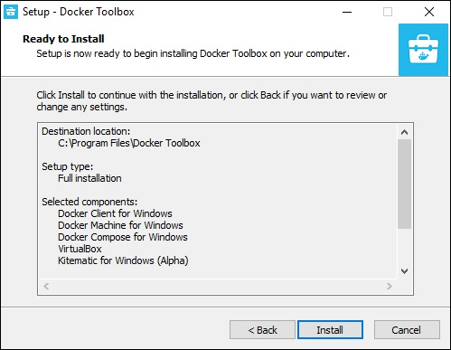

## **Working with Docker Toolbox**

Let’s now look at how Docker Toolbox can be used to work with Docker containers on Windows. The first step is to launch the Docker Toolbox application for which the shortcut is created on the desktop when the installation of Docker toolbox is carried out.

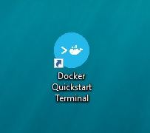

Next, you will see the configuration being carried out when Docker toolbox is launched.

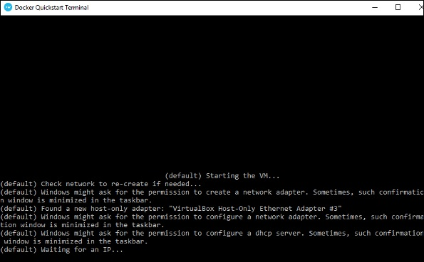

Once done, you will see Docker configured and launched. You will get an interactive shell for Docker.

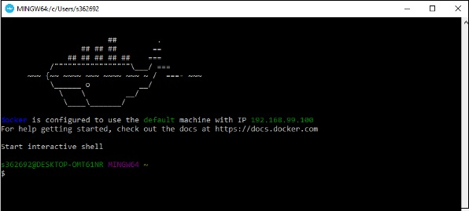

To test that Docker runs properly, we can use the Docker **run command** to download and run a simple **HelloWorld Docker container**.

The working of the Docker **run command** is given below −

docker run

This command is used to run a command in a Docker container.

### **Syntax**

docker run image

### **Options**

* **Image** − This is the name of the image which is used to run the container.

### **Return Value**

The output will run the command in the desired container.

### **Example**

sudo docker run hello-world

This command will download the **hello-world** image, if it is not already present, and run the **hello-world** as a container.

### **Output**

When we run the above command, we will get the following result −

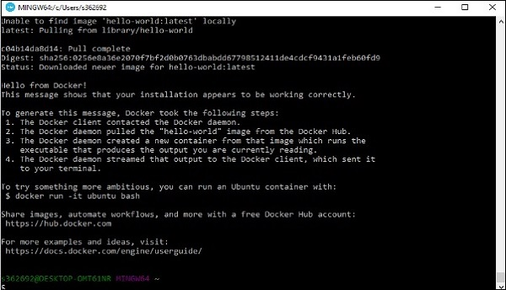

If you want to run the Ubuntu OS on Windows, you can download the Ubuntu Image using the following command −

Docker run –it ubuntu bash

Here you are telling Docker to run the command in the interactive mode via the **–it** option.

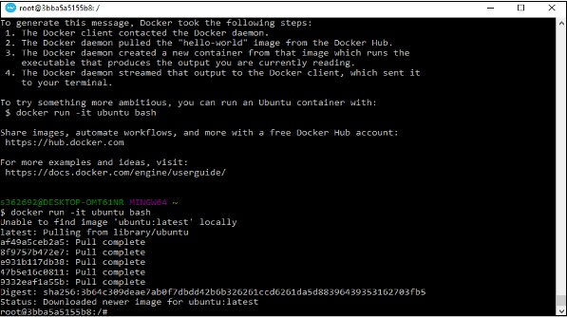

In the output you can see that the Ubuntu image is downloaded and run and then you will be logged in as a root user in the Ubuntu container.

# Docker - Hub

Docker Hub is a registry service on the cloud that allows you to download Docker images that are built by other communities. You can also upload your own Docker built images to Docker hub. In this chapter, we will see how to download and the use the Jenkins Docker image from Docker hub.

The official site for Docker hub is − <https://www.docker.com/community-edition#/add_ons>

**Step 1** − First you need to do a simple sign-up on Docker hub.

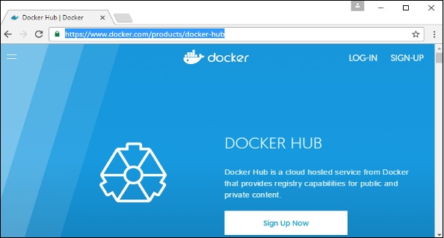

**Step 2** − Once you have signed up, you will be logged into Docker Hub.

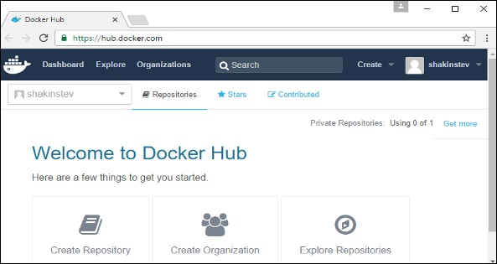

**Step 3** − Next, let’s browse and find the Jenkins image.

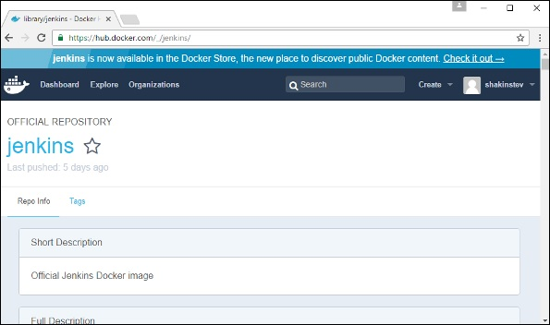

**Step 4** − If you scroll down on the same page, you can see the Docker **pull** command. This will be used to download the Jenkins image onto the local Ubuntu server.

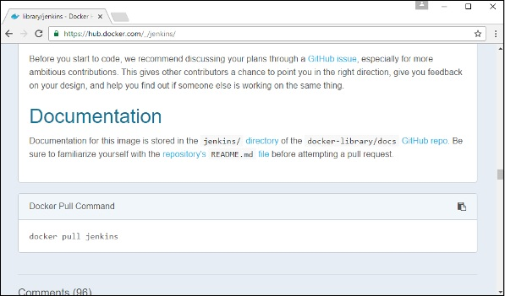

**Step 5** − Now, go to the Ubuntu server and run the following command −

sudo docker pull jenkins

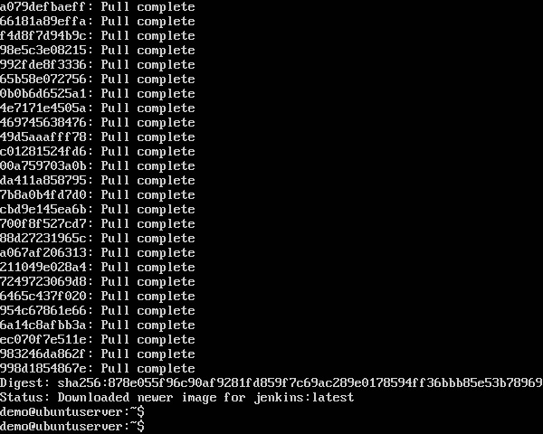

To run Jenkins, you need to run the following command −

sudo docker run -p 8080:8080 -p 50000:50000 jenkins

Note the following points about the above **sudo** command −

* We are using the **sudo** command to ensure it runs with root access.
* Here, **jenkins** is the name of the image we want to download from Docker hub and install on our Ubuntu machine.
* **-p** is used to map the port number of the internal Docker image to our main Ubuntu server so that we can access the container accordingly.

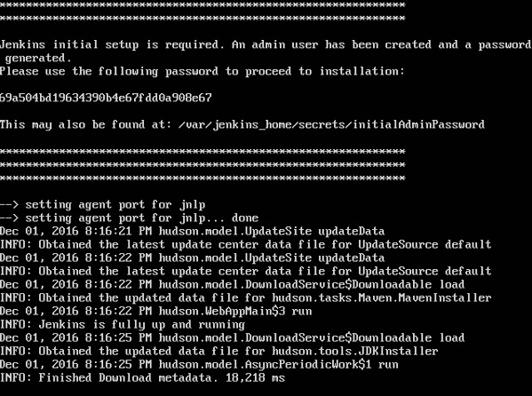

You will then have Jenkins successfully running as a container on the Ubuntu machine.

# Docker - Images

In Docker, everything is based on Images. An image is a combination of a file system and parameters. Let’s take an example of the following command in Docker.

docker run hello-world

* The Docker command is specific and tells the Docker program on the Operating System that something needs to be done.
* The **run** command is used to mention that we want to create an instance of an image, which is then called a **container**.
* Finally, "hello-world" represents the image from which the container is made.

Now let’s look at how we can use the CentOS image available in Docker Hub to run CentOS on our Ubuntu machine. We can do this by executing the following command on our Ubuntu machine −

sudo docker run centos –it /bin/bash

Note the following points about the above **sudo** command −

* We are using the **sudo** command to ensure that it runs with **root** access.
* Here, **centos** is the name of the image we want to download from Docker Hub and install on our Ubuntu machine.
* **─it** is used to mention that we want to run in **interactive mode**.
* **/bin/bash** is used to run the bash shell once CentOS is up and running.

## **Displaying Docker Images**

To see the list of Docker images on the system, you can issue the following command.

docker images

This command is used to display all the images currently installed on the system.

### **Syntax**

docker images

### **Options**

None

### **Return Value**

The output will provide the list of images on the system.

### **Example**

sudo docker images

### **Output**

When we run the above command, it will produce the following result −

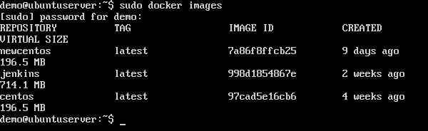

From the above output, you can see that the server has three images: **centos, newcentos,** and **jenkins**. Each image has the following attributes −

* **TAG** − This is used to logically tag images.
* **Image ID** − This is used to uniquely identify the image.
* **Created** − The number of days since the image was created.
* **Virtual Size** − The size of the image.

## **Downloading Docker Images**

Images can be downloaded from Docker Hub using the Docker **run** command. Let’s see in detail how we can do this.

### **Syntax**

The following syntax is used to run a command in a Docker container.

docker run image

### **Options**

* **Image** − This is the name of the image which is used to run the container.

### **Return Value**

The output will run the command in the desired container.

### **Example**

sudo docker run centos

This command will download the **centos** image, if it is not already present, and run the OS as a container.

### **Output**

When we run the above command, we will get the following result −

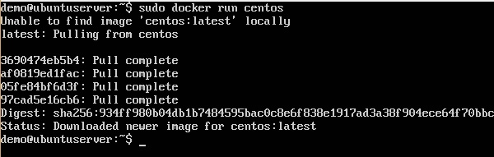

You will now see the CentOS Docker image downloaded. Now, if we run the Docker **images** command to see the list of images on the system, we should be able to see the **centos** image as well.

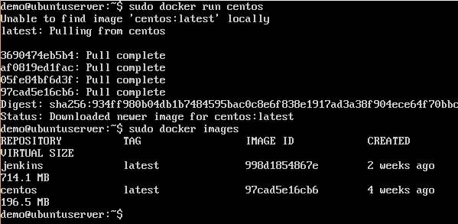

## **Removing Docker Images**

The Docker images on the system can be removed via the **docker rmi** command. Let’s look at this command in more detail.

docker rmi

This command is used to remove Docker images.

### **Syntax**

docker rmi ImageID

### **Options**

* **ImageID** − This is the ID of the image which needs to be removed.

### **Return Value**

The output will provide the Image ID of the deleted Image.

### **Example**

sudo docker rmi 7a86f8ffcb25

Here, **7a86f8ffcb25** is the Image ID of the **newcentos** image.

### **Output**

When we run the above command, it will produce the following result −

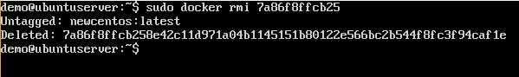

Let’s see some more Docker commands on images.

## **docker images -q**

This command is used to return only the Image ID’s of the images.

### **Syntax**

docker images

### **Options**

* **q** − It tells the Docker command to return the Image ID’s only.

### **Return Value**

The output will show only the Image ID’s of the images on the Docker host.

### **Example**

sudo docker images -q

### **Output**

When we run the above command, it will produce the following result −

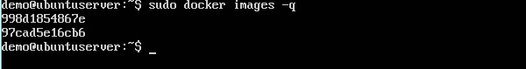

## **docker inspect**

This command is used see the details of an image or container.

### **Syntax**

docker inspect Repository

### **Options**

* **Repository** − This is the name of the Image.

### **Return Value**

The output will show detailed information on the Image.

### **Example**

sudo docker inspect jenkins

### **Output**

When we run the above command, it will produce the following result −

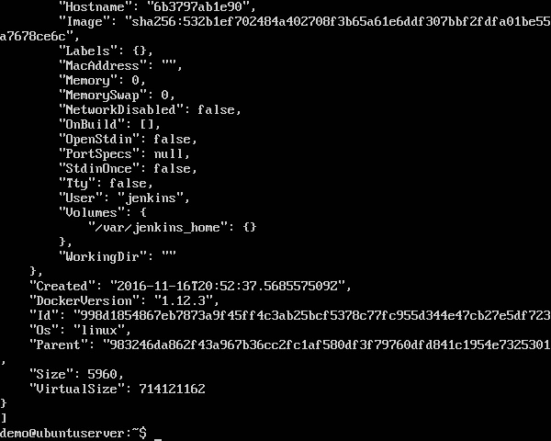

# Docker - Containers

Containers are instances of Docker images that can be run using the Docker run command. The basic purpose of Docker is to run containers. Let’s discuss how to work with containers.

## **Running a Container**

Running of containers is managed with the Docker **run** command. To run a container in an interactive mode, first launch the Docker container.

sudo docker run –it centos /bin/bash

Then hit Crtl+p and you will return to your OS shell.

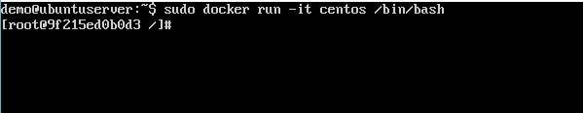

You will then be running in the instance of the CentOS system on the Ubuntu server.

## **Listing of Containers**

One can list all of the containers on the machine via the **docker ps** command. This command is used to return the currently running containers.

docker ps

### **Syntax**

docker ps

### **Options**

None

### **Return Value**

The output will show the currently running containers.

### **Example**

sudo docker ps

### **Output**

When we run the above command, it will produce the following result −

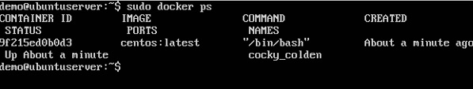

Let’s see some more variations of the **docker ps** command.

## **docker ps -a**

This command is used to list all of the containers on the system

### **Syntax**

docker ps -a

### **Options**

* **─a** − It tells the **docker ps** command to list all of the containers on the system.

### **Return Value**

The output will show all containers.

### **Example**

sudo docker ps -a

### **Output**

When we run the above command, it will produce the following result −

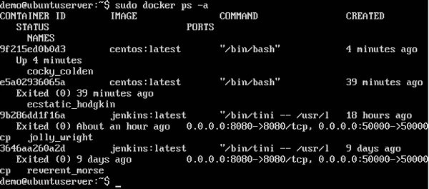

## **docker history**

With this command, you can see all the commands that were run with an image via a container.

### **Syntax**

docker history ImageID

### **Options**

* **ImageID** − This is the Image ID for which you want to see all the commands that were run against it.

### **Return Value**

The output will show all the commands run against that image.

### **Example**

sudo docker history centos

The above command will show all the commands that were run against the **centos** image.

### **Output**

When we run the above command, it will produce the following result −

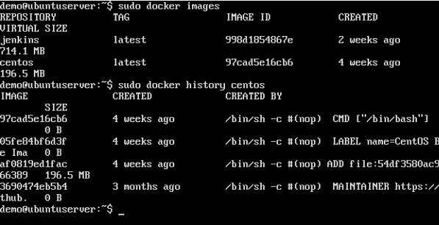

# Docker - Working with Containers

In this chapter, we will explore in detail what we can do with containers.

## **docker top**

With this command, you can see the top processes within a container.

### **Syntax**

docker top ContainerID

### **Options**

* **ContainerID** − This is the Container ID for which you want to see the top processes.

### **Return Value**

The output will show the top-level processes within a container.

### **Example**

sudo docker top 9f215ed0b0d3

The above command will show the top-level processes within a container.

### **Output**

When we run the above command, it will produce the following result −

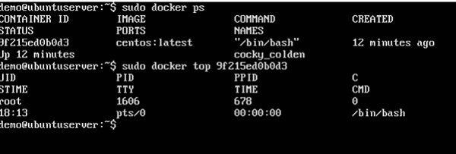

## **docker stop**

This command is used to stop a running container.

### **Syntax**

docker stop ContainerID

### **Options**

* **ContainerID** − This is the Container ID which needs to be stopped.

### **Return Value**

The output will give the ID of the stopped container.

### **Example**

sudo docker stop 9f215ed0b0d3

The above command will stop the Docker container **9f215ed0b0d3**.

### **Output**

When we run the above command, it will produce the following result −

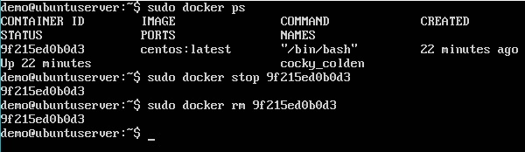

## **docker rm**

This command is used to delete a container.

### **Syntax**

docker rm ContainerID

### **Options**

* **ContainerID** − This is the Container ID which needs to be removed.

### **Return Value**

The output will give the ID of the removed container.

### **Example**

sudo docker rm 9f215ed0b0d3

The above command will remove the Docker container **9f215ed0b0d3**.

### **Output**

When we run the above command, it will produce the following result −

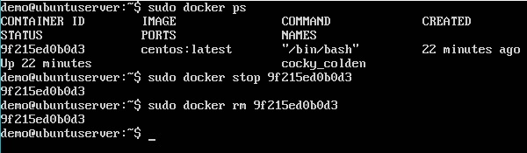

## **docker stats**

This command is used to provide the statistics of a running container.

### **Syntax**

docker stats ContainerID

### **Options**

* **ContainerID** − This is the Container ID for which the stats need to be provided.

### **Return Value**

The output will show the CPU and Memory utilization of the Container.

### **Example**

sudo docker stats 9f215ed0b0d3

The above command will provide CPU and memory utilization of the Container **9f215ed0b0d3**.

### **Output**

When we run the above command, it will produce the following result −

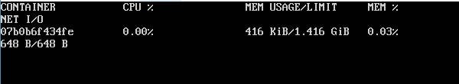

## **docker attach**

This command is used to attach to a running container.

### **Syntax**

docker attach ContainerID

### **Options**

* **ContainerID** − This is the Container ID to which you need to attach.

### **Return Value**

None

### **Example**

sudo docker attach 07b0b6f434fe

The above command will attach to the Docker container **07b0b6f434fe**.

### **Output**

When we run the above command, it will produce the following result −

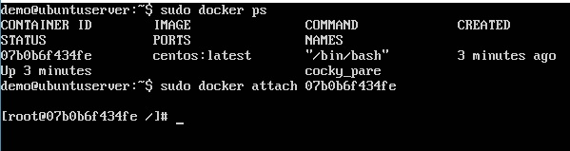

Once you have attached to the Docker container, you can run the above command to see the process utilization in that Docker container.

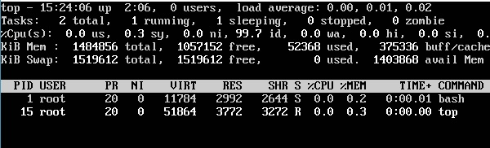

## **docker pause**

This command is used to pause the processes in a running container.

### **Syntax**

docker pause ContainerID

### **Options**

* **ContainerID** − This is the Container ID to which you need to pause the processes in the container.

### **Return Value**

The ContainerID of the paused container.

### **Example**

sudo docker pause 07b0b6f434fe

The above command will pause the processes in a running container **07b0b6f434fe**.

### **Output**

When we run the above command, it will produce the following result −

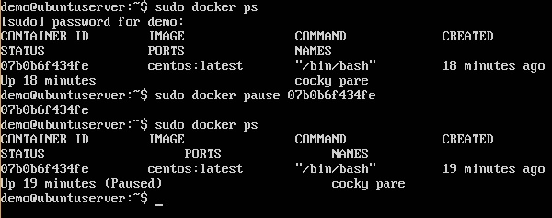

## **docker unpause**

This command is used to **unpause** the processes in a running container.

### **Syntax**

docker unpause ContainerID

### **Options**

* **ContainerID** − This is the Container ID to which you need to unpause the processes in the container.

### **Return Value**

The ContainerID of the running container.

### **Example**

sudo docker unpause 07b0b6f434fe

The above command will unpause the processes in a running container: 07b0b6f434fe

### **Output**

When we run the above command, it will produce the following result −

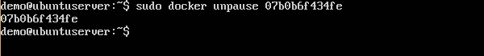

## **docker kill**

This command is used to kill the processes in a running container.

### **Syntax**

docker kill ContainerID

### **Options**

* **ContainerID** − This is the Container ID to which you need to kill the processes in the container.

### **Return Value**

The ContainerID of the running container.

### **Example**

sudo docker kill 07b0b6f434fe

The above command will kill the processes in the running container **07b0b6f434fe**.

### **Output**

When we run the above command, it will produce the following result −

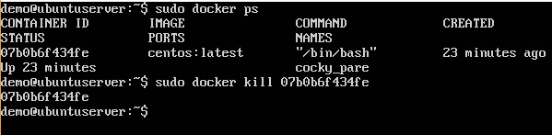

## **Docker – Container Lifecycle**

The following illustration explains the entire lifecycle of a Docker container.

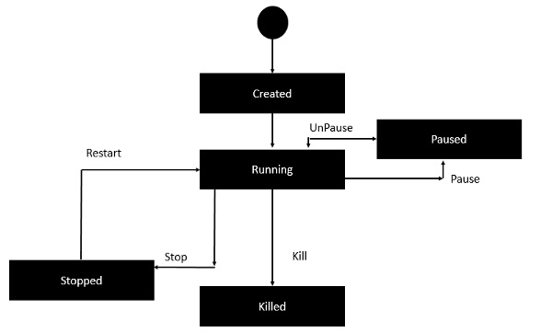

* Initially, the Docker container will be in the **created** state.
* Then the Docker container goes into the running state when the Docker **run** command is used.
* The Docker **kill** command is used to kill an existing Docker container.
* The Docker **pause** command is used to pause an existing Docker container.
* The Docker **stop** command is used to pause an existing Docker container.
* The Docker **run** command is used to put a container back from a **stopped** state to a **running** state.

# Docker - Architecture

The following image shows the standard and traditional architecture of **virtualization**.

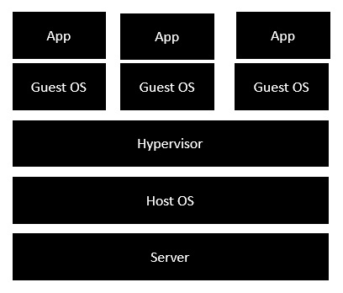

* The server is the physical server that is used to host multiple virtual machines.
* The Host OS is the base machine such as Linux or Windows.
* The Hypervisor is either VMWare or Windows Hyper V that is used to host virtual machines.
* You would then install multiple operating systems as virtual machines on top of the existing hypervisor as Guest OS.
* You would then host your applications on top of each Guest OS.

The following image shows the new generation of virtualization that is enabled via Dockers. Let’s have a look at the various layers.

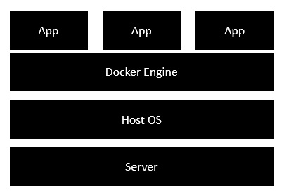

* The server is the physical server that is used to host multiple virtual machines. So this layer remains the same.
* The Host OS is the base machine such as Linux or Windows. So this layer remains the same.
* Now comes the new generation which is the Docker engine. This is used to run the operating system which earlier used to be virtual machines as Docker containers.
* All of the Apps now run as Docker containers.

The clear advantage in this architecture is that you don’t need to have extra hardware for Guest OS. Everything works as Docker containers.

# Docker - Container and Hosts

The good thing about the Docker engine is that it is designed to work on various operating systems. We have already seen the installation on Windows and seen all the Docker commands on Linux systems. Now let’s see the various Docker commands on the Windows OS.

## **Docker Images**

Let’s run the Docker **images** command on the Windows host.

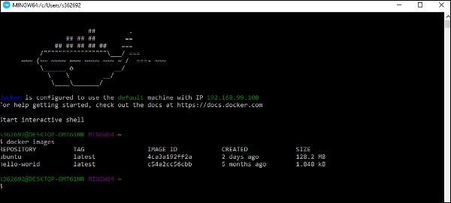

From here, we can see that we have two images − **ubuntu** and **hello-world**.

## **Running a Container**

Now let’s run a container in the Windows Docker host.

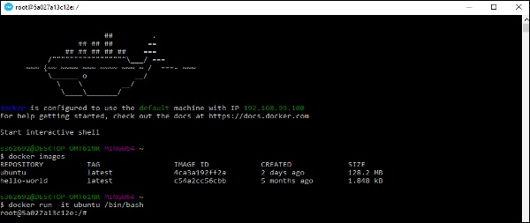

We can see that by running the container, we can now run the Ubuntu container on a Windows host.

## **Listing All Containers**

Let’s list all the containers on the Windows host.

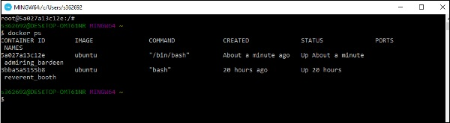

## **Stopping a Container**

Let’s now stop a running container on the Windows host.

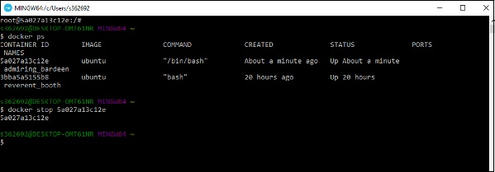

So you can see that the Docker engine is pretty consistent when it comes to different Docker hosts and it works on Windows in the same way it works on Linux.

# Docker - Configuring

In this chapter, we will look at the different options to configure Docker.

## **service docker stop**

This command is used to stop the Docker **daemon** process.

### **Syntax**

service docker stop

### **Options**

None

### **Return Value**

A message showing that the Docker process has stopped.

### **Example**

sudo service docker stop

### **Output**

When we run the above command, it will produce the following result −

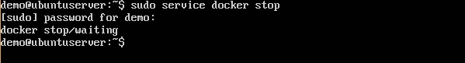

## **service docker start**

This command is used to start the Docker daemon process.

### **Syntax**

service docker start

### **Options**

None

### **Return Value**

A message showing that the Docker process has started.

### **Example**

sudo service docker start

### **Output**

When we run the above command, it will produce the following result −

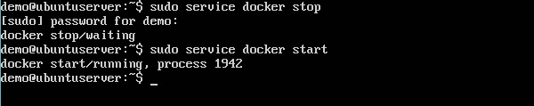

# Docker - Containers and Shells

By default, when you launch a container, you will also use a **shell command** while launching the container as shown below. This is what we have seen in the earlier chapters when we were working with containers.

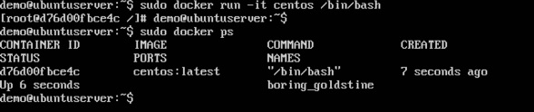

In the above screenshot, you can observe that we have issued the following command −

sudo docker run –it centos /bin/bash

We used this command to create a new container and then used the Ctrl+P+Q command to exit out of the container. It ensures that the container still exists even after we exit from the container.

We can verify that the container still exists with the Docker **ps** command. If we had to exit out of the container directly, then the container itself would be destroyed.

Now there is an easier way to attach to containers and exit them cleanly without the need of destroying them. One way of achieving this is by using the **nsenter** command.

Before we run the **nsenter** command, you need to first install the **nsenter** image. It can be done by using the following command −

docker run --rm -v /usr/local/bin:/target jpetazzo/nsenter

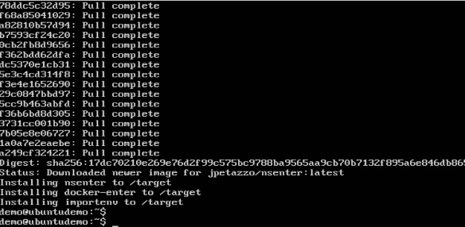

Before we use the **nsenter** command, we need to get the Process ID of the container, because this is required by the **nsenter** command. We can get the Process ID via the Docker **inspect command** and filtering it via the **Pid**.

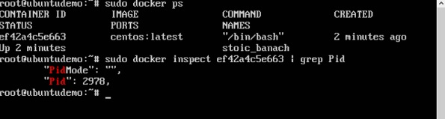

As seen in the above screenshot, we have first used the **docker ps** command to see the running containers. We can see that there is one running container with the ID of ef42a4c5e663.

We then use the Docker **inspect** command to inspect the configuration of this container and then use the **grep** command to just filter the Process ID. And from the output, we can see that the Process ID is 2978.

Now that we have the process ID, we can proceed forward and use the **nsenter** command to attach to the Docker container.

## **nsenter**

This method allows one to attach to a container without exiting the container.

### **Syntax**

nsenter –m –u –n –p –i –t containerID command

### **Options**

* **-u** is used to mention the **Uts namespace**
* **-m** is used to mention the **mount namespace**
* **-n** is used to mention the **network namespace**
* **-p** is used to mention the **process namespace**
* **-i** s to make the container run in interactive mode.
* **-t** is used to connect the I/O streams of the container to the host OS.
* **containerID** − This is the ID of the container.
* **Command** − This is the command to run within the container.

### **Return Value**

None

### **Example**

sudo nsenter –m –u –n –p –i –t 2978 /bin/bash

### **Output**

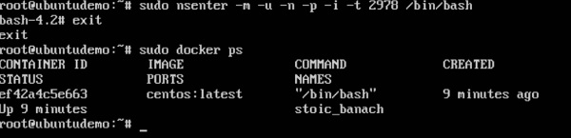

From the output, we can observe the following points −

* The prompt changes to the **bash shell** directly when we issue the **nsenter** command.
* We then issue the **exit** command. Now normally if you did not use the **nsenter** command, the container would be destroyed. But you would notice that when we run the **nsenter** command, the container is still up and running.

# Docker - File

In the earlier chapters, we have seen the various Image files such as Centos which get downloaded from **Docker hub** from which you can spin up containers. An example is again shown below.

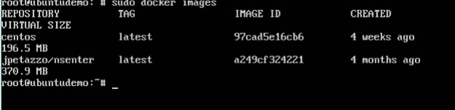

If we use the Docker **images** command, we can see the existing images in our system. From the above screenshot, we can see that there are two images: **centos** and **nsenter**.

But Docker also gives you the capability to create your own Docker images, and it can be done with the help of **Docker Files**. A Docker File is a simple text file with instructions on how to build your images.

The following steps explain how you should go about creating a Docker File.

**Step 1** − Create a file called **Docker File** and edit it using **vim**. Please note that the name of the file has to be "Dockerfile" with "D" as capital.

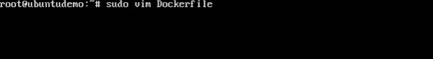

**Step 2** − Build your Docker File using the following instructions.

#This is a sample Image

FROM ubuntu

MAINTAINER demousr@gmail.com

RUN apt-get update

RUN apt-get install –y nginx

CMD [“echo”,”Image created”]

The following points need to be noted about the above file −

* The first line "#This is a sample Image" is a comment. You can add comments to the Docker File with the help of the **#** command
* The next line has to start with the **FROM** keyword. It tells docker, from which base image you want to base your image from. In our example, we are creating an image from the **ubuntu** image.
* The next command is the person who is going to maintain this image. Here you specify the **MAINTAINER** keyword and just mention the email ID.
* The **RUN** command is used to run instructions against the image. In our case, we first update our Ubuntu system and then install the nginx server on our **ubuntu** image.
* The last command is used to display a message to the user.

**Step 3** − Save the file. In the next chapter, we will discuss how to build the image.

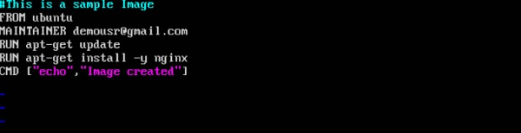

# Docker - Building Files

We created our Docker File in the last chapter. It’s now time to build the Docker File. The Docker File can be built with the following command −

docker build

Let’s learn more about this command.

## **docker build**

This method allows the users to build their own Docker images.

### **Syntax**

docker build -t ImageName:TagName dir

### **Options**

* **-t** − is to mention a tag to the image
* **ImageName** − This is the name you want to give to your image.
* **TagName** − This is the tag you want to give to your image.
* **Dir** − The directory where the Docker File is present.

### **Return Value**

None

### **Example**

sudo docker build –t myimage:0.1.

Here, **myimage** is the name we are giving to the Image and **0.1** is the tag number we are giving to our image.

Since the Docker File is in the present working directory, we used "." at the end of the command to signify the present working directory.

### **Output**

From the output, you will first see that the Ubuntu Image will be downloaded from Docker Hub, because there is no image available locally on the machine.

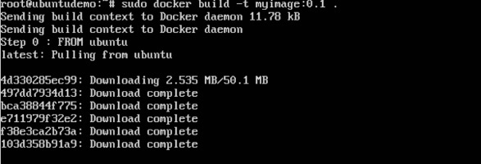

Finally, when the build is complete, all the necessary commands would have run on the image.

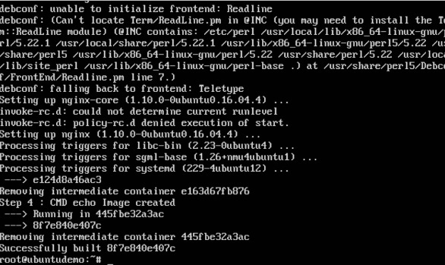

You will then see the successfully built message and the ID of the new Image. When you run the Docker **images command**, you would then be able to see your new image.

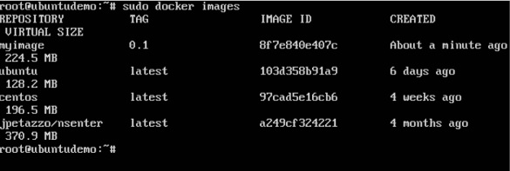

You can now build containers from your new Image.

# Docker - Public Repositories

Public repositories can be used to host Docker images which can be used by everyone else. An example is the images which are available in Docker Hub. Most of the images such as Centos, Ubuntu, and Jenkins are all publicly available for all. We can also make our images available by publishing it to the public repository on Docker Hub.

For our example, we will use the **myimage** repository built in the "Building Docker Files" chapter and upload that image to Docker Hub. Let’s first review the images on our Docker host to see what we can push to the Docker registry.

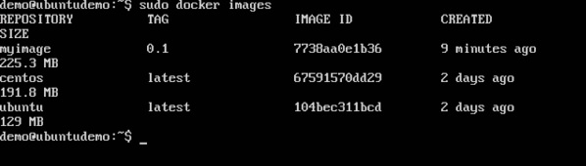

Here, we have our **myimage:0.1** image which was created as a part of the “Building Docker Files” chapter. Let’s use this to upload to the Docker public repository.

The following steps explain how you can upload an image to public repository.

**Step 1** − Log into Docker Hub and create your repository. This is the repository where your image will be stored. Go to <https://hub.docker.com/> and log in with your credentials.

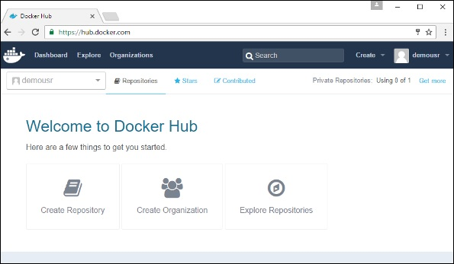

**Step 2** − Click the button "Create Repository" on the above screen and create a repository with the name **demorep**. Make sure that the visibility of the repository is public.

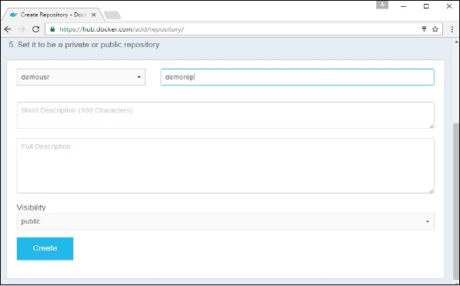

Once the repository is created, make a note of the **pull** command which is attached to the repository.

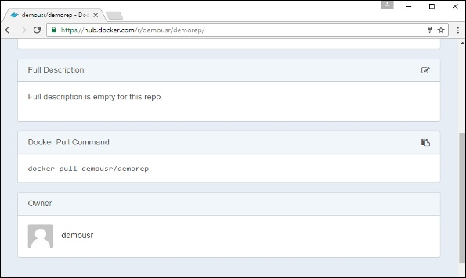

The **pull** command which will be used in our repository is as follows −

docker pull demousr/demorep

**Step 3** − Now go back to the Docker Host. Here we need to tag our **myimage** to the new repository created in Docker Hub. We can do this via the Docker **tag command**.

We will learn more about this **tag command** later in this chapter.

**Step 4** − Issue the Docker login command to login into the Docker Hub repository from the command prompt. The Docker login command will prompt you for the username and password to the Docker Hub repository.

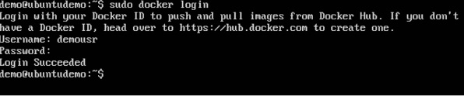

**Step 5** − Once the image has been tagged, it’s now time to push the image to the Docker Hub repository. We can do this via the Docker **push** command. We will learn more about this command later in this chapter.

## **docker tag**

This method allows one to tag an image to the relevant repository.

### **Syntax**

docker tag imageID Repositoryname

### **Options**

* **imageID** − This is the ImageID which needs to be tagged to the repository.
* **Repositoryname** − This is the repository name to which the ImageID needs to be tagged to.

### **Return Value**

None

### **Example**

sudo docker tag ab0c1d3744dd demousr/demorep:1.0

### **Output**

A sample output of the above example is given below.

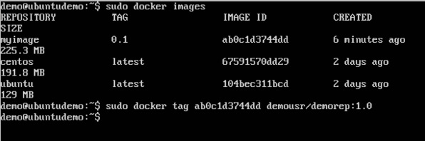

## **docker push**

This method allows one to push images to the Docker Hub.

### **Syntax**

docker push Repositoryname

### **Options**

* **Repositoryname** − This is the repository name which needs to be pushed to the Docker Hub.

### **Return Value**

The long ID of the repository pushed to Docker Hub.

### **Example**

sudo docker push demousr/demorep:1.0

### **Output**

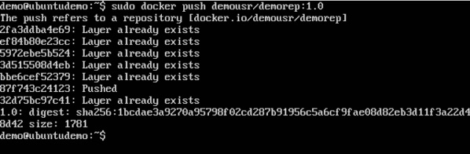

If you go back to the Docker Hub page and go to your repository, you will see the tag name in the repository.

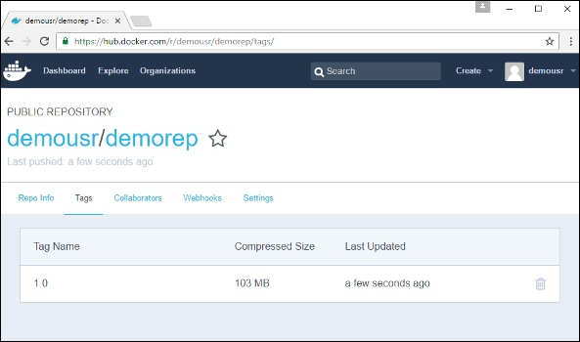

Now let’s try to pull the repository we uploaded onto our Docker host. Let’s first delete the images, **myimage:0.1** and **demousr/demorep:1.0**, from the local Docker host. Let’s use the Docker **pull command** to pull the repository from the Docker Hub.

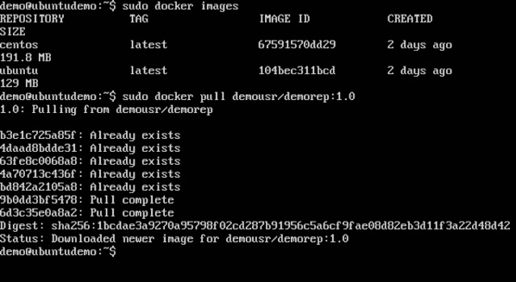

From the above screenshot, you can see that the Docker **pull** command has taken our new repository from the Docker Hub and placed it on our machine.

# Docker - Managing Ports

In Docker, the containers themselves can have applications running on ports. When you run a container, if you want to access the application in the container via a port number, you need to map the port number of the container to the port number of the Docker host. Let’s look at an example of how this can be achieved.

In our example, we are going to download the Jenkins container from Docker Hub. We are then going to map the Jenkins port number to the port number on the Docker host.

**Step 1** − First, you need to do a simple sign-up on Docker Hub.

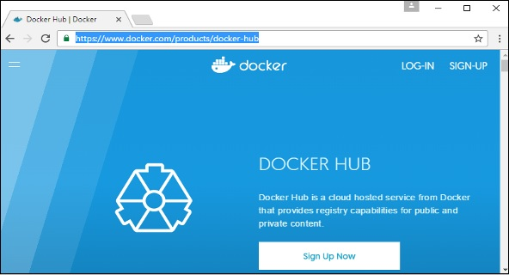

**Step 2** − Once you have signed up, you will be logged into Docker Hub.

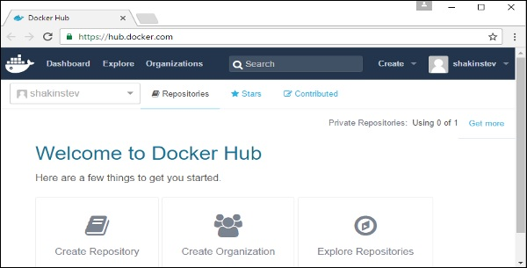

**Step 3** − Next, let’s browse and find the Jenkins image.

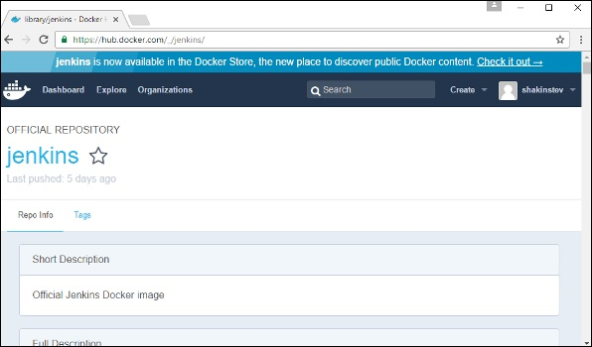

**Step 4** − If you scroll down on the same page, you can see the Docker **pull** command. This will be used to download the Jenkins Image onto the local Ubuntu server.

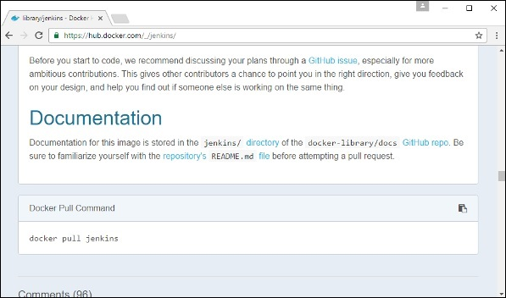

**Step 5** − Now go to the Ubuntu server and run the command −

sudo docker pull jenkins

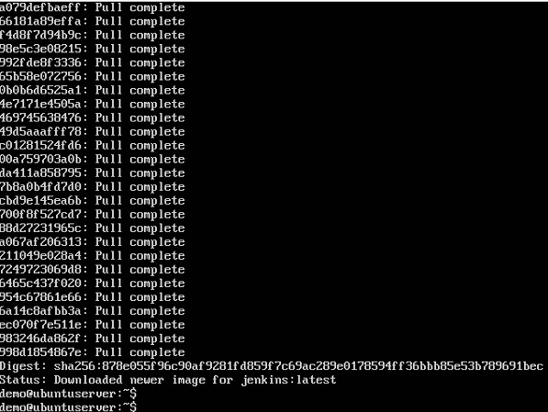

**Step 6** − To understand what ports are exposed by the container, you should use the Docker **inspect command** to inspect the image.

Let’s now learn more about this **inspect** command.

## **docker inspect**

This method allows one to return low-level information on the container or image.

### **Syntax**

docker inspect Container/Image

### **Options**

* **Container/Image** − The container or image to inspect

### **Return Value**

The low-level information of the image or container in JSON format.

### **Example**

sudo docker inspect jenkins

### **Output**

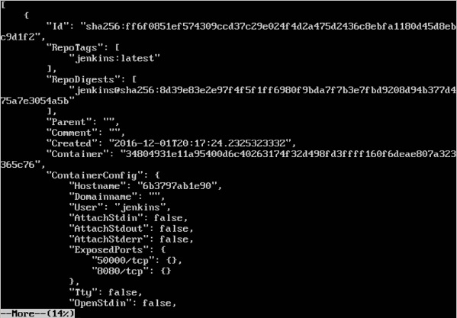

The output of the **inspect** command gives a JSON output. If we observe the output, we can see that there is a section of "ExposedPorts" and see that there are two ports mentioned. One is the **data port** of 8080 and the other is the **control port** of 50000.

To run Jenkins and map the ports, you need to change the Docker **run** command and add the ‘p’ option which specifies the port mapping. So, you need to run the following command −

sudo docker run -p 8080:8080 -p 50000:50000 jenkins

The left-hand side of the port number mapping is the Docker host port to map to and the right-hand side is the Docker container port number.

When you open the browser and navigate to the Docker host on port 8080, you will see Jenkins up and running.

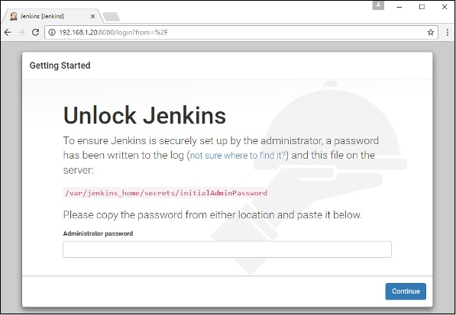

# Docker - Private Registries

You might have the need to have your own private repositories. You may not want to host the repositories on Docker Hub. For this, there is a repository container itself from Docker. Let’s see how we can download and use the container for registry.

**Step 1** − Use the Docker **run** command to download the private registry. This can be done using the following command.

sudo docker run –d –p 5000:5000 –-name registry registry:2

The following points need to be noted about the above command −

* **Registry** is the container managed by Docker which can be used to host private repositories.
* The port number exposed by the container is 5000. Hence with the **–p command**, we are mapping the same port number to the 5000 port number on our localhost.
* We are just tagging the registry container as “2”, to differentiate it on the Docker host.
* The **–d** option is used to run the container in detached mode. This is so that the container can run in the background

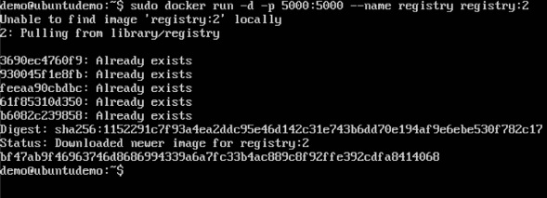

**Step 2** − Let’s do a **docker ps** to see that the registry container is indeed running.

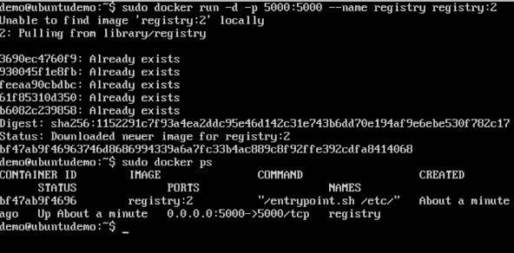

We have now confirmed that the registry container is indeed running.

**Step 3** − Now let’s tag one of our existing images so that we can push it to our local repository. In our example, since we have the **centos** image available locally, we are going to tag it to our private repository and add a tag name of **centos**.

sudo docker tag 67591570dd29 localhost:5000/centos

The following points need to be noted about the above command −

* **67591570dd29** refers to the Image ID for the **centos** image.
* **localhost:5000** is the location of our private repository.
* We are tagging the repository name as **centos** in our private repository.

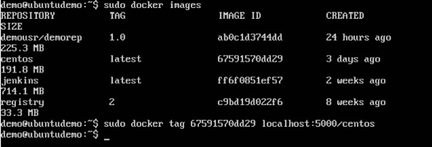

**Step 4** − Now let’s use the Docker **push** command to push the repository to our private repository.

sudo docker push localhost:5000/centos

Here, we are pushing the **centos** image to the private repository hosted at **localhost:5000**.

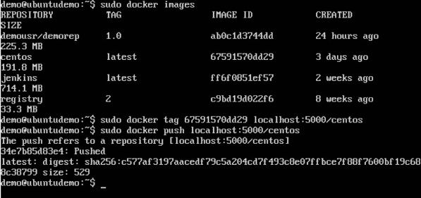

**Step 5** − Now let’s delete the local images we have for **centos** using the **docker rmi** commands. We can then download the required **centos** image from our private repository.

sudo docker rmi centos:latest

sudo docker rmi 67591570dd29

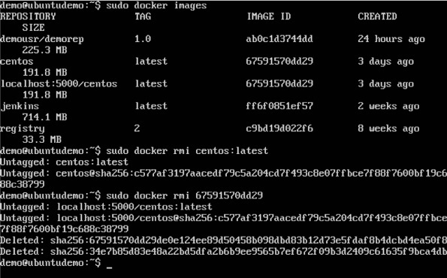

**Step 6** − Now that we don’t have any **centos** images on our local machine, we can now use the following Docker **pull** command to pull the **centos** image from our private repository.

sudo docker pull localhost:5000/centos

Here, we are pulling the **centos** image to the private repository hosted at **localhost:5000**.

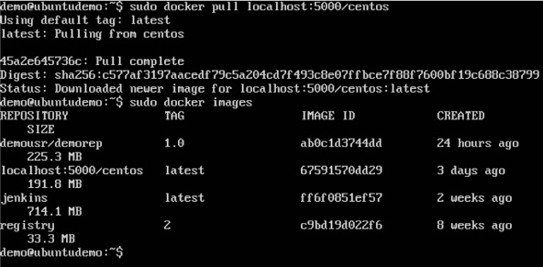

If you now see the images on your system, you will see the **centos** image as well.

# Docker - Building a Web Server Docker File

We have already learnt how to use Docker File to build our own custom images. Now let’s see how we can build a web server image which can be used to build containers.

In our example, we are going to use the Apache Web Server on Ubuntu to build our image. Let’s follow the steps given below, to build our web server Docker file.

**Step 1** − The first step is to build our Docker File. Let’s use **vim** and create a Docker File with the following information.

FROM ubuntu

RUN apt-get update

RUN apt-get install –y apache2

RUN apt-get install –y apache2-utils

RUN apt-get clean

EXPOSE 80 CMD [“apache2ctl”, “-D”, “FOREGROUND”]

The following points need to be noted about the above statements −

* We are first creating our image to be from the Ubuntu base image.
* Next, we are going to use the RUN command to update all the packages on the Ubuntu system.
* Next, we use the RUN command to install apache2 on our image.
* Next, we use the RUN command to install the necessary utility apache2 packages on our image.
* Next, we use the RUN command to clean any unnecessary files from the system.
* The EXPOSE command is used to expose port 80 of Apache in the container to the Docker host.
* Finally, the CMD command is used to run apache2 in the background.

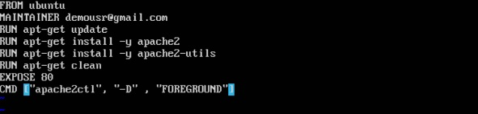

Now that the file details have been entered, just save the file.

**Step 2** − Run the Docker **build** command to build the Docker file. It can be done using the following command −

sudo docker build –t=”mywebserver” .

We are tagging our image as **mywebserver**. Once the image is built, you will get a successful message that the file has been built.

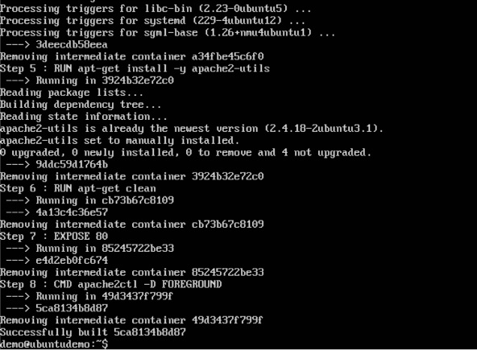

**Step 3** − Now that the web server file has been built, it’s now time to create a container from the image. We can do this with the Docker **run** command.

sudo docker run –d –p 80:80 mywebserver

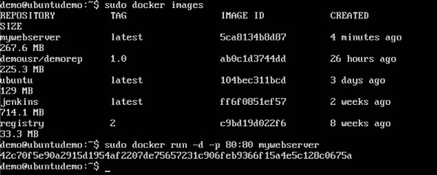

The following points need to be noted about the above command −

* The port number exposed by the container is 80. Hence with the **–p** command, we are mapping the same port number to the 80 port number on our localhost.
* The **–d** option is used to run the container in detached mode. This is so that the container can run in the background.

If you go to port 80 of the Docker host in your web browser, you will now see that Apache is up and running.

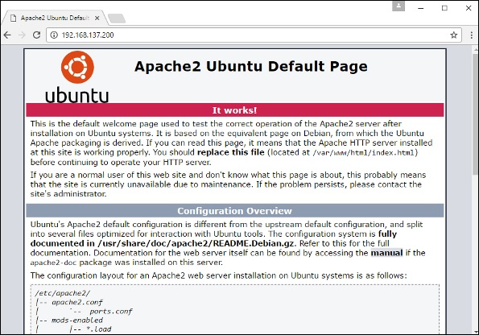

# Docker - Instruction Commands

Docker has a host of instruction commands. These are commands that are put in the Docker File. Let’s look at the ones which are available.

## **CMD Instruction**

This command is used to execute a command at runtime when the container is executed.

### **Syntax**

CMD command param1

### **Options**

* **command** − This is the command to run when the container is launched.
* **param1** − This is the parameter entered to the command.

### **Return Value**

The command will execute accordingly.

### **Example**

In our example, we will enter a simple **Hello World** echo in our Docker File and create an image and launch a container from it.

**Step 1** − Build the Docker File with the following commands −

FROM ubuntu

MAINTAINER demousr@gmail.com

CMD [“echo” , “hello world”]

Here, the CMD is just used to print **hello world**.

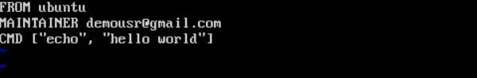

**Step 2** − Build the image using the Docker **build** command.

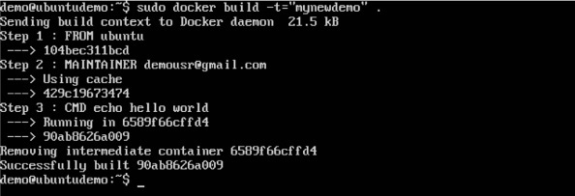

**Step 3** − Run a container from the image.

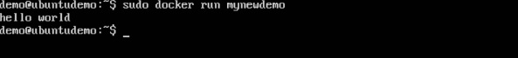

## **ENTRYPOINT**

This command can also be used to execute commands at runtime for the container. But we can be more flexible with the ENTRYPOINT command.

### **Syntax**

ENTRYPOINT command param1

### **Options**

* **command** − This is the command to run when the container is launched.
* **param1** − This is the parameter entered into the command.

### **Return Value**

The command will execute accordingly.

### **Example**

Let’s take a look at an example to understand more about ENTRYPOINT. In our example, we will enter a simple **echo** command in our Docker File and create an image and launch a container from it.

**Step 1** − Build the Docker File with the following commands −

FROM ubuntu

MAINTAINER demousr@gmail.com

ENTRYPOINT [“echo”]

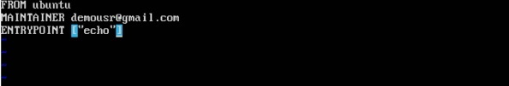

**Step 2** − Build the image using the Docker **build** command.

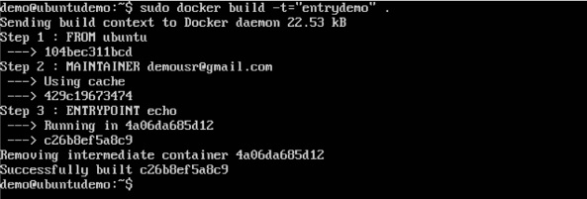

**Step 3** − Run a container from the image.

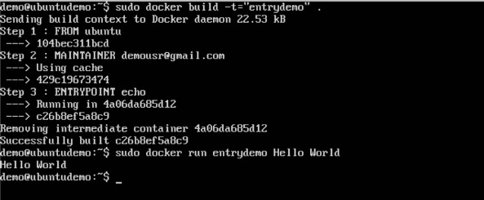

## **ENV**

This command is used to set environment variables in the container.

### **Syntax**

ENV key value

### **Options**

* **Key** − This is the key for the environment variable.
* **value** − This is the value for the environment variable.

### **Return Value**

The command will execute accordingly.

### **Example**

In our example, we will enter a simple **echo** command in our Docker File and create an image and launch a container from it.

**Step 1** − Build the Docker File with the following commands −

FROM ubuntu

MAINTAINER demousr@gmail.com

ENV var1=Tutorial var2=point

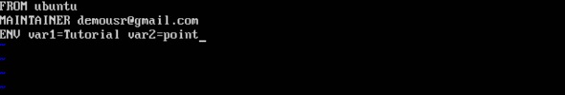

**Step 2** − Build the image using the Docker **build** command.

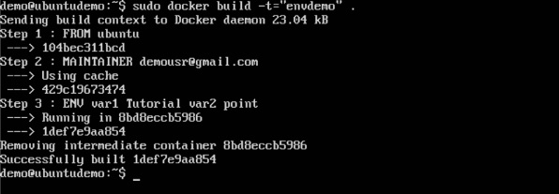

**Step 3** − Run a container from the image.

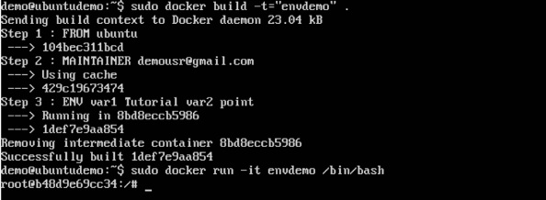

**Step 4** − Finally, execute the **env** command to see the environment variables.

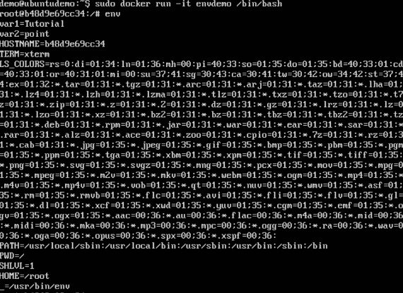

## **WORKDIR**

This command is used to set the working directory of the container.

### **Syntax**

WORKDIR dirname

### **Options**

* **dirname** − The new working directory. If the directory does not exist, it will be added.

### **Return Value**

The command will execute accordingly.

### **Example**

In our example, we will enter a simple **echo** command in our Docker File and create an image and launch a container from it.

**Step 1** − Build the Docker File with the following commands −

FROM ubuntu

MAINTAINER demousr@gmail.com

WORKDIR /newtemp

CMD pwd

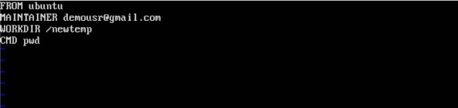

**Step 2** − Build the image using the Docker **build** command.

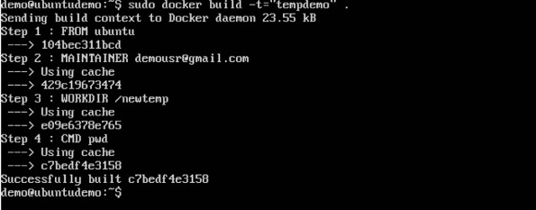

**Step 3** − Run a container from the image.

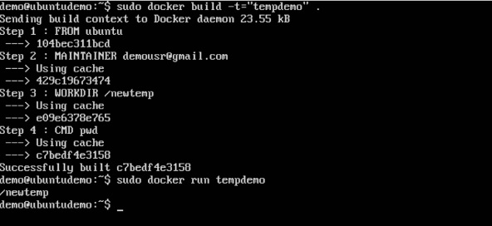

# Docker - Container Linking

Container Linking allows multiple containers to link with each other. It is a better option than exposing ports. Let’s go step by step and learn how it works.

**Step 1** − Download the Jenkins image, if it is not already present, using the Jenkins **pull** command.

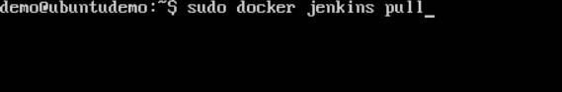

**Step 2** − Once the image is available, run the container, but this time, you can specify a name to the container by using the **–-name** option. This will be our **source container**.

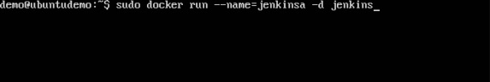

**Step 3** − Next, it is time to launch the destination container, but this time, we will link it with our source container. For our destination container, we will use the standard Ubuntu image.

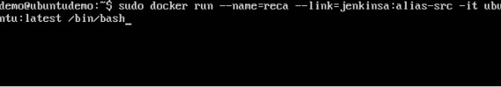

When you do a **docker ps**, you will see both the containers running.

**Step 4** − Now, attach to the receiving container.

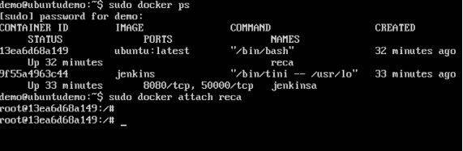

Then run the **env** command. You will notice new variables for linking with the source container.

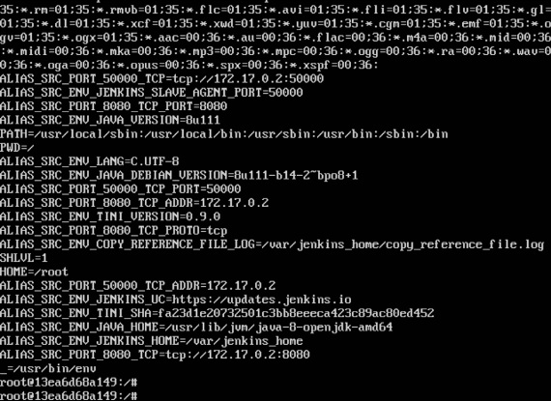

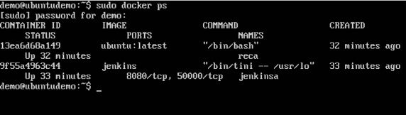

# Docker - Storage

### **Storage Drivers**

Docker has multiple storage drivers that allow one to work with the underlying storage devices. The following table shows the different storage drivers along with the technology used for the storage drivers.

|  |  |
| --- | --- |
| **Technology** | **Storage Driver** |
| OverlayFS | overlay or overlay2 |
| AUFS | aufs |
| Btrfs | brtfs |
| Device Manager | devicemanager |
| VFS | vfs |
| ZFS | zfs |

Let us now discuss some of the instances in which you would use the various storage drivers −

### **AUFS**

* This is a stable driver; can be used for production-ready applications.
* It has good memory usage and is good for ensuring a smooth Docker experience for containers.
* There is a high-write activity associated with this driver which should be considered.
* It’s good for systems which are of Platform as a service type work.

### **Devicemapper**

* This is a stable driver; ensures a smooth Docker experience.
* This driver is good for testing applications in the lab.
* This driver is in line with the main Linux kernel functionality.

### **Btrfs**

* This driver is in line with the main Linux kernel functionality.
* There is a high-write activity associated with this driver which should be considered.
* This driver is good for instances where you maintain multiple build pools.

### **Ovelay**

* This is a stable driver and it is in line with the main Linux kernel functionality.
* It has a good memory usage.
* This driver is good for testing applications in the lab.

### **ZFS**

* This is a stable driver and it is good for testing applications in the lab.
* It’s good for systems which are of Platform-as-a-Service type work.

To see the storage driver being used, issue the **docker info** command.

### **Syntax**

docker info

### **Options**

None

### **Return Value**

The command will provide all relative information on the Docker component installed on the Docker Host.

### **Example**

sudo docker info

### **Output**

The following output shows that the main driver used is the **aufs** driver and that the root directory is stored in **/var/lib/docker/aufs**.

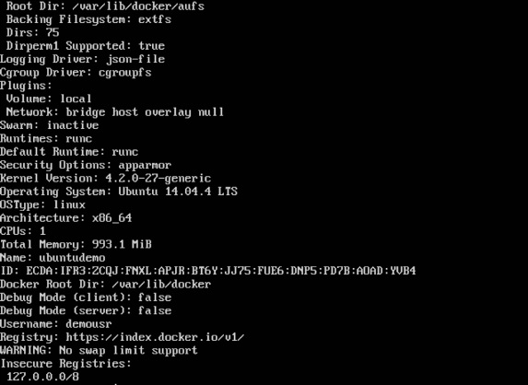

## **Data Volumes**

In Docker, you have a separate volume that can shared across containers. These are known as **data volumes**. Some of the features of data volume are −

* They are initialized when the container is created.
* They can be shared and also reused amongst many containers.
* Any changes to the volume itself can be made directly.
* They exist even after the container is deleted.

Let’s look at our Jenkins container. Let’s do a **docker inspect** to see the details of this image. We can issue the following command to write the output of the **docker inspect** command to a text file and then view the file accordingly.

sudo docker inspect Jenkins > tmp.txt

When you view the text file using the **more command**, you will see an entry as **JENKINS_HOME=/var/Jenkins_home**.

This is the mapping that is done within the container via the Jenkins image.

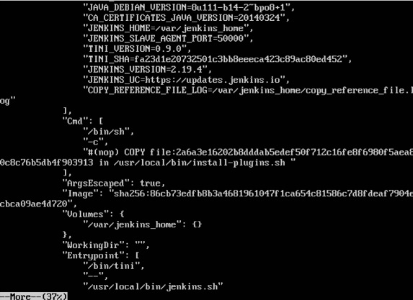

Now suppose you wanted to map the volume in the container to a local volume, then you need to specify the –v option when launching the container. An example is shown below −

sudo docker run –d –v /home/demo:/var/jenkins_home –p 8080:8080 –p 50000:50000 jenkins

The –v option is used to map the volume in the container which is **/var/jenkins_home** to a location on our Docker Host which is **/home/demo**.



Now if you go to the **/home/demo** location on your Docker Host after launching your container, you will see all the container files present there.

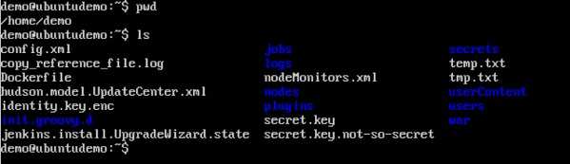

## **Changing the Storage Driver for a Container**

If you wanted to change to the storage driver used for a container, you can do so when launching the container. This can be done by using the **–volume-driver** parameter when using the **docker run** command. An example is given below −

sudo docker run –d --volume-driver=flocker

–v /home/demo:/var/jenkins_home –p 8080:8080 –p 50000:50000 jenkins

The **–volume-driver** option is used to specify another storage driver for the container.

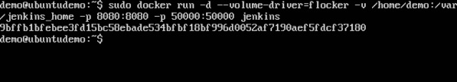

To confirm that the driver has been changed, first let’s use the **docker ps** command to see the running containers and get the container ID. So, issue the following command first −

sudo docker ps

Then issue a **docker inspect** against the container and put the output in a text file using the command.

sudo docker inspect 9bffb1bfebee > temp.txt

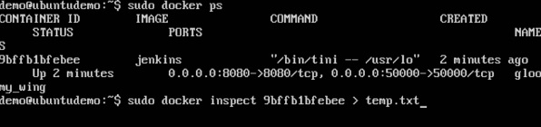

If you browse through the text file and go to the line which says **VolumeDriver**, you will see that the driver name has been changed.

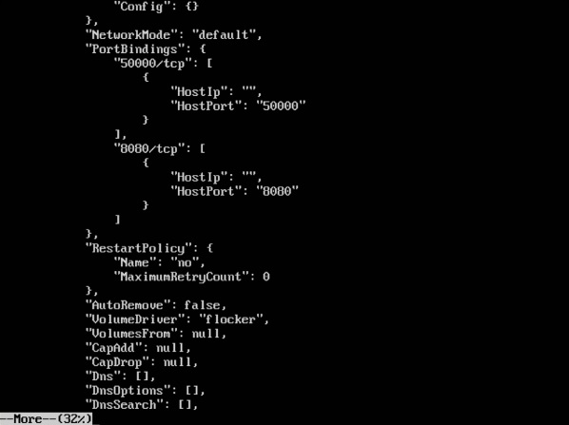

## **Creating a Volume**

A volume can be created beforehand using the **docker** command. Let’s learn more about this command.

### **Syntax**

docker volume create –-name=volumename –-opt options

### **Options**

* **name** − This is the name of the volume which needs to be created.
* **opt** − These are options you can provide while creating the volume.

### **Return Value**

The command will output the name of the volume created.

### **Example**

sudo docker volume create –-name = demo –opt o = size = 100m

In the above command, we are creating a volume of size 100MB and with a name of demo.

### **Output**

The output of the above command is shown below −

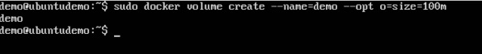

## **Listing all the Volumes**

You can also list all the **docker volumes** on a **docker host**. More details on this command is given below −

### **Syntax**

docker volume ls

### **Options**

None

### **Return Value**

The command will output all the volumes on the **docker host**.

### **Example**

sudo docker volume ls

### **Output**

The output of the above command is shown below −

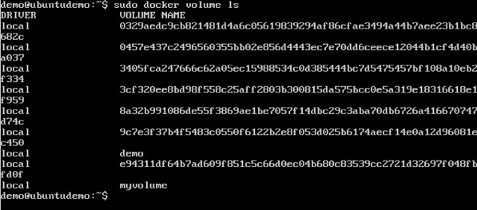

# Docker - Networking

Docker takes care of the networking aspects so that the containers can communicate with other containers and also with the Docker Host. If you do an **ifconfig** on the Docker Host, you will see the Docker Ethernet adapter. This adapter is created when Docker is installed on the Docker Host.

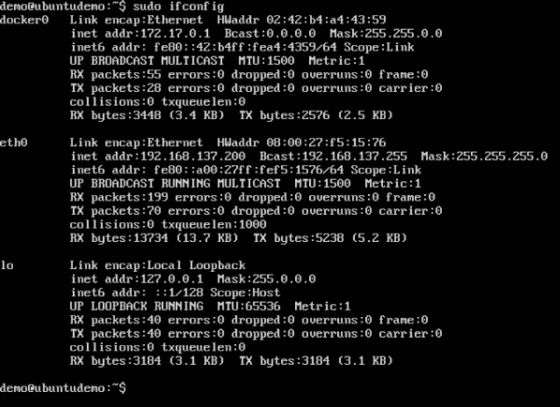

This is a bridge between the Docker Host and the Linux Host. Now let’s look at some commands associated with networking in Docker.

## **Listing All Docker Networks**

This command can be used to list all the networks associated with Docker on the host.

### **Syntax**

docker network ls

### **Options**

None

### **Return Value**

The command will output all the networks on the Docker Host.

### **Example**

sudo docker network ls

### **Output**

The output of the above command is shown below

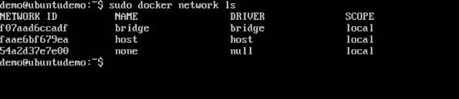

## **Inspecting a Docker network**

If you want to see more details on the network associated with Docker, you can use the Docker **network inspect** command.

### **Syntax**

docker network inspect networkname

### **Options**

* **networkname** − This is the name of the network you need to inspect.

### **Return Value**

The command will output all the details about the network.

### **Example**

sudo docker network inspect bridge

### **Output**

The output of the above command is shown below −

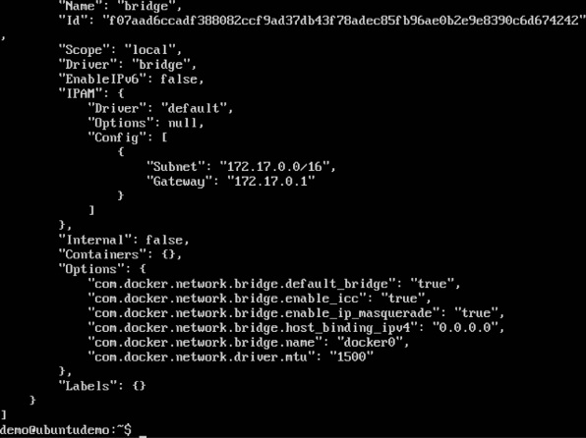

Now let’s run a container and see what happens when we inspect the network again. Let’s spin up an Ubuntu container with the following command −

sudo docker run –it ubuntu:latest /bin/bash

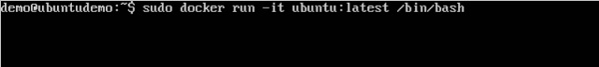

Now if we inspect our network name via the following command, you will now see that the container is attached to the bridge.

sudo docker network inspect bridge

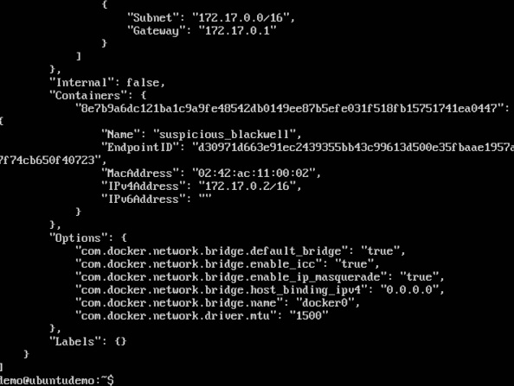

## **Creating Your Own New Network**

One can create a network in Docker before launching containers. This can be done with the following command −

### **Syntax**

docker network create –-driver drivername name

### **Options**

* **drivername** − This is the name used for the network driver.
* **name** − This is the name given to the network.

### **Return Value**

The command will output the long ID for the new network.

### **Example**

sudo docker network create –-driver bridge new_nw

### **Output**

The output of the above command is shown below −

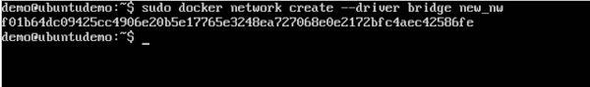

You can now attach the new network when launching the container. So let’s spin up an Ubuntu container with the following command −

sudo docker run –it –network=new_nw ubuntu:latest /bin/bash

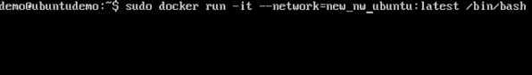

And now when you inspect the network via the following command, you will see the container attached to the network.

sudo docker network inspect new_nw

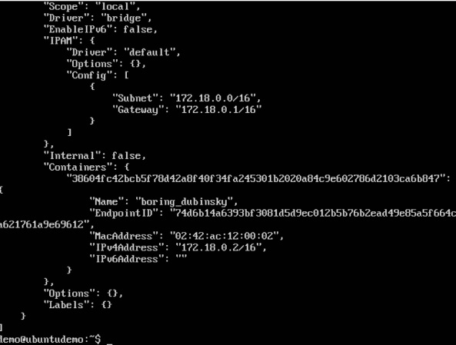

# Docker - Setting Node.js

Node.js is a JavaScript framework that is used for developing server-side applications. It is an open source framework that is developed to run on a variety of operating systems. Since Node.js is a popular framework for development, Docker has also ensured it has support for Node.js applications.

We will now see the various steps for getting the Docker container for Node.js up and running.

**Step 1** − The first step is to pull the image from Docker Hub. When you log into Docker Hub, you will be able to search and see the image for Node.js as shown below. Just type in Node in the search box and click on the node (official) link which comes up in the search results.

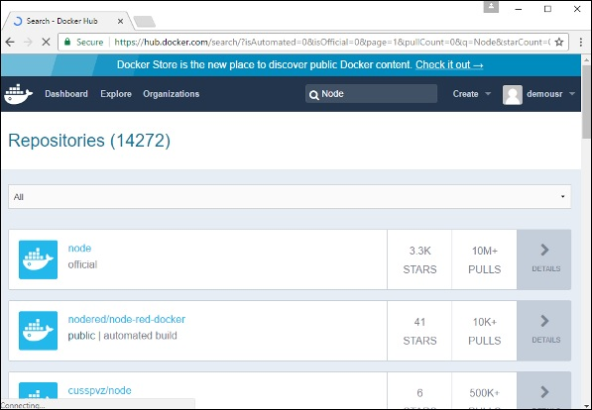

**Step 2** − You will see that the Docker **pull** command for node in the details of the repository in Docker Hub.

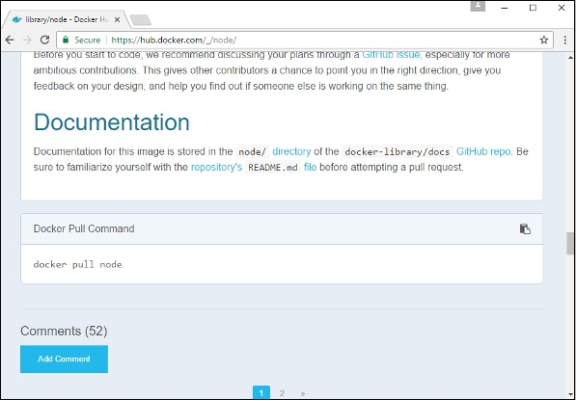

**Step 3** − On the Docker Host, use the Docker **pull** command as shown above to download the latest node image from Docker Hub.

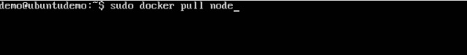

Once the **pull** is complete, we can then proceed with the next step.

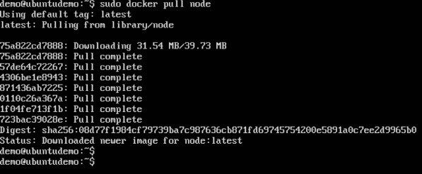

**Step 4** − On the Docker Host, let’s use the **vim** editor and create one Node.js example file. In this file, we will add a simple command to display “HelloWorld” to the command prompt.

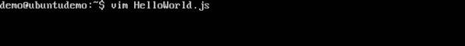

In the Node.js file, let’s add the following statement −

Console.log(‘Hello World’);

This will output the “Hello World” phrase when we run it through Node.js.



Ensure that you save the file and then proceed to the next step.

**Step 5** − To run our Node.js script using the Node Docker container, we need to execute the following statement −

sudo docker run –it –rm –name = HelloWorld –v “$PWD”:/usr/src/app

–w /usr/src/app node node HelloWorld.js

The following points need to be noted about the above command −

* The **–rm** option is used to remove the container after it is run.
* We are giving a name to the container called “HelloWorld”.
* We are mentioning to map the volume in the container which is **/usr/src/app** to our current present working directory. This is done so that the node container will pick up our HelloWorld.js script which is present in our working directory on the Docker Host.
* The **–w** option is used to specify the working directory used by Node.js.
* The first node option is used to specify to run the node image.
* The second node option is used to mention to run the node command in the node container.
* And finally we mention the name of our script.

We will then get the following output. And from the output, we can clearly see that the Node container ran as a container and executed the HelloWorld.js script.

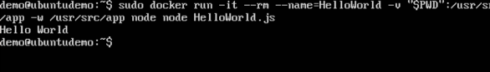

# Docker - Setting MongoDB

MongoDB is a famous document-oriented database that is used by many modern-day web applications. Since MongoDB is a popular database for development, Docker has also ensured it has support for MongoDB.

We will now see the various steps for getting the Docker container for MongoDB up and running.

**Step 1** − The first step is to pull the image from Docker Hub. When you log into Docker Hub, you will be able to search and see the image for Mongo as shown below. Just type in Mongo in the search box and click on the Mongo (official) link which comes up in the search results.

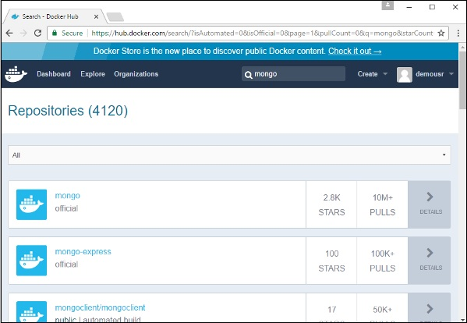

**Step 2** − You will see that the Docker **pull** command for Mongo in the details of the repository in Docker Hub.

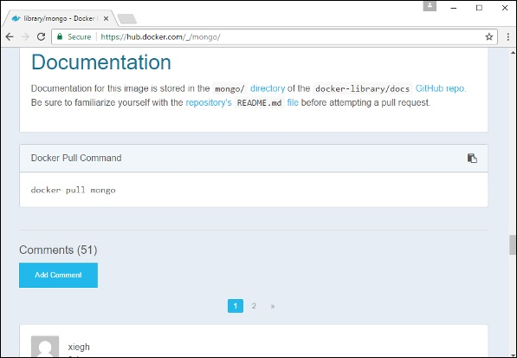

**Step 3** − On the Docker Host, use the Docker **pull** command as shown above to download the latest Mongo image from Docker Hub.



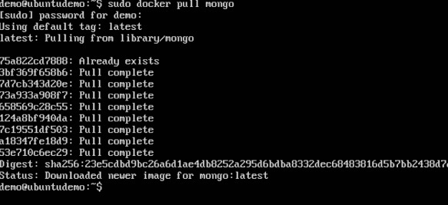

**Step 4** − Now that we have the image for Mongo, let’s first run a MongoDB container which will be our instance for MongoDB. For this, we will issue the following command −

sudo docker run -it -d mongo

The following points can be noted about the above command −

* The **–it** option is used to run the container in interactive mode.
* The **–d** option is used to run the container as a daemon process.
* And finally we are creating a container from the Mongo image.

You can then issue the **docker ps** command to see the running containers −

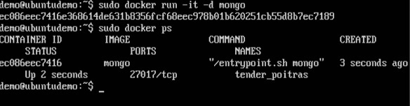

Take a note of the following points −

* The name of the container is **tender_poitras**. This name will be different since the name of the containers keep on changing when you spin up a container. But just make a note of the container which you have launched.
* Next, also notice the port number it is running on. It is listening on the TCP port of 27017.

**Step 5** − Now let’s spin up another container which will act as our client which will be used to connect to the MongoDB database. Let’s issue the following command for this −

sudo docker run –it –link=tender_poitras:mongo mongo /bin/bash

The following points can be noted about the above command −

* The **–it** option is used to run the container in interactive mode.
* We are now linking our new container to the already launched MongoDB server container. Here, you need to mention the name of the already launched container.
* We are then specifying that we want to launch the Mongo container as our client and then run the **bin/bash** shell in our new container.

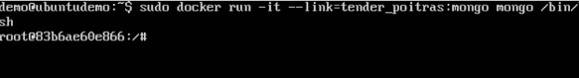

You will now be in the new container.

**Step 6** − Run the **env** command in the new container to see the details of how to connect to the MongoDB server container.

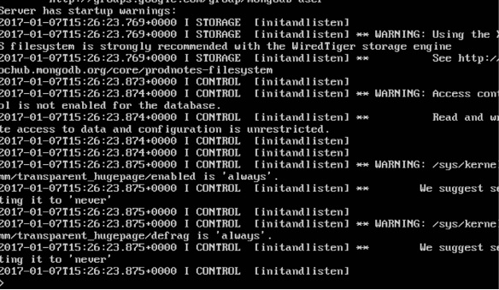

**Step 6** − Now it’s time to connect to the MongoDB server from the client container. We can do this via the following command −

mongo 172.17.0.2:27017

The following points need to be noted about the above command

* The **mongo** command is the client **mongo** command that is used to connect to a MongoDB database.
* The IP and port number is what you get when you use the **env** command.

Once you run the command, you will then be connected to the MongoDB database.

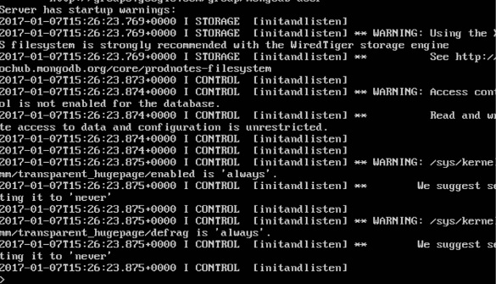

You can then run any MongoDB command in the command prompt. In our example, we are running the following command −

use demo

This command is a MongoDB command which is used to switch to a database name **demo**. If the database is not available, it will be created.

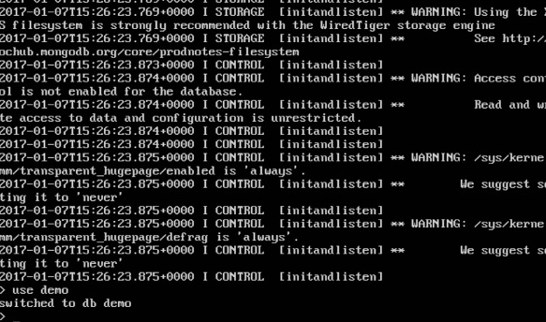

Now you have successfully created a client and server MongoDB container.

# Docker - Setting NGINX

NGINX is a popular lightweight web application that is used for developing server-side applications. It is an open-source web server that is developed to run on a variety of operating systems. Since **nginx** is a popular web server for development, Docker has ensured that it has support for **nginx**.

We will now see the various steps for getting the Docker container for **nginx** up and running.

**Step 1** − The first step is to pull the image from Docker Hub. When you log into Docker Hub, you will be able to search and see the image for **nginx** as shown below. Just type in nginx in the search box and click on the **nginx** (official) link which comes up in the search results.

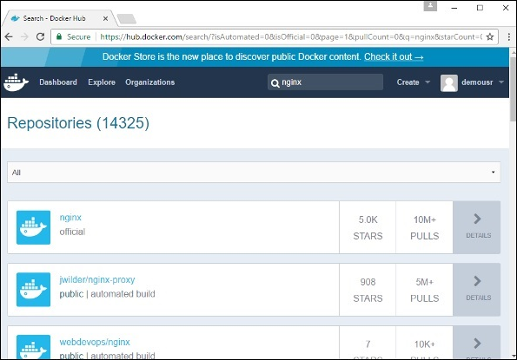

**Step 2** − You will see that the Docker **pull** command for **nginx** in the details of the repository in Docker Hub.

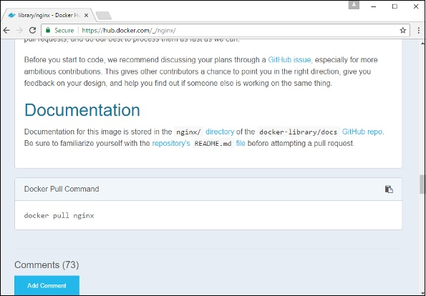

**Step 3** − On the Docker Host, use the Docker **pull** command as shown above to download the latest nginx image from Docker Hub.

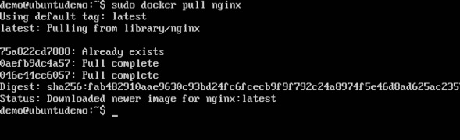

**Step 4** − Now let’s run the **nginx** container via the following command.

sudo docker run –p 8080:80 –d nginx

We are exposing the port on the **nginx** server which is port 80 to the port 8080 on the Docker Host.

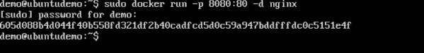

Once you run the command, you will get the following output if you browse to the URL **http://dockerhost:8080**. This shows that the **nginx** container is up and running.

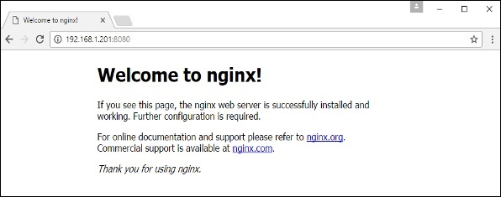

**Step 5** − Let’s look at another example where we can host a simple web page in our **ngnix** container. In our example, we will create a simple **HelloWorld.html** file and host it in our **nginx** container.

Let’s first create an HTML file called **HelloWorld.html**

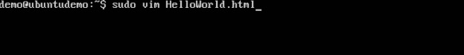

Let’s add a simple line of Hello World in the HTML file.

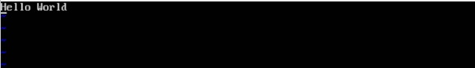

Let’s then run the following Docker command.

sudo docker run –p 8080:80 –v

“$PWD”:/usr/share/nginx/html:ro –d nginx

The following points need to be noted about the above command −

* We are exposing the port on the **nginx** server which is port 80 to the port 8080 on the Docker Host.
* Next, we are attaching the volume on the container which is **/usr/share/nginx/html** to our present working directory. This is where our HelloWorld.html file is stored.

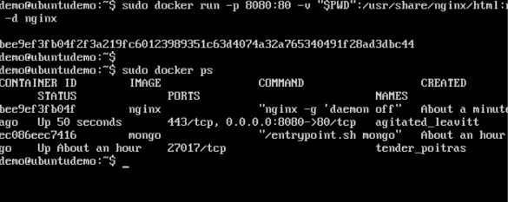

Now if we browse to the URL **http://dockerhost:8080/HelloWorld.html** we will get the following output as expected −

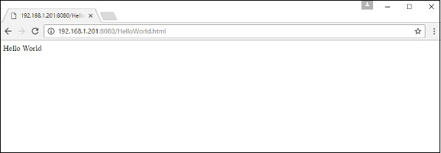

# Docker - Toolbox

In the introductory chapters, we have seen the installation of Docker toolbox on Windows. The Docker toolbox is developed so that Docker containers can be run on Windows and MacOS. The site for toolbox on Windows is <https://docs.docker.com/docker-for-windows/>

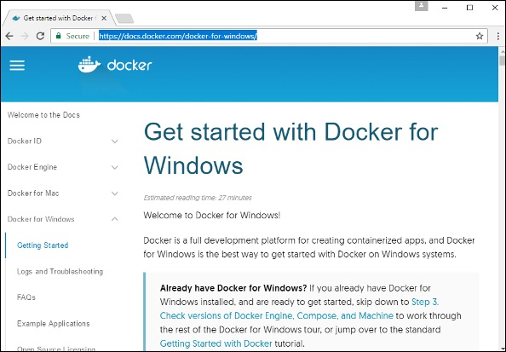

For Windows, you need to have Windows 10 or Windows Server 2016 with Hyper-V enabled.

The toolbox consists of the following components −

* **Docker Engine** − This is used as the base engine or Docker daemon that is used to run Docker containers.
* **Docker Machine** − for running Docker machine commands.
* **Docker Compose** for running Docker compose commands.
* **Kinematic** − This is the Docker GUI built for Windows and Mac OS.
* **Oracle virtualbox**

Let’s now discuss the different types of activities that are possible with Docker toolbox.

## **Running in Powershell**

With Docker toolbox on Windows 10, you can now run Docker commands off **powershell**. If you open powershell on Windows and type in the command of Docker version, you will get all the required details about the Docker version installed.

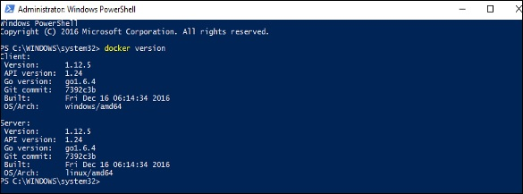

## **Pulling Images and Running Containers**

You can also now pull Images from Docker Hub and run containers in powershell as you would do in Linux. The following example will show in brief the downloading of the Ubuntu image and running of the container off the image.

The first step is to use the Docker **pull** command to pull the Ubuntu image from Docker Hub.

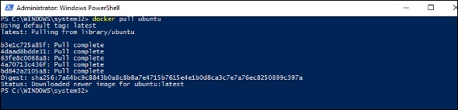

The next step is to run the Docker image using the following **run** command −

docker run –it ubuntu /bin/bash

You will notice that the command is the same as it was in Linux.

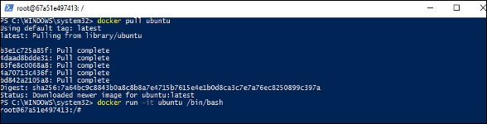

## **Kitematic**

This is the GUI equivalent of Docker on Windows. To open this GUI, go to the taskbar and on the Docker icon, right-click and choose to open Kitematic.

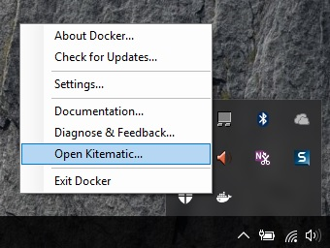

It will prompt you to download Kitematic GUI. Once downloaded, just unzip the contents. There will be a file called **Kitematic.exe**. Double-click this exe file to open the GUI interface.

You will then be requested to log into Docker Hub, enter through the GUI. Just enter the required username and password and then click the Login button.

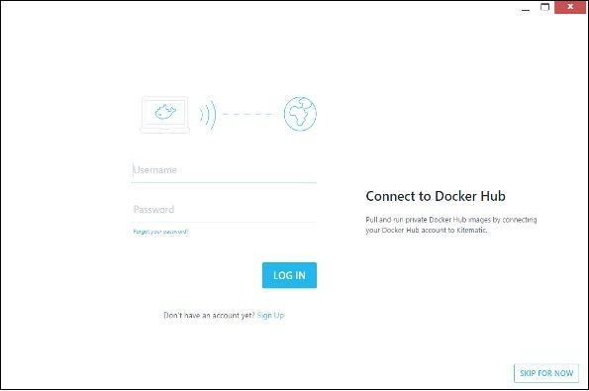

Once logged in, you will be able to see all the images downloaded on the system on the left-hand side of the interface.

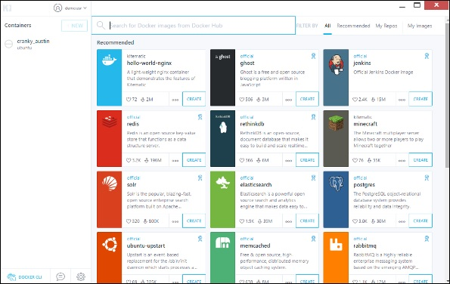

On the right-hand side, you will find all the images available on Docker Hub.

Let’s take an example to understand how to download the Node image from Docker Hub using Kitematic.

**Step 1** − Enter the keyword of node in the search criteria.

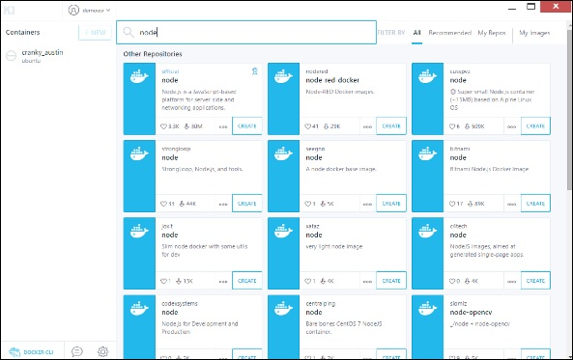

**Step 2** − Click the **create** button on official Node image. You will then see the image being downloaded.

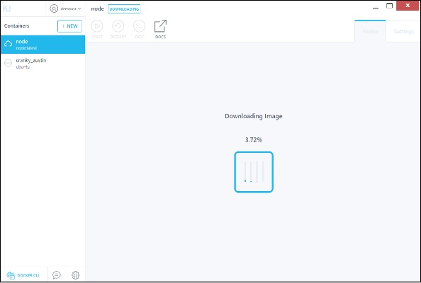

Once the image has been downloaded, it will then start running the Node container.

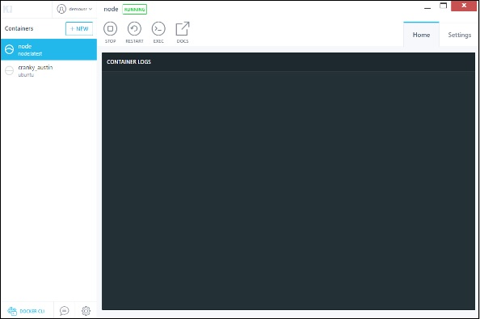

**Step 3** − If you go to the **settings** tab, you can drill-down to further settings options, as shown below.

* **General settings** − In this tab, you can name the container, change the path settings, and delete the container.

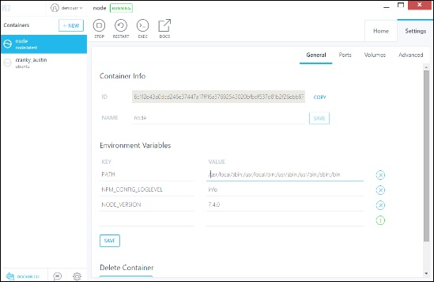

* **Ports** − Here you can see the different port mappings. If you want, you can create your own port mappings.

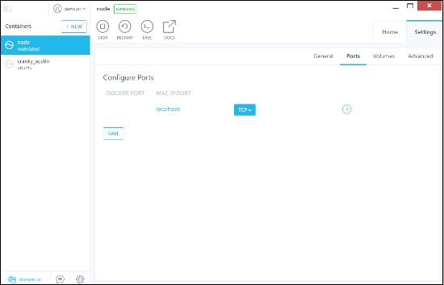

* **Volumes** − Here you can see the different volume mappings.

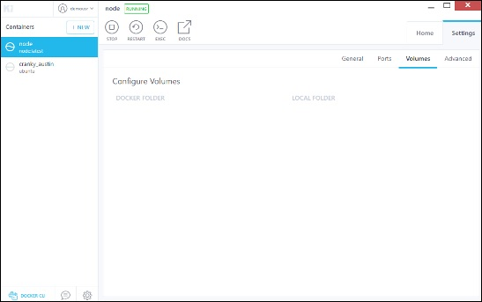

* **Advanced** − It contains the advanced settings for the container.

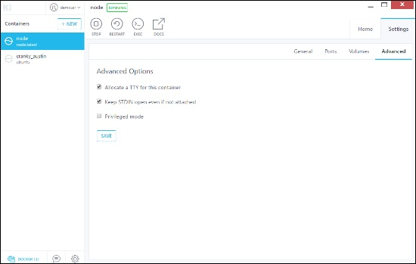

# Docker - Setting ASP.Net

ASP.Net is the standard web development framework that is provided by Microsoft for developing server-side applications. Since ASP.Net has been around for quite a long time for development, Docker has ensured that it has support for ASP.Net.

In this chapter, we will see the various steps for getting the Docker container for ASP.Net up and running.

## **Prerequisites**

The following steps need to be carried out first for running ASP.Net.

**Step 1** − Since this can only run on Windows systems, you first need to ensure that you have either Windows 10 or Window Server 2016.

**Step 2** − Next, ensure that Hyper-V is and Containers are installed on the Windows system. To install Hyper–V and Containers, you can go to Turn Windows Features ON or OFF. Then ensure the Hyper-V option and Containers is checked and click the OK button.

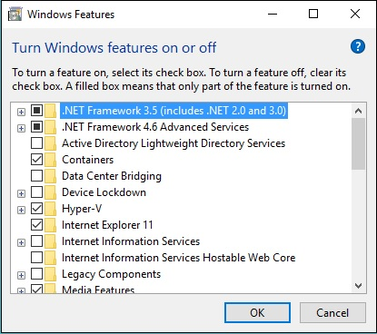

The system might require a restart after this operation.

**Step 3** − Next, you need to use the following Powershell command to install the **1.13.0rc4** version of Docker. The following command will download this and store it in the temp location.

Invoke-WebRequest "https://test.docker.com/builds/Windows/x86_64/docker-1.13.0-

rc4.zip" -OutFile "$env:TEMP\docker-1.13.0-rc4.zip" –UseBasicParsing

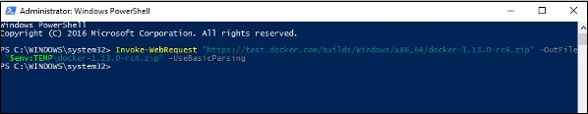

**Step 4** − Next, you need to expand the archive using the following **powershell** command.

Expand-Archive -Path "$env:TEMP\docker-1.13.0-rc4.zip" -DestinationPath $env:ProgramFiles

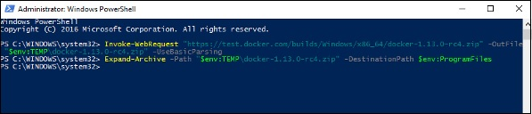

**Step 5** − Next, you need to add the Docker Files to the environment variable using the following **powershell** command.

$env:path += ";$env:ProgramFiles\Docker"

**Step 6** − Next, you need to register the Docker Daemon Service using the following **powershell** command.

dockerd --register-service

**Step 7** − Finally, you can start the **docker daemon** using the following command.

Start-Service Docker

Use the **docker version** command in **powershell** to verify that the **docker daemon** is working

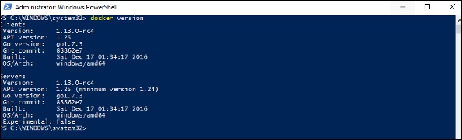

## **Installing the ASP.Net Container**

Let’s see how to install the ASP.Net container.

**Step 1** − The first step is to pull the image from Docker Hub. When you log into Docker Hub, you will be able to search and see the image for **Microsoft/aspnet** as shown below. Just type in **asp** in the search box and click on the Microsoft/aspnet link which comes up in the search results.

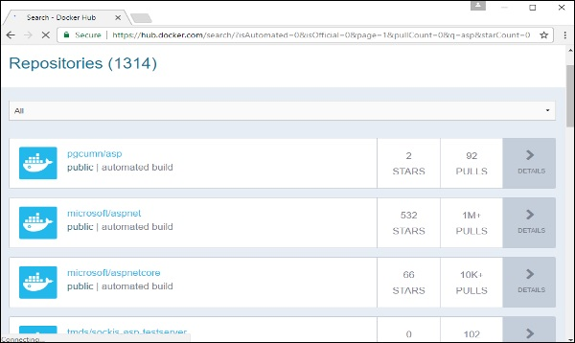

**Step 2** − You will see that the Docker **pull** command for ASP.Net in the details of the repository in Docker Hub.

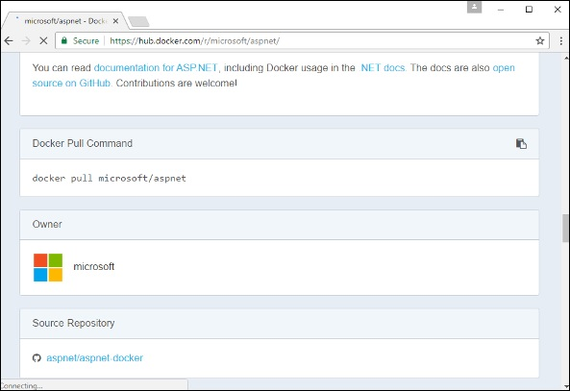

**Step 3** − Go to Docker Host and run the Docker **pull** command for the microsoft/aspnet image. Note that the image is pretty large, somewhere close to 4.2 GB.

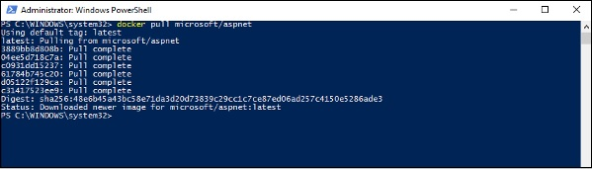

**Step 4** − Now go to the following location <https://github.com/Microsoft/aspnet-docker> and download the entire Git repository.

**Step 5** − Create a folder called **App** in your C drive. Then copy the contents from the **4.6.2/sample** folder to your C drive. Go the Docker File in the sample directory and issue the following command −

docker build –t aspnet-site-new –build-arg site_root=/

The following points need to be noted about the above command −

* It builds a new image called **aspnet-site-new** from the Docker File.
* The root path is set to the localpath folder.

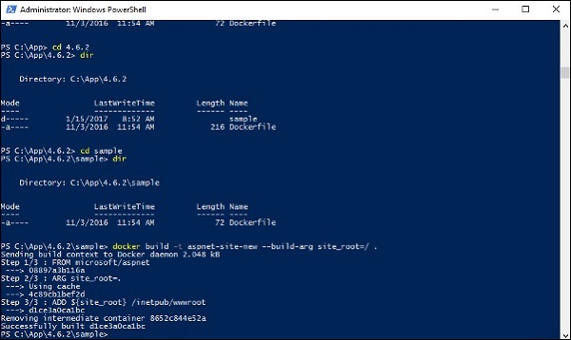

**Step 6** − Now it’s time to run the container. It can be done using the following command −

docker run –d –p 8000:80 –name my-running-site-new aspnet-site-new

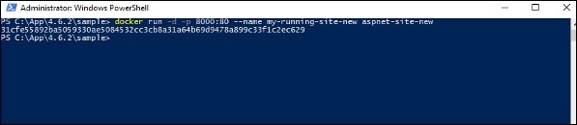

**Step 7** − You will now have IIS running in the Docker container. To find the IP Address of the Docker container, you can issue the Docker **inspect** command as shown below.

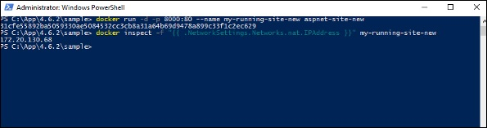

# Docker - Cloud

The Docker Cloud is a service provided by Docker in which you can carry out the following operations −

* **Nodes** − You can connect the Docker Cloud to your existing cloud providers such as Azure and AWS to spin up containers on these environments.
* **Cloud Repository** − Provides a place where you can store your own repositories.
* **Continuous Integration** − Connect with **Github** and build a continuous integration pipeline.
* **Application Deployment** − Deploy and scale infrastructure and containers.
* **Continuous Deployment** − Can automate deployments.

## **Getting started**

You can go to the following link to getting started with Docker Cloud − <https://cloud.docker.com/>

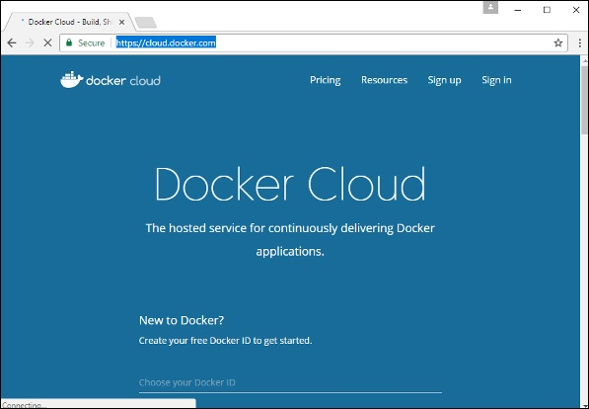

Once logged in, you will be provided with the following basic interface −

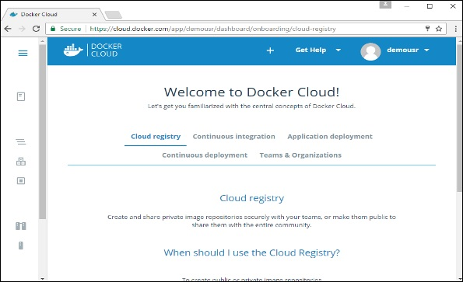

## **Connecting to the Cloud Provider**

The first step is to connect to an existing cloud provider. The following steps will show you how to connect with an Amazon Cloud provider.

**Step 1** − The first step is to ensure that you have the right AWS keys. This can be taken from the **aws** console. Log into your **aws** account using the following link − <https://aws.amazon.com/console/>

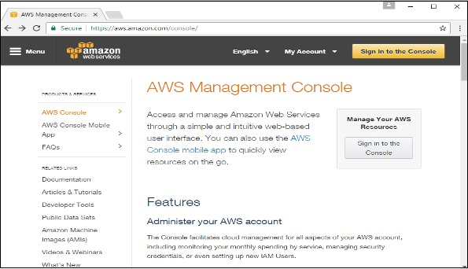

**Step 2** − Once logged in, go to the Security Credentials section. Make a note of the access keys which will be used from Docker Hub.

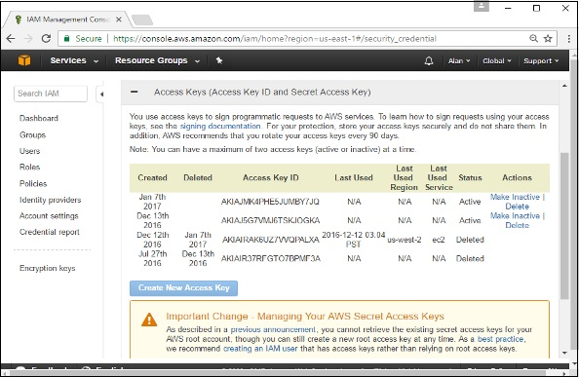

**Step 3** − Next, you need to create a policy in **aws** that will allow Docker to view EC2 instances. Go to the profiles section in **aws**. Click the **Create Policy** button.

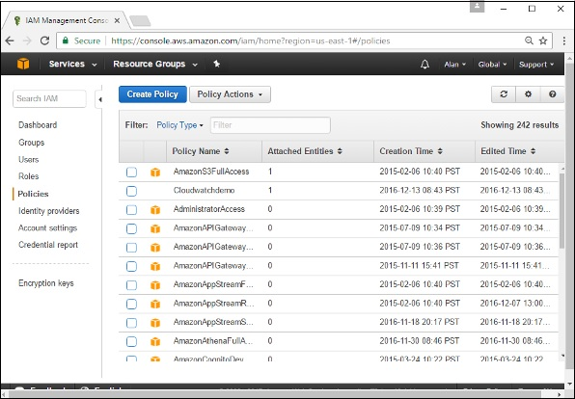

**Step 4** − Click on ‘Create Your Own Policy’ and give the policy name as **dockercloudpolicy** and the policy definition as shown below.

{

"Version": "2012-10-17",

"Statement": [ {

"Action": [

"ec2:*",

"iam:ListInstanceProfiles"

],

"Effect": "Allow",

"Resource": "*"

} ]

}

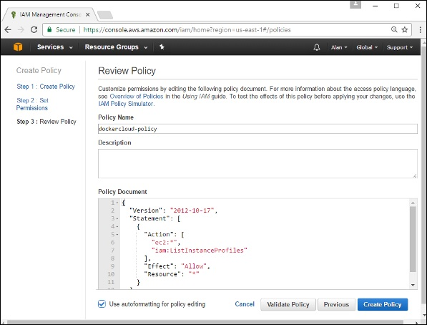

Next, click the **Create Policy** button

**Step 5** − Next, you need to create a **role** which will be used by Docker to spin up nodes on AWS. For this, go to the **Roles** section in AWS and click the **Create New Role** option.

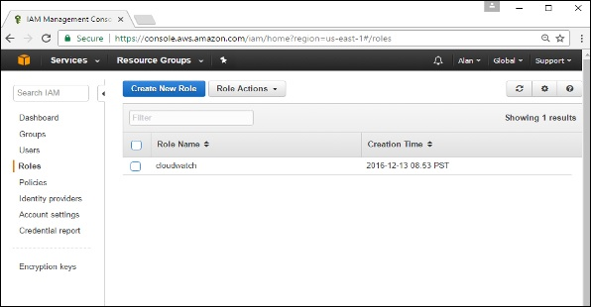

**Step 6** − Give the name for the role as **dockercloud-role**.

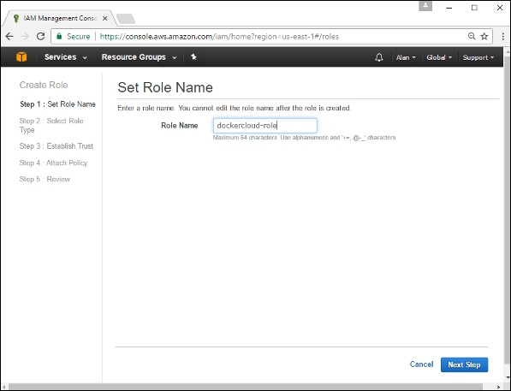

**Step 7** − On the next screen, go to ‘Role for Cross Account Access’ and select “Provide access between your account and a 3rd party AWS account".

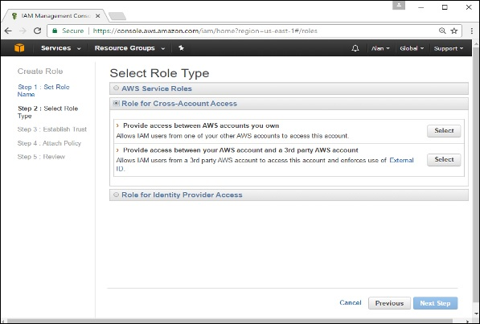

**Step 8** − On the next screen, enter the following details −

* In the Account ID field, enter the ID for the Docker Cloud service: 689684103426.
* In the External ID field, enter your Docker Cloud username.

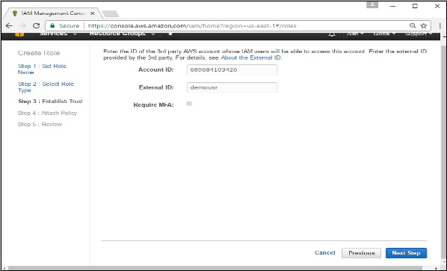

**Step 9** − Then, click the **Next Step** button and on the next screen, attach the policy which was created in the earlier step.

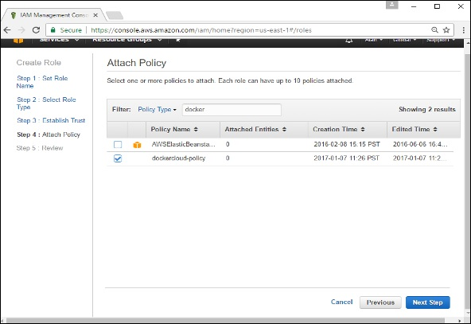

**Step 10** − Finally, on the last screen when the role is created, make sure to copy the **arn** role which is created.

arn:aws:iam::085363624145:role/dockercloud-role

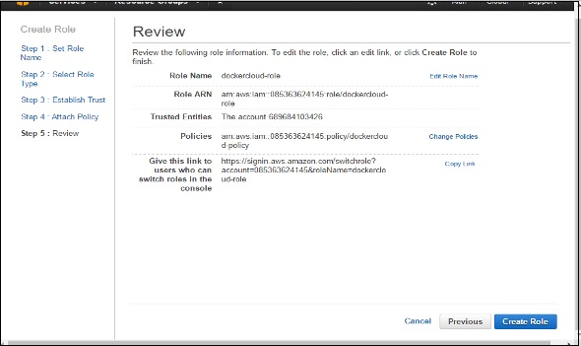

**Step 11** − Now go back to **Docker Cloud**, select **Cloud Providers**, and click the **plug symbol** next to Amazon Web Services.

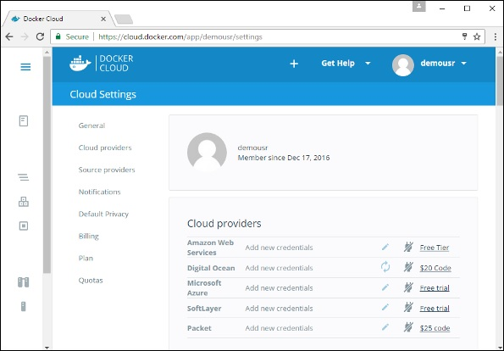

Enter the **arn** role and click the **Save** button.

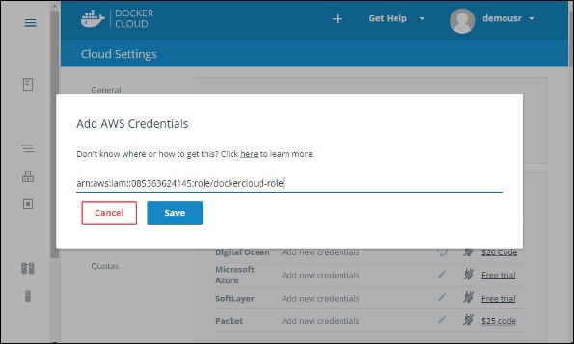

Once saved, the integration with AWS would be complete.

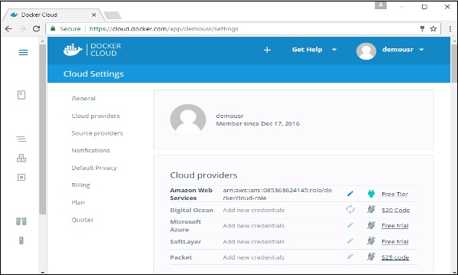

## **Setting Up Nodes**

Once the integration with AWS is complete, the next step is to setup a node. Go to the Nodes section in Docker Cloud. Note that the setting up of nodes will automatically setup a node cluster first.

**Step 1** − Go to the Nodes section in Docker Cloud.

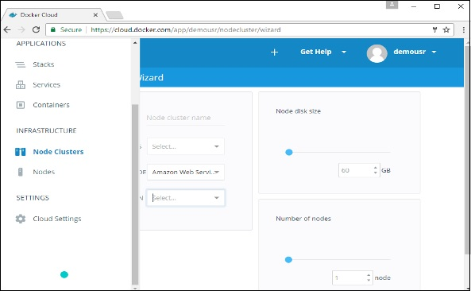

**Step 2** − Next, you can give the details of the nodes which will be setup in AWS.

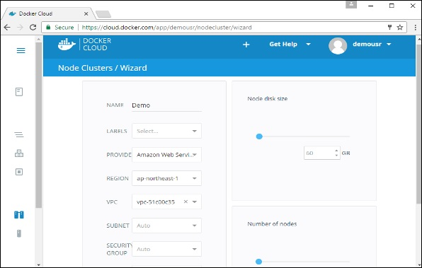

You can then click the Launch Node cluster which will be present at the bottom of the screen. Once the node is deployed, you will get the notification in the Node Cluster screen.

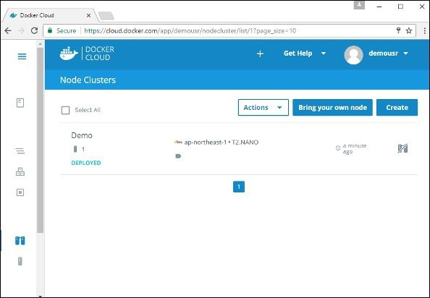

## **Deploying a Service**

The next step after deploying a node is to deploy a service. To do this, we need to perform the following steps.

**Step 1** − Go to the **Services Section** in Docker Cloud. Click the **Create** button

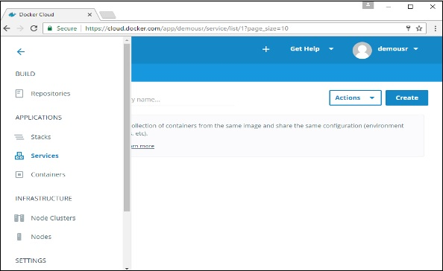

**Step 2** − Choose the Service which is required. In our case, let’s choose **mongo**.

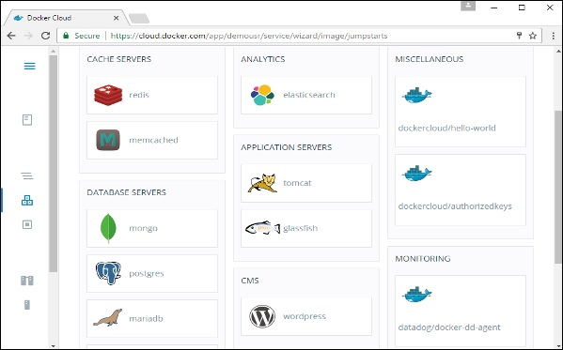

**Step 3** − On the next screen, choose the **Create & Deploy** option. This will start deploying the **Mongo** container on your node cluster.

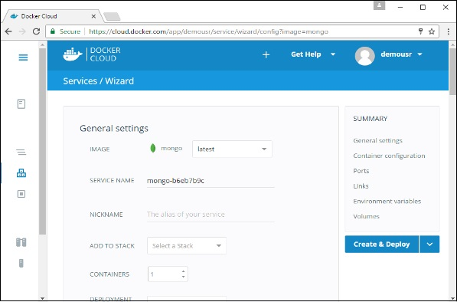

Once deployed, you will be able to see the container in a running state.

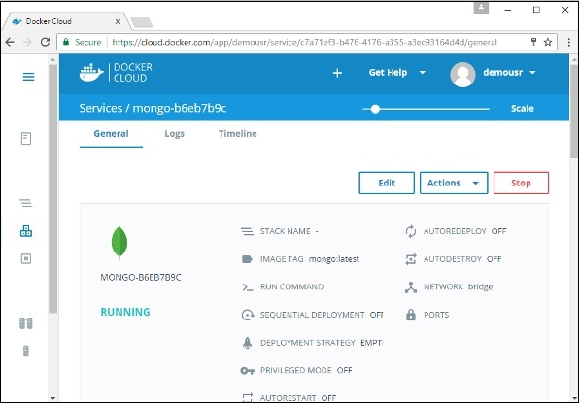

# Docker - Logging

Docker has logging mechanisms in place which can be used to debug issues as and when they occur. There is logging at the **daemon level** and at the **container level**. Let’s look at the different levels of logging.

## **Daemon Logging**

At the daemon logging level, there are four levels of logging available −

* **Debug** − It details all the possible information handled by the daemon process.
* **Info** − It details all the errors + Information handled by the daemon process.
* **Errors** − It details all the errors handled by the daemon process.
* **Fatal** − It only details all the fatal errors handled by the daemon process.

Go through the following steps to learn how to enable logging.

**Step 1** − First, we need to stop the **docker daemon process**, if it is already running. It can be done using the following command −

sudo service docker stop

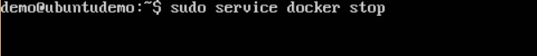

**Step 2** − Now we need to start the **docker daemon process**. But this time, we need to append the **–l** parameter to specify the logging option. So let’s issue the following command when starting the **docker daemon process**.

sudo dockerd –l debug &

The following points need to be noted about the above command −

* **dockerd** is the executable for the **docker daemon process**.
* The **–l** option is used to specify the logging level. In our case, we are putting this as debug
* **&** is used to come back to the command prompt after the logging has been enabled.



Once you start the Docker process with logging, you will also now see the **Debug Logs** being sent to the console.

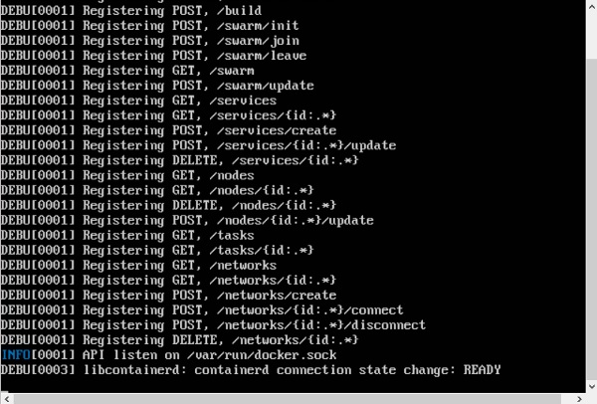

Now, if you execute any Docker command such as **docker images**, the Debug information will also be sent to the console.

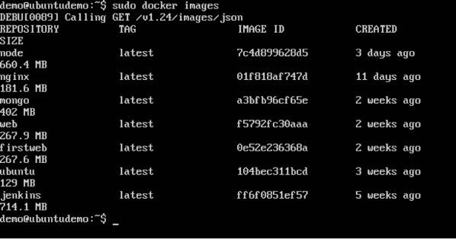

## **Container Logging**

Logging is also available at the container level. So in our example, let’s spin up an Ubuntu container first. We can do it by using the following command.

sudo docker run –it ubuntu /bin/bash

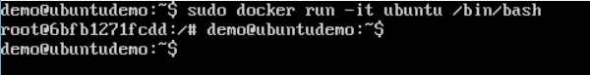

Now, we can use the **docker log command** to see the logs of the container.

### **Syntax**

Docker logs containerID

### **Parameters**

* **containerID** − This is the ID of the container for which you need to see the logs.

### **Example**

On our Docker Host, let’s issue the following command. Before that, you can issue some commands whilst in the container.

sudo docker logs 6bfb1271fcdd

### **Output**

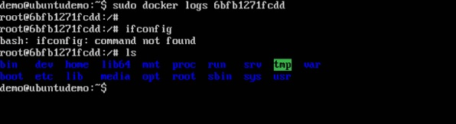

From the output, you can see that the commands executed in the container are shown in the logs.

# Docker - Compose

**Docker Compose** is used to run multiple containers as a single service. For example, suppose you had an application which required NGNIX and MySQL, you could create one file which would start both the containers as a service without the need to start each one separately.

In this chapter, we will see how to get started with Docker Compose. Then, we will look at how to get a simple service with MySQL and NGNIX up and running using Docker Compose.

## **Docker Compose ─ Installation**

The following steps need to be followed to get Docker Compose up and running.

**Step 1** − Download the necessary files from **github** using the following command −

curl -L "https://github.com/docker/compose/releases/download/1.10.0-rc2/dockercompose

-$(uname -s) -$(uname -m)" -o /home/demo/docker-compose

The above command will download the latest version of Docker Compose which at the time of writing this article is **1.10.0-rc2**. It will then store it in the directory **/home/demo/**.

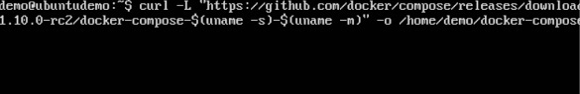

**Step 2** − Next, we need to provide **execute privileges** to the downloaded Docker Compose file, using the following command −

chmod +x /home/demo/docker-compose

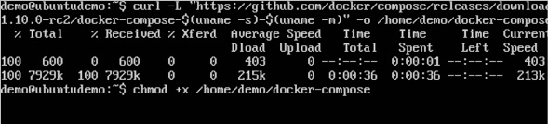

We can then use the following command to see the **compose** version.

### **Syntax**

docker-compose version

### **Parameters**

* **version** − This is used to specify that we want the details of the version of **Docker Compose**.

### **Output**

The version details of Docker Compose will be displayed.

### **Example**

The following example shows how to get the **docker-compose** version.

sudo ./docker-compose -version

### **Output**

You will then get the following output −

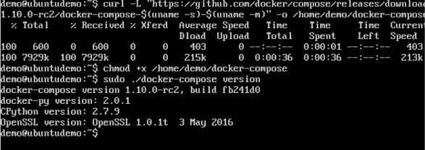

## **Creating Your First Docker-Compose File**

Now let’s go ahead and create our first Docker Compose file. All Docker Compose files are YAML files. You can create one using the vim editor. So execute the following command to create the **compose** file −

sudo vim docker-compose.yml

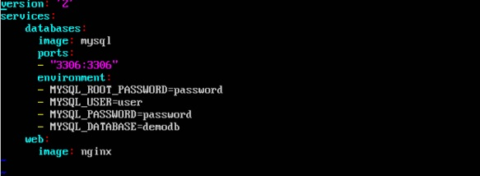

Let’s take a close look at the various details of this file −

* The **database** and **web** keyword are used to define two separate services. One will be running our **mysql** database and the other will be our **nginx** web server.
* The **image** keyword is used to specify the image from **dockerhub** for our **mysql** and **nginx** containers
* For the database, we are using the ports keyword to mention the ports that need to be exposed for **mysql**.
* And then, we also specify the environment variables for **mysql** which are required to run **mysql**.

Now let’s run our Docker Compose file using the following command −

sudo ./docker-compose up

This command will take the **docker-compose.yml** file in your local directory and start building the containers.

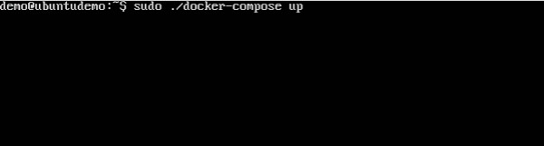

Once executed, all the images will start downloading and the containers will start automatically.

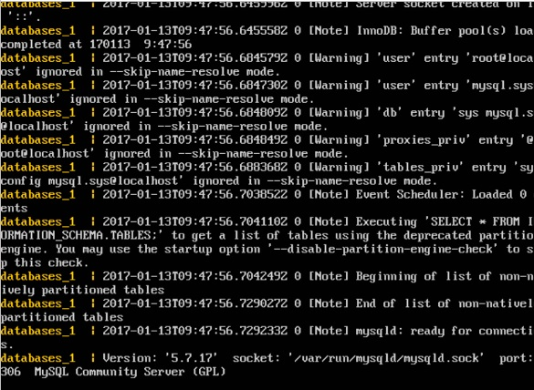

And when you do a **docker ps**, you can see that the containers are indeed up and running.

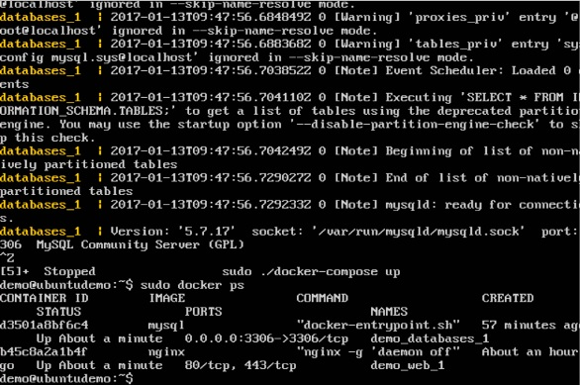

# Docker - Continuous Integration

Docker has integrations with many Continuous Integrations tools, which also includes the popular CI tool known as **Jenkins**. Within Jenkins, you have plugins available which can be used to work with containers. So let’s quickly look at a Docker plugin available for the Jenkins tool.

Let’s go step by step and see what’s available in Jenkins for Docker containers.

**Step 1** − Go to your Jenkins dashboard and click **Manage Jenkins**.

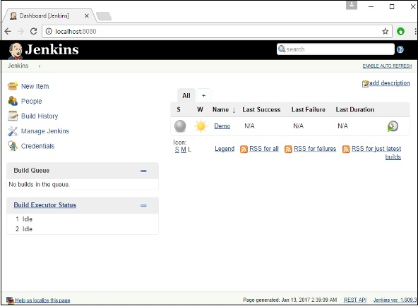

**Step 2** − Go to **Manage Plugins**.

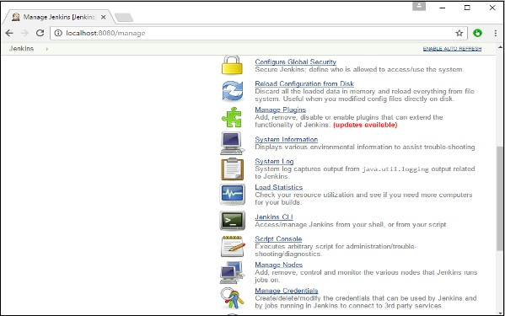

**Step 3** − Search for Docker plugins. Choose the Docker plugin and click the **Install** **without restart** button.

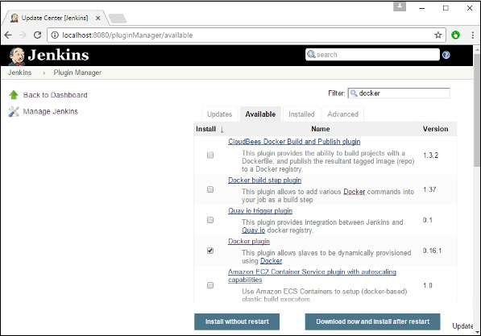

**Step 4** − Once the installation is completed, go to your job in the Jenkins dashboard. In our example, we have a job called **Demo**.

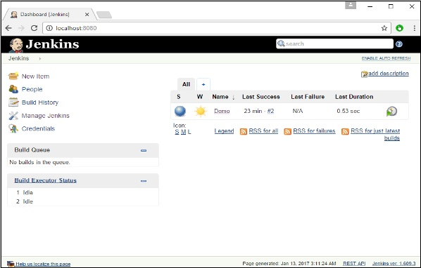

**Step 5** − In the job, when you go to the Build step, you can now see the option to start and stop containers.

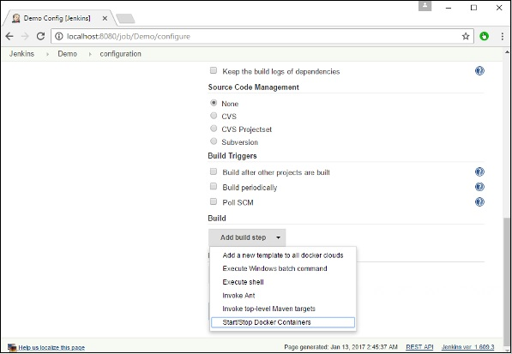

**Step 6** − As a simple example, you can choose the further option to stop containers when the build is completed. Then, click the **Save** button.

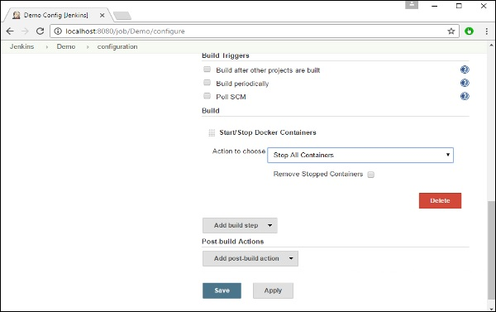

Now, just run your job in Jenkins. In the Console output, you will now be able to see that the command to Stop All containers has run.

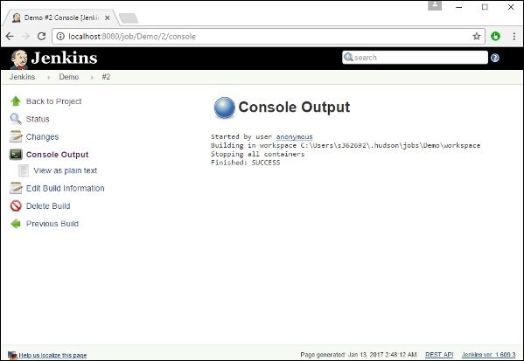

# Docker - Kubernetes Architecture

Kubernetes is an orchestration framework for Docker containers which helps expose containers as services to the outside world. For example, you can have two services − One service would contain **nginx** and **mongoDB**, and another service would contain **nginx** and **redis**. Each service can have an IP or service point which can be connected by other applications. Kubernetes is then used to manage these services.

The following diagram shows in a simplistic format how Kubernetes works from an architecture point of view.

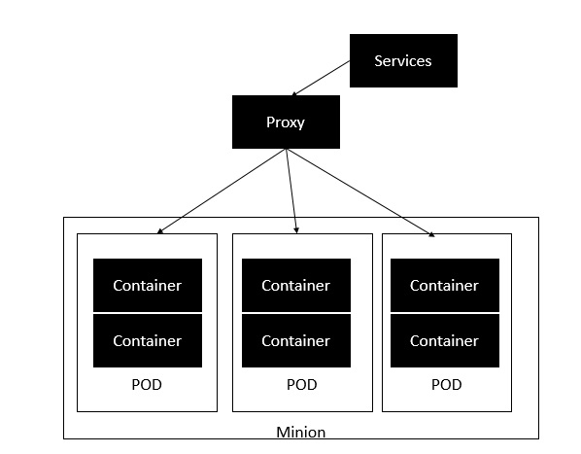

The **minion** is the node on which all the services run. You can have many minions running at one point in time. Each minion will host one or more POD. Each **POD** is like hosting a service. Each POD then contains the Docker containers. Each POD can host a different set of Docker containers. The proxy is then used to control the exposing of these services to the outside world.

Kubernetes has several components in its architecture. The role of each component is explained below &mius;

* **etcd** − This component is a highly available **key-value** store that is used for storing **shared configuration** and **service discovery**. Here the various applications will be able to connect to the services via the **discovery service**.
* **Flannel** − This is a backend network which is required for the containers.
* **kube-apiserver** − This is an API which can be used to orchestrate the Docker containers.
* **kube-controller-manager** − This is used to control the **Kubernetes services**.
* **kube-scheduler** − This is used to schedule the containers on hosts.
* **Kubelet** − This is used to control the launching of containers via **manifest files**.
* **kube-proxy** − This is used to provide network proxy services to the outside world.

# Docker - Working of Kubernetes

In this chapter, we will see how to install **Kubenetes** via **kubeadm**. This is a tool which helps in the installation of Kubernetes. Let’s go step by step and learn how to install Kubernetes.

**Step 1** − Ensure that the **Ubuntu server version** you are working on is **16.04**.

**Step 2** − Ensure that you generate a **ssh** key which can be used for **ssh** login. You can do this using the following command.

ssh-keygen

This will generate a key in your **home folder** as shown below.

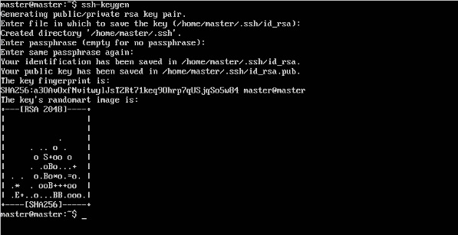

**Step 3** − Next, depending on the version of Ubuntu you have, you will need to add the relevant site to the **docker.list** for the **apt package manager**, so that it will be able to detect the **Kubernetes packages** from the **kubernetes** site and download them accordingly.

We can do it using the following commands.

curl -s https://packages.cloud.google.com/apt/doc/apt-key.gpg | apt-key add -

echo "deb http://apt.kubernetes.io/ kubernetes-xenial main” | sudo tee /etc/apt/sources.list.d/docker.list

**Step 4** − We then issue an apt-get update to ensure all packages are downloaded on the Ubuntu server.

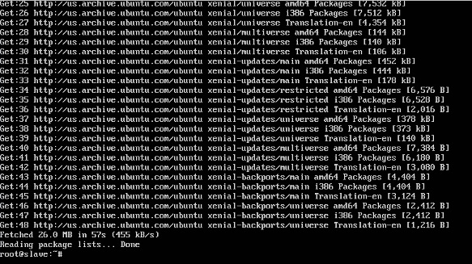

**Step 5** − Install the Docker package as detailed in the earlier chapters.

**Step 6** − Now it’s time to install **kubernetes** by installing the following packages −

apt-get install –y kubelet kubeadm kubectl kubernetes-cni

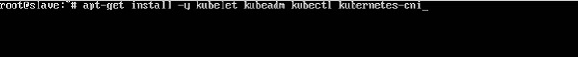

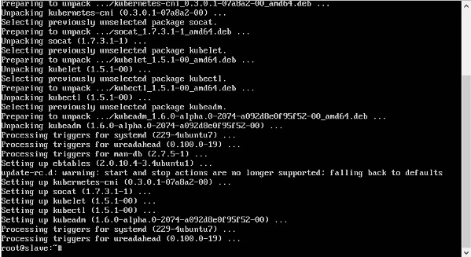

**Step 7** − Once all **kubernetes** packages are downloaded, it’s time to start the kubernetes controller using the following command −

kubeadm init

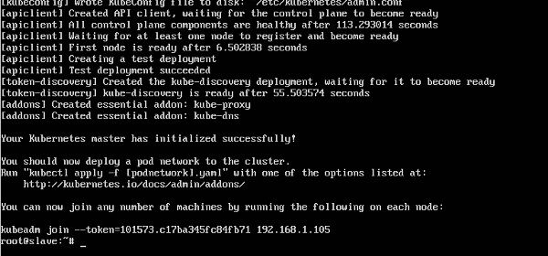

Once done, you will get a successful message that the master is up and running and nodes can now join the cluster.

# Kubernetes - Overview

Kubernetes in an open source container management tool hosted by Cloud Native Computing Foundation (CNCF). This is also known as the enhanced version of Borg which was developed at Google to manage both long running processes and batch jobs, which was earlier handled by separate systems.

Kubernetes comes with a capability of automating deployment, scaling of application, and operations of application containers across clusters. It is capable of creating container centric infrastructure.

## **Features of Kubernetes**

Following are some of the important features of Kubernetes.

* Continues development, integration and deployment
* Containerized infrastructure
* Application-centric management
* Auto-scalable infrastructure
* Environment consistency across development testing and production
* Loosely coupled infrastructure, where each component can act as a separate unit
* Higher density of resource utilization
* Predictable infrastructure which is going to be created

One of the key components of Kubernetes is, it can run application on clusters of physical and virtual machine infrastructure. It also has the capability to run applications on cloud. **It helps in moving from host-centric infrastructure to container-centric infrastructure.**

# Kubernetes - Architecture

In this chapter, we will discuss the basic architecture of Kubernetes.

AD

## **Kubernetes - Cluster Architecture**

As seen in the following diagram, Kubernetes follows client-server architecture. Wherein, we have master installed on one machine and the node on separate Linux machines.

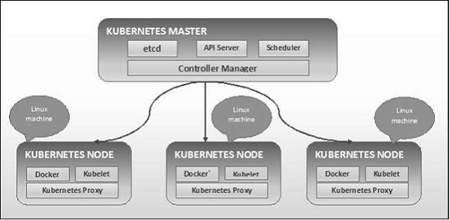

The key components of master and node are defined in the following section.

## **Kubernetes - Master Machine Components**

Following are the components of Kubernetes Master Machine.

### **etcd**

It stores the configuration information which can be used by each of the nodes in the cluster. It is a high availability key value store that can be distributed among multiple nodes. It is accessible only by Kubernetes API server as it may have some sensitive information. It is a distributed key value Store which is accessible to all.

### **API Server**

Kubernetes is an API server which provides all the operation on cluster using the API. API server implements an interface, which means different tools and libraries can readily communicate with it. **Kubeconfig** is a package along with the server side tools that can be used for communication. It exposes Kubernetes API.

### **Controller Manager**

This component is responsible for most of the collectors that regulates the state of cluster and performs a task. In general, it can be considered as a daemon which runs in nonterminating loop and is responsible for collecting and sending information to API server. It works toward getting the shared state of cluster and then make changes to bring the current status of the server to the desired state. The key controllers are replication controller, endpoint controller, namespace controller, and service account controller. The controller manager runs different kind of controllers to handle nodes, endpoints, etc.

### **Scheduler**

This is one of the key components of Kubernetes master. It is a service in master responsible for distributing the workload. It is responsible for tracking utilization of working load on cluster nodes and then placing the workload on which resources are available and accept the workload. In other words, this is the mechanism responsible for allocating pods to available nodes. The scheduler is responsible for workload utilization and allocating pod to new node.

AD

## **Kubernetes - Node Components**

Following are the key components of Node server which are necessary to communicate with Kubernetes master.

### **Docker**

The first requirement of each node is Docker which helps in running the encapsulated application containers in a relatively isolated but lightweight operating environment.

### **Kubelet Service**

This is a small service in each node responsible for relaying information to and from control plane service. It interacts with **etcd** store to read configuration details and wright values. This communicates with the master component to receive commands and work. The **kubelet** process then assumes responsibility for maintaining the state of work and the node server. It manages network rules, port forwarding, etc.

### **Kubernetes Proxy Service**

This is a proxy service which runs on each node and helps in making services available to the external host. It helps in forwarding the request to correct containers and is capable of performing primitive load balancing. It makes sure that the networking environment is predictable and accessible and at the same time it is isolated as well. It manages pods on node, volumes, secrets, creating new containers’ health checkup, etc.

## **Kubernetes - Master and Node Structure**

The following illustrations show the structure of Kubernetes Master and Node.

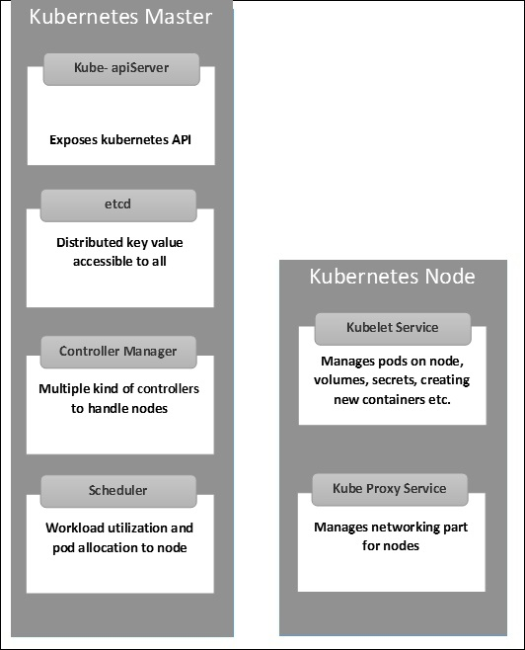

# Kubernetes - Setup

It is important to set up the Virtual Datacenter (vDC) before setting up Kubernetes. This can be considered as a set of machines where they can communicate with each other via the network. For hands-on approach, you can set up vDC on **PROFITBRICKS** if you do not have a physical or cloud infrastructure set up.

Once the IaaS setup on any cloud is complete, you need to configure the **Master** and the **Node**.

**Note** − The setup is shown for Ubuntu machines. The same can be set up on other Linux machines as well.

## **Prerequisites**

**Installing Docker** − Docker is required on all the instances of Kubernetes. Following are the steps to install the Docker.

**Step 1** − Log on to the machine with the root user account.

**Step 2** − Update the package information. Make sure that the apt package is working.

**Step 3** − Run the following commands.

$ sudo apt-get update

$ sudo apt-get install apt-transport-https ca-certificates

**Step 4** − Add the new GPG key.

$ sudo apt-key adv \

--keyserver hkp://ha.pool.sks-keyservers.net:80 \

--recv-keys 58118E89F3A912897C070ADBF76221572C52609D

$ echo "deb https://apt.dockerproject.org/repo ubuntu-trusty main" | sudo tee

/etc/apt/sources.list.d/docker.list

**Step 5** − Update the API package image.

$ sudo apt-get update

Once all the above tasks are complete, you can start with the actual installation of the Docker engine. However, before this you need to verify that the kernel version you are using is correct.

## **Install Docker Engine**

Run the following commands to install the Docker engine.

**Step 1** − Logon to the machine.

**Step 2** − Update the package index.

$ sudo apt-get update

**Step 3** − Install the Docker Engine using the following command.

$ sudo apt-get install docker-engine

**Step 4** − Start the Docker daemon.

$ sudo apt-get install docker-engine

**Step 5** − To very if the Docker is installed, use the following command.

$ sudo docker run hello-world

## **Install etcd 2.0**

This needs to be installed on Kubernetes Master Machine. In order to install it, run the following commands.

$ curl -L https://github.com/coreos/etcd/releases/download/v2.0.0/etcd

-v2.0.0-linux-amd64.tar.gz -o etcd-v2.0.0-linux-amd64.tar.gz ->1

$ tar xzvf etcd-v2.0.0-linux-amd64.tar.gz ------>2

$ cd etcd-v2.0.0-linux-amd64 ------------>3

$ mkdir /opt/bin ------------->4

$ cp etcd* /opt/bin ----------->5

In the above set of command −

* First, we download the **etcd**. Save this with specified name.
* Then, we have to un-tar the tar package.
* We make a dir. inside the /opt named bin.
* Copy the extracted file to the target location.

Now we are ready to build Kubernetes. We need to install Kubernetes on all the machines on the cluster.

$ git clone https://github.com/GoogleCloudPlatform/kubernetes.git

$ cd kubernetes

$ make release

The above command will create a **_output** dir in the root of the kubernetes folder. Next, we can extract the directory into any of the directory of our choice /opt/bin, etc.

Next, comes the networking part wherein we need to actually start with the setup of Kubernetes master and node. In order to do this, we will make an entry in the host file which can be done on the node machine.

$ echo "<IP address of master machine> kube-master

< IP address of Node Machine>" >> /etc/hosts

Following will be the output of the above command.

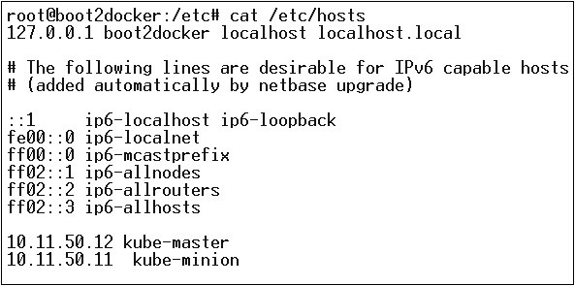

Now, we will start with the actual configuration on Kubernetes Master.

First, we will start copying all the configuration files to their correct location.

$ cp <Current dir. location>/kube-apiserver /opt/bin/

$ cp <Current dir. location>/kube-controller-manager /opt/bin/

$ cp <Current dir. location>/kube-kube-scheduler /opt/bin/

$ cp <Current dir. location>/kubecfg /opt/bin/

$ cp <Current dir. location>/kubectl /opt/bin/

$ cp <Current dir. location>/kubernetes /opt/bin/

The above command will copy all the configuration files to the required location. Now we will come back to the same directory where we have built the Kubernetes folder.

$ cp kubernetes/cluster/ubuntu/init_conf/kube-apiserver.conf /etc/init/

$ cp kubernetes/cluster/ubuntu/init_conf/kube-controller-manager.conf /etc/init/

$ cp kubernetes/cluster/ubuntu/init_conf/kube-kube-scheduler.conf /etc/init/

$ cp kubernetes/cluster/ubuntu/initd_scripts/kube-apiserver /etc/init.d/

$ cp kubernetes/cluster/ubuntu/initd_scripts/kube-controller-manager /etc/init.d/

$ cp kubernetes/cluster/ubuntu/initd_scripts/kube-kube-scheduler /etc/init.d/

$ cp kubernetes/cluster/ubuntu/default_scripts/kubelet /etc/default/

$ cp kubernetes/cluster/ubuntu/default_scripts/kube-proxy /etc/default/

$ cp kubernetes/cluster/ubuntu/default_scripts/kubelet /etc/default/

The next step is to update the copied configuration file under /etc. dir.

Configure etcd on master using the following command.

$ ETCD_OPTS = "-listen-client-urls = http://kube-master:4001"

## **Configure kube-apiserver**

For this on the master, we need to edit the **/etc/default/kube-apiserver** file which we copied earlier.

$ KUBE_APISERVER_OPTS = "--address = 0.0.0.0 \

--port = 8080 \

--etcd_servers = <The path that is configured in ETCD_OPTS> \

--portal_net = 11.1.1.0/24 \

--allow_privileged = false \

--kubelet_port = < Port you want to configure> \

--v = 0"

## **Configure the kube Controller Manager**

We need to add the following content in **/etc/default/kube-controller-manager**.

$ KUBE_CONTROLLER_MANAGER_OPTS = "--address = 0.0.0.0 \

--master = 127.0.0.1:8080 \

--machines = kube-minion \ -----> #this is the kubernatics node

--v = 0

Next, configure the kube scheduler in the corresponding file.

$ KUBE_SCHEDULER_OPTS = "--address = 0.0.0.0 \

--master = 127.0.0.1:8080 \

--v = 0"

Once all the above tasks are complete, we are good to go ahead by bring up the Kubernetes Master. In order to do this, we will restart the Docker.

$ service docker restart

## **Kubernetes Node Configuration**

Kubernetes node will run two services the **kubelet and the kube-proxy**. Before moving ahead, we need to copy the binaries we downloaded to their required folders where we want to configure the kubernetes node.

Use the same method of copying the files that we did for kubernetes master. As it will only run the kubelet and the kube-proxy, we will configure them.

$ cp <Path of the extracted file>/kubelet /opt/bin/

$ cp <Path of the extracted file>/kube-proxy /opt/bin/

$ cp <Path of the extracted file>/kubecfg /opt/bin/

$ cp <Path of the extracted file>/kubectl /opt/bin/

$ cp <Path of the extracted file>/kubernetes /opt/bin/

Now, we will copy the content to the appropriate dir.

$ cp kubernetes/cluster/ubuntu/init_conf/kubelet.conf /etc/init/

$ cp kubernetes/cluster/ubuntu/init_conf/kube-proxy.conf /etc/init/

$ cp kubernetes/cluster/ubuntu/initd_scripts/kubelet /etc/init.d/

$ cp kubernetes/cluster/ubuntu/initd_scripts/kube-proxy /etc/init.d/

$ cp kubernetes/cluster/ubuntu/default_scripts/kubelet /etc/default/

$ cp kubernetes/cluster/ubuntu/default_scripts/kube-proxy /etc/default/

We will configure the **kubelet** and **kube-proxy conf** files.

We will configure the **/etc/init/kubelet.conf**.

$ KUBELET_OPTS = "--address = 0.0.0.0 \

--port = 10250 \

--hostname_override = kube-minion \

--etcd_servers = http://kube-master:4001 \

--enable_server = true

--v = 0"

/

For kube-proxy, we will configure using the following command.

$ KUBE_PROXY_OPTS = "--etcd_servers = http://kube-master:4001 \

--v = 0"

/etc/init/kube-proxy.conf

Finally, we will restart the Docker service.

$ service docker restart

Now we are done with the configuration. You can check by running the following commands.

$ /opt/bin/kubectl get minions

# Kubernetes - Images

Kubernetes (Docker) images are the key building blocks of Containerized Infrastructure. As of now, we are only supporting Kubernetes to support Docker images. Each container in a pod has its Docker image running inside it.

When we are configuring a pod, the image property in the configuration file has the same syntax as the Docker command does. The configuration file has a field to define the image name, which we are planning to pull from the registry.

Following is the common configuration structure which will pull image from Docker registry and deploy in to Kubernetes container.

apiVersion: v1

kind: pod

metadata:

name: Tesing_for_Image_pull -----------> 1

spec:

containers:

- name: neo4j-server ------------------------> 2

image: <Name of the Docker image>----------> 3

imagePullPolicy: Always ------------->4

command: ["echo", "SUCCESS"] ------------------->

In the above code, we have defined −

* **name: Tesing_for_Image_pull** − This name is given to identify and check what is the name of the container that would get created after pulling the images from Docker registry.
* **name: neo4j-server** − This is the name given to the container that we are trying to create. Like we have given neo4j-server.
* **image: <Name of the Docker image>** − This is the name of the image which we are trying to pull from the Docker or internal registry of images. We need to define a complete registry path along with the image name that we are trying to pull.
* **imagePullPolicy** − Always - This image pull policy defines that whenever we run this file to create the container, it will pull the same name again.
* **command: [“echo”, “SUCCESS”]** − With this, when we create the container and if everything goes fine, it will display a message when we will access the container.

In order to pull the image and create a container, we will run the following command.

$ kubectl create –f Tesing_for_Image_pull

Once we fetch the log, we will get the output as successful.

$ kubectl log Tesing_for_Image_pull

The above command will produce an output of success or we will get an output as failure.

**Note** − It is recommended that you try all the commands yourself.

# Kubernetes - Jobs

The main function of a job is to create one or more pod and tracks about the success of pods. They ensure that the specified number of pods are completed successfully. When a specified number of successful run of pods is completed, then the job is considered complete.

## **Creating a Job**

Use the following command to create a job −

apiVersion: v1

kind: Job ------------------------> 1

metadata:

name: py

spec:

template:

metadata

name: py -------> 2

spec:

containers:

- name: py ------------------------> 3

image: python----------> 4

command: ["python", "SUCCESS"]

restartPocliy: Never --------> 5

In the above code, we have defined −

* **kind: Job →** We have defined the kind as Job which will tell **kubectl** that the **yaml** file being used is to create a job type pod.
* **Name:py →** This is the name of the template that we are using and the spec defines the template.
* **name: py →** we have given a name as **py** under container spec which helps to identify the Pod which is going to be created out of it.
* **Image: python →** the image which we are going to pull to create the container which will run inside the pod.
* **restartPolicy: Never →**This condition of image restart is given as never which means that if the container is killed or if it is false, then it will not restart itself.

We will create the job using the following command with yaml which is saved with the name **py.yaml**.

$ kubectl create –f py.yaml

The above command will create a job. If you want to check the status of a job, use the following command.

$ kubectl describe jobs/py

The above command will create a job. If you want to check the status of a job, use the following command.

## **Scheduled Job**

Scheduled job in Kubernetes uses **Cronetes**, which takes Kubernetes job and launches them in Kubernetes cluster.

* Scheduling a job will run a pod at a specified point of time.
* A parodic job is created for it which invokes itself automatically.

**Note** − The feature of a scheduled job is supported by version 1.4 and the betch/v2alpha 1 API is turned on by passing the **–runtime-config=batch/v2alpha1** while bringing up the API server.

We will use the same yaml which we used to create the job and make it a scheduled job.

apiVersion: v1

kind: Job

metadata:

name: py

spec:

schedule: h/30 * * * * ? -------------------> 1

template:

metadata

name: py

spec:

containers:

- name: py

image: python

args:

/bin/sh -------> 2

-c

ps –eaf ------------> 3

restartPocliy: OnFailure

In the above code, we have defined −

* **schedule: h/30 * * * * ?** → To schedule the job to run in every 30 minutes.
* **/bin/sh:** This will enter in the container with /bin/sh
* **ps –eaf →** Will run ps -eaf command on the machine and list all the running process inside a container.

This scheduled job concept is useful when we are trying to build and run a set of tasks at a specified point of time and then complete the process.

# Kubernetes - Labels & Selectors

## **Labels**

Labels are key-value pairs which are attached to pods, replication controller and services. They are used as identifying attributes for objects such as pods and replication controller. They can be added to an object at creation time and can be added or modified at the run time.

## **Selectors**

Labels do not provide uniqueness. In general, we can say many objects can carry the same labels. Labels selector are core grouping primitive in Kubernetes. They are used by the users to select a set of objects.

Kubernetes API currently supports two type of selectors −

* Equality-based selectors
* Set-based selectors

### **Equality-based Selectors**

They allow filtering by key and value. Matching objects should satisfy all the specified labels.

### **Set-based Selectors**

Set-based selectors allow filtering of keys according to a set of values.

apiVersion: v1

kind: Service

metadata:

name: sp-neo4j-standalone

spec:

ports:

- port: 7474

name: neo4j

type: NodePort

selector:

app: salesplatform ---------> 1

component: neo4j -----------> 2

In the above code, we are using the label selector as **app: salesplatform** and component as **component: neo4j**.

Once we run the file using the **kubectl** command, it will create a service with the name **sp-neo4j-standalone** which will communicate on port 7474. The ype is **NodePort** with the new label selector as **app: salesplatform** and **component: neo4j**.

# Kubernetes - Namespace

Namespace provides an additional qualification to a resource name. This is helpful when multiple teams are using the same cluster and there is a potential of name collision. It can be as a virtual wall between multiple clusters.

## **Functionality of Namespace**

Following are some of the important functionalities of a Namespace in Kubernetes −

* Namespaces help pod-to-pod communication using the same namespace.
* Namespaces are virtual clusters that can sit on top of the same physical cluster.
* They provide logical separation between the teams and their environments.

## **Create a Namespace**

The following command is used to create a namespace.

apiVersion: v1

kind: Namespce

metadata

name: elk

## **Control the Namespace**

The following command is used to control the namespace.

$ kubectl create –f namespace.yml ---------> 1

$ kubectl get namespace -----------------> 2

$ kubectl get namespace <Namespace name> ------->3

$ kubectl describe namespace <Namespace name> ---->4

$ kubectl delete namespace <Namespace name>

In the above code,

* We are using the command to create a namespace.
* This will list all the available namespace.
* This will get a particular namespace whose name is specified in the command.
* This will describe the complete details about the service.
* This will delete a particular namespace present in the cluster.

## **Using Namespace in Service - Example**

Following is an example of a sample file for using namespace in service.

apiVersion: v1

kind: Service

metadata:

name: elasticsearch

namespace: elk

labels:

component: elasticsearch

spec:

type: LoadBalancer

selector:

component: elasticsearch

ports:

- name: http

port: 9200

protocol: TCP

- name: transport

port: 9300

protocol: TCP

In the above code, we are using the same namespace under service metadata with the name of **elk**.

# Kubernetes - Node

A node is a working machine in Kubernetes cluster which is also known as a minion. They are working units which can be physical, VM, or a cloud instance.

Each node has all the required configuration required to run a pod on it such as the proxy service and kubelet service along with the Docker, which is used to run the Docker containers on the pod created on the node.

They are not created by Kubernetes but they are created externally either by the cloud service provider or the Kubernetes cluster manager on physical or VM machines.

The key component of Kubernetes to handle multiple nodes is the controller manager, which runs multiple kind of controllers to manage nodes. To manage nodes, Kubernetes creates an object of kind node which will validate that the object which is created is a valid node.

## **Service with Selector**

apiVersion: v1

kind: node

metadata:

name: < ip address of the node>

labels:

name: <lable name>

In JSON format the actual object is created which looks as follows −

{

Kind: node

apiVersion: v1

"metadata":

{

"name": "10.01.1.10",

"labels"

{

"name": "cluster 1 node"

}

}

}

## **Node Controller**

They are the collection of services which run in the Kubernetes master and continuously monitor the node in the cluster on the basis of metadata.name. If all the required services are running, then the node is validated and a newly created pod will be assigned to that node by the controller. If it is not valid, then the master will not assign any pod to it and will wait until it becomes valid.

Kubernetes master registers the node automatically, if **–register-node** flag is true.

–register-node = true

However, if the cluster administrator wants to manage it manually then it could be done by turning the flat of −

–register-node = false

# Kubernetes - Service

A service can be defined as a logical set of pods. It can be defined as an abstraction on the top of the pod which provides a single IP address and DNS name by which pods can be accessed. With Service, it is very easy to manage load balancing configuration. It helps pods to scale very easily.

A service is a REST object in Kubernetes whose definition can be posted to Kubernetes apiServer on the Kubernetes master to create a new instance.

## **Service without Selector**

apiVersion: v1

kind: Service

metadata:

name: Tutorial_point_service

spec:

ports:

- port: 8080

targetPort: 31999

The above configuration will create a service with the name Tutorial_point_service.

## **Service Config File with Selector**

apiVersion: v1

kind: Service

metadata:

name: Tutorial_point_service

spec:

selector:

application: "My Application" -------------------> (Selector)

ports:

- port: 8080

targetPort: 31999

In this example, we have a selector; so in order to transfer traffic, we need to create an endpoint manually.

apiVersion: v1

kind: Endpoints

metadata:

name: Tutorial_point_service

subnets:

address:

"ip": "192.168.168.40" -------------------> (Selector)

ports:

- port: 8080

In the above code, we have created an endpoint which will route the traffic to the endpoint defined as “192.168.168.40:8080”.

## **Multi-Port Service Creation**

apiVersion: v1

kind: Service

metadata:

name: Tutorial_point_service

spec:

selector:

application: “My Application” -------------------> (Selector)

ClusterIP: 10.3.0.12

ports:

-name: http

protocol: TCP

port: 80

targetPort: 31999

-name:https

Protocol: TCP

Port: 443

targetPort: 31998

## **Types of Services**

**ClusterIP** − This helps in restricting the service within the cluster. It exposes the service within the defined Kubernetes cluster.

spec:

type: NodePort

ports:

- port: 8080

nodePort: 31999

name: NodeportService

**NodePort** − It will expose the service on a static port on the deployed node. A **ClusterIP** service, to which **NodePort** service will route, is automatically created. The service can be accessed from outside the cluster using the **NodeIP:nodePort**.

spec:

ports:

- port: 8080

nodePort: 31999

name: NodeportService

clusterIP: 10.20.30.40

**Load Balancer** − It uses cloud providers’ load balancer. **NodePort** and **ClusterIP** services are created automatically to which the external load balancer will route.

A full service **yaml** file with service type as Node Port. Try to create one yourself.

apiVersion: v1

kind: Service

metadata:

name: appname

labels:

k8s-app: appname

spec:

type: NodePort

ports:

- port: 8080

nodePort: 31999

name: omninginx

selector:

k8s-app: appname

component: nginx

env: env_name

# Kubernetes - Pod

A pod is a collection of containers and its storage inside a node of a Kubernetes cluster. It is possible to create a pod with multiple containers inside it. For example, keeping a database container and data container in the same pod.

## **Types of Pod**

There are two types of Pods −

* Single container pod
* Multi container pod

### **Single Container Pod**

They can be simply created with the kubctl run command, where you have a defined image on the Docker registry which we will pull while creating a pod.

$ kubectl run <name of pod> --image=<name of the image from registry>

**Example** − We will create a pod with a tomcat image which is available on the Docker hub.

$ kubectl run tomcat --image = tomcat:8.0

This can also be done by creating the **yaml** file and then running the **kubectl create** command.

apiVersion: v1

kind: Pod

metadata:

name: Tomcat

spec:

containers:

- name: Tomcat

image: tomcat: 8.0

ports:

containerPort: 7500

imagePullPolicy: Always

Once the above **yaml** file is created, we will save the file with the name of **tomcat.yml** and run the create command to run the document.

$ kubectl create –f tomcat.yml

It will create a pod with the name of tomcat. We can use the describe command along with **kubectl** to describe the pod.

### **Multi Container Pod**

Multi container pods are created using **yaml mail** with the definition of the containers.

apiVersion: v1

kind: Pod

metadata:

name: Tomcat

spec:

containers:

- name: Tomcat

image: tomcat: 8.0

ports:

containerPort: 7500

imagePullPolicy: Always

-name: Database

Image: mongoDB

Ports:

containerPort: 7501

imagePullPolicy: Always

In the above code, we have created one pod with two containers inside it, one for tomcat and the other for MongoDB.

# Kubernetes - Replication Controller

Replication Controller is one of the key features of Kubernetes, which is responsible for managing the pod lifecycle. It is responsible for making sure that the specified number of pod replicas are running at any point of time. It is used in time when one wants to make sure that the specified number of pod or at least one pod is running. It has the capability to bring up or down the specified no of pod.

It is a best practice to use the replication controller to manage the pod life cycle rather than creating a pod again and again.

apiVersion: v1

kind: ReplicationController --------------------------> 1

metadata:

name: Tomcat-ReplicationController --------------------------> 2

spec:

replicas: 3 ------------------------> 3

template:

metadata:

name: Tomcat-ReplicationController

labels:

app: App

component: neo4j

spec:

containers:

- name: Tomcat- -----------------------> 4

image: tomcat: 8.0

ports:

- containerPort: 7474 ------------------------> 5

## **Setup Details**

* **Kind: ReplicationController** → In the above code, we have defined the kind as replication controller which tells the **kubectl** that the **yaml** file is going to be used for creating the replication controller.
* **name: Tomcat-ReplicationController** → This helps in identifying the name with which the replication controller will be created. If we run the kubctl, get **rc < Tomcat-ReplicationController >** it will show the replication controller details.
* **replicas: 3** → This helps the replication controller to understand that it needs to maintain three replicas of a pod at any point of time in the pod lifecycle.
* **name: Tomcat** → In the spec section, we have defined the name as tomcat which will tell the replication controller that the container present inside the pods is tomcat.
* **containerPort: 7474** → It helps in making sure that all the nodes in the cluster where the pod is running the container inside the pod will be exposed on the same port 7474.

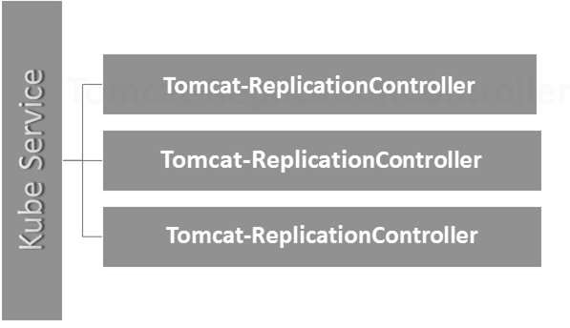

Here, the Kubernetes service is working as a load balancer for three tomcat replicas.

# Kubernetes - Replica Sets

Replica Set ensures how many replica of pod should be running. It can be considered as a replacement of replication controller. The key difference between the replica set and the replication controller is, the replication controller only supports equality-based selector whereas the replica set supports set-based selector.

apiVersion: extensions/v1beta1 --------------------->1

kind: ReplicaSet --------------------------> 2

metadata:

name: Tomcat-ReplicaSet

spec:

replicas: 3

selector:

matchLables:

tier: Backend ------------------> 3

matchExpression:

{ key: tier, operation: In, values: [Backend]} --------------> 4

template:

metadata:

lables:

app: Tomcat-ReplicaSet

tier: Backend

labels:

app: App

component: neo4j

spec:

containers:

- name: Tomcat

image: tomcat: 8.0

ports:

- containerPort: 7474

## **Setup Details**

* **apiVersion: extensions/v1beta1** → In the above code, the API version is the advanced beta version of Kubernetes which supports the concept of replica set.
* **kind: ReplicaSet** → We have defined the kind as the replica set which helps kubectl to understand that the file is used to create a replica set.
* **tier: Backend** → We have defined the label tier as backend which creates a matching selector.
* **{key: tier, operation: In, values: [Backend]}** → This will help **matchExpression** to understand the matching condition we have defined and in the operation which is used by **matchlabel** to find details.

Run the above file using **kubectl** and create the backend replica set with the provided definition in the **yaml** file.

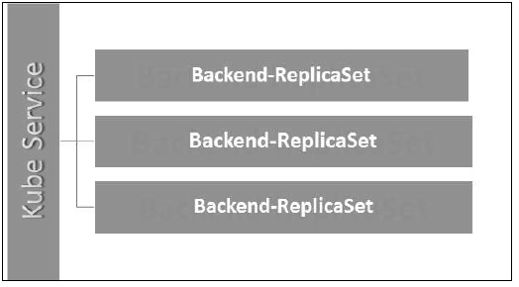

# Kubernetes - Deployments

Deployments are upgraded and higher version of replication controller. They manage the deployment of replica sets which is also an upgraded version of the replication controller. They have the capability to update the replica set and are also capable of rolling back to the previous version.

They provide many updated features of **matchLabels** and **selectors**. We have got a new controller in the Kubernetes master called the deployment controller which makes it happen. It has the capability to change the deployment midway.

## **Changing the Deployment**

**Updating** − The user can update the ongoing deployment before it is completed. In this, the existing deployment will be settled and new deployment will be created.

**Deleting** − The user can pause/cancel the deployment by deleting it before it is completed. Recreating the same deployment will resume it.

**Rollback** − We can roll back the deployment or the deployment in progress. The user can create or update the deployment by using **DeploymentSpec.PodTemplateSpec = oldRC.PodTemplateSpec.**

## **Deployment Strategies**

Deployment strategies help in defining how the new RC should replace the existing RC.

**Recreate** − This feature will kill all the existing RC and then bring up the new ones. This results in quick deployment however it will result in downtime when the old pods are down and the new pods have not come up.

**Rolling Update** − This feature gradually brings down the old RC and brings up the new one. This results in slow deployment, however there is no deployment. At all times, few old pods and few new pods are available in this process.

The configuration file of Deployment looks like this.

apiVersion: extensions/v1beta1 --------------------->1

kind: Deployment --------------------------> 2

metadata:

name: Tomcat-ReplicaSet

spec:

replicas: 3

template:

metadata:

lables:

app: Tomcat-ReplicaSet

tier: Backend

spec:

containers:

- name: Tomcatimage:

tomcat: 8.0

ports:

- containerPort: 7474

In the above code, the only thing which is different from the replica set is we have defined the kind as deployment.

## **Create Deployment**

$ kubectl create –f Deployment.yaml -–record

deployment "Deployment" created Successfully.

## **Fetch the Deployment**

$ kubectl get deployments

NAME DESIRED CURRENT UP-TO-DATE AVILABLE AGE

Deployment 3 3 3 3 20s

## **Check the Status of Deployment**

$ kubectl rollout status deployment/Deployment

## **Updating the Deployment**

$ kubectl set image deployment/Deployment tomcat=tomcat:6.0

## **Rolling Back to Previous Deployment**

$ kubectl rollout undo deployment/Deployment –to-revision=2

# Kubernetes - Volumes

In Kubernetes, a volume can be thought of as a directory which is accessible to the containers in a pod. We have different types of volumes in Kubernetes and the type defines how the volume is created and its content.

The concept of volume was present with the Docker, however the only issue was that the volume was very much limited to a particular pod. As soon as the life of a pod ended, the volume was also lost.

On the other hand, the volumes that are created through Kubernetes is not limited to any container. It supports any or all the containers deployed inside the pod of Kubernetes. A key advantage of Kubernetes volume is, it supports different kind of storage wherein the pod can use multiple of them at the same time.

### **Types of Kubernetes Volume**

Here is a list of some popular Kubernetes Volumes −

* **emptyDir** − It is a type of volume that is created when a Pod is first assigned to a Node. It remains active as long as the Pod is running on that node. The volume is initially empty and the containers in the pod can read and write the files in the emptyDir volume. Once the Pod is removed from the node, the data in the emptyDir is erased.
* **hostPath** − This type of volume mounts a file or directory from the host node’s filesystem into your pod.
* **gcePersistentDisk** − This type of volume mounts a Google Compute Engine (GCE) Persistent Disk into your Pod. The data in a **gcePersistentDisk** remains intact when the Pod is removed from the node.
* **awsElasticBlockStore** − This type of volume mounts an Amazon Web Services (AWS) Elastic Block Store into your Pod. Just like **gcePersistentDisk**, the data in an **awsElasticBlockStore** remains intact when the Pod is removed from the node.
* **nfs** − An **nfs** volume allows an existing NFS (Network File System) to be mounted into your pod. The data in an **nfs** volume is not erased when the Pod is removed from the node. The volume is only unmounted.
* **iscsi** − An **iscsi** volume allows an existing iSCSI (SCSI over IP) volume to be mounted into your pod.
* **flocker** − It is an open-source clustered container data volume manager. It is used for managing data volumes. A **flocker** volume allows a Flocker dataset to be mounted into a pod. If the dataset does not exist in Flocker, then you first need to create it by using the Flocker API.
* **glusterfs** − Glusterfs is an open-source networked filesystem. A glusterfs volume allows a glusterfs volume to be mounted into your pod.
* **rbd** − RBD stands for Rados Block Device. An **rbd** volume allows a Rados Block Device volume to be mounted into your pod. Data remains preserved after the Pod is removed from the node.
* **cephfs** − A **cephfs** volume allows an existing CephFS volume to be mounted into your pod. Data remains intact after the Pod is removed from the node.
* **gitRepo** − A **gitRepo** volume mounts an empty directory and clones a **git** repository into it for your pod to use.
* **secret** − A **secret** volume is used to pass sensitive information, such as passwords, to pods.
* **persistentVolumeClaim** − A **persistentVolumeClaim** volume is used to mount a PersistentVolume into a pod. PersistentVolumes are a way for users to “claim” durable storage (such as a GCE PersistentDisk or an iSCSI volume) without knowing the details of the particular cloud environment.
* **downwardAPI** − A **downwardAPI** volume is used to make downward API data available to applications. It mounts a directory and writes the requested data in plain text files.
* **azureDiskVolume** − An **AzureDiskVolume** is used to mount a Microsoft Azure Data Disk into a Pod.

## **Persistent Volume and Persistent Volume Claim**

**Persistent Volume (PV)** − It’s a piece of network storage that has been provisioned by the administrator. It’s a resource in the cluster which is independent of any individual pod that uses the PV.

**Persistent Volume Claim (PVC)** − The storage requested by Kubernetes for its pods is known as PVC. The user does not need to know the underlying provisioning. The claims must be created in the same namespace where the pod is created.

### **Creating Persistent Volume**

kind: PersistentVolume ---------> 1

apiVersion: v1

metadata:

name: pv0001 ------------------> 2

labels:

type: local

spec:

capacity: -----------------------> 3

storage: 10Gi ----------------------> 4

accessModes:

- ReadWriteOnce -------------------> 5

hostPath:

path: "/tmp/data01" --------------------------> 6

In the above code, we have defined −

* **kind: PersistentVolume** → We have defined the kind as PersistentVolume which tells kubernetes that the yaml file being used is to create the Persistent Volume.
* **name: pv0001** → Name of PersistentVolume that we are creating.
* **capacity:** → This spec will define the capacity of PV that we are trying to create.
* **storage: 10Gi** → This tells the underlying infrastructure that we are trying to claim 10Gi space on the defined path.
* **ReadWriteOnce** → This tells the access rights of the volume that we are creating.
* **path: "/tmp/data01"** → This definition tells the machine that we are trying to create volume under this path on the underlying infrastructure.

### **Creating PV**

$ kubectl create –f local-01.yaml

persistentvolume "pv0001" created

### **Checking PV**

$ kubectl get pv

NAME CAPACITY ACCESSMODES STATUS CLAIM REASON AGE

pv0001 10Gi RWO Available 14s

### **Describing PV**

$ kubectl describe pv pv0001

### **Creating Persistent Volume Claim**

kind: PersistentVolumeClaim --------------> 1

apiVersion: v1

metadata:

name: myclaim-1 --------------------> 2

spec:

accessModes:

- ReadWriteOnce ------------------------> 3

resources:

requests:

storage: 3Gi ---------------------> 4

In the above code, we have defined −

* **kind: PersistentVolumeClaim** → It instructs the underlying infrastructure that we are trying to claim a specified amount of space.
* **name: myclaim-1** → Name of the claim that we are trying to create.
* **ReadWriteOnce** → This specifies the mode of the claim that we are trying to create.
* **storage: 3Gi** → This will tell kubernetes about the amount of space we are trying to claim.

### **Creating PVC**

$ kubectl create –f myclaim-1

persistentvolumeclaim "myclaim-1" created

### **Getting Details About PVC**

$ kubectl get pvc

NAME STATUS VOLUME CAPACITY ACCESSMODES AGE

myclaim-1 Bound pv0001 10Gi RWO 7s

### **Describe PVC**

$ kubectl describe pv pv0001

### **Using PV and PVC with POD**

kind: Pod

apiVersion: v1

metadata:

name: mypod

labels:

name: frontendhttp

spec:

containers:

- name: myfrontend

image: nginx

ports:

- containerPort: 80

name: "http-server"

volumeMounts: ----------------------------> 1

- mountPath: "/usr/share/tomcat/html"

name: mypd

volumes: -----------------------> 2

- name: mypd

persistentVolumeClaim: ------------------------->3

claimName: myclaim-1

In the above code, we have defined −

* **volumeMounts:** → This is the path in the container on which the mounting will take place.
* **Volume:** → This definition defines the volume definition that we are going to claim.
* **persistentVolumeClaim:** → Under this, we define the volume name which we are going to use in the defined pod.

# Kubernetes - Secrets

Secrets can be defined as Kubernetes objects used to store sensitive data such as user name and passwords with encryption.

There are multiple ways of creating secrets in Kubernetes.

* Creating from txt files.
* Creating from yaml file.

### **Creating From Text File**

In order to create secrets from a text file such as user name and password, we first need to store them in a txt file and use the following command.

$ kubectl create secret generic tomcat-passwd –-from-file = ./username.txt –fromfile = ./.

password.txt

### **Creating From Yaml File**

apiVersion: v1

kind: Secret

metadata:

name: tomcat-pass

type: Opaque

data:

password: <User Password>

username: <User Name>

### **Creating the Secret**

$ kubectl create –f Secret.yaml

secrets/tomcat-pass

## **Using Secrets**

Once we have created the secrets, it can be consumed in a pod or the replication controller as −

* Environment Variable
* Volume

### **As Environment Variable**

In order to use the secret as environment variable, we will use **env** under the spec section of pod yaml file.

env:

- name: SECRET_USERNAME

valueFrom:

secretKeyRef:

name: mysecret

key: tomcat-pass

### **As Volume**

spec:

volumes:

- name: "secretstest"

secret:

secretName: tomcat-pass

containers:

- image: tomcat:7.0

name: awebserver

volumeMounts:

- mountPath: "/tmp/mysec"

name: "secretstest"

### **Secret Configuration As Environment Variable**

apiVersion: v1

kind: ReplicationController

metadata:

name: appname

spec:

replicas: replica_count

template:

metadata:

name: appname

spec:

nodeSelector:

resource-group:

containers:

- name: appname

image:

imagePullPolicy: Always

ports:

- containerPort: 3000

env: -----------------------------> 1

- name: ENV

valueFrom:

configMapKeyRef:

name: appname

key: tomcat-secrets

In the above code, under the **env** definition, we are using secrets as environment variable in the replication controller.

### **Secrets As Volume Mount**

apiVersion: v1

kind: pod

metadata:

name: appname

spec:

metadata:

name: appname

spec:

volumes:

- name: "secretstest"

secret:

secretName: tomcat-pass

containers:

- image: tomcat: 8.0

name: awebserver

volumeMounts:

- mountPath: "/tmp/mysec"

name: "secretstest"

# Kubernetes - Network Policy

Network Policy defines how the pods in the same namespace will communicate with each other and the network endpoint. It requires **extensions/v1beta1/networkpolicies** to be enabled in the runtime configuration in the API server. Its resources use labels to select the pods and define rules to allow traffic to a specific pod in addition to which is defined in the namespace.

First, we need to configure Namespace Isolation Policy. Basically, this kind of networking policies are required on the load balancers.

kind: Namespace

apiVersion: v1

metadata:

annotations:

net.beta.kubernetes.io/network-policy: |

{

"ingress":

{

"isolation": "DefaultDeny"

}

}

$ kubectl annotate ns <namespace> "net.beta.kubernetes.io/network-policy =

{\"ingress\": {\"isolation\": \"DefaultDeny\"}}"

Once the namespace is created, we need to create the Network Policy.

## **Network Policy Yaml**

kind: NetworkPolicy

apiVersion: extensions/v1beta1

metadata:

name: allow-frontend

namespace: myns

spec:

podSelector:

matchLabels:

role: backend

ingress:

- from:

- podSelector:

matchLabels:

role: frontend

ports:

- protocol: TCP

port: 6379

# Kubernetes - API

Kubernetes API serves as a foundation for declarative configuration schema for the system. **Kubectl** command-line tool can be used to create, update, delete, and get API object. Kubernetes API acts a communicator among different components of Kubernetes.

## **Adding API to Kubernetes**

Adding a new API to Kubernetes will add new features to Kubernetes, which will increase the functionality of Kubernetes. However, alongside it will also increase the cost and maintainability of the system. In order to create a balance between the cost and complexity, there are a few sets defined for it.

The API which is getting added should be useful to more than 50% of the users. There is no other way to implement the functionality in Kubernetes. Exceptional circumstances are discussed in the community meeting of Kubernetes, and then API is added.

## **API Changes**

In order to increase the capability of Kubernetes, changes are continuously introduced to the system. It is done by Kubernetes team to add the functionality to Kubernetes without removing or impacting the existing functionality of the system.

To demonstrate the general process, here is an (hypothetical) example −

* A user POSTs a Pod object to **/api/v7beta1/...**
* The JSON is unmarshalled into a **v7beta1.Pod** structure
* Default values are applied to the **v7beta1.Pod**
* The **v7beta1.Pod** is converted to an **api.Pod** structure
* The **api.Pod** is validated, and any errors are returned to the user
* The **api.Pod** is converted to a v6.Pod (because v6 is the latest stable version)
* The **v6.Pod** is marshalled into JSON and written to **etcd**

Now that we have the Pod object stored, a user can GET that object in any supported API version. For example −

* A user GETs the Pod from **/api/v5/...**
* The JSON is read from **etcd** and **unmarshalled** into a **v6.Pod** structure
* Default values are applied to the **v6.Pod**
* The **v6.Pod** is converted to an api.Pod structure
* The **api.Pod** is converted to a **v5.Pod** structure
* The **v5.Pod** is marshalled into JSON and sent to the user

The implication of this process is that API changes must be done carefully and backward compatibly.

## **API Versioning**

To make it easier to support multiple structures, Kubernetes supports multiple API versions each at different API path such as **/api/v1** or **/apsi/extensions/v1beta1**

Versioning standards at Kubernetes are defined in multiple standards.

### **Alpha Level**

* This version contains alpha (e.g. v1alpha1)
* This version may be buggy; the enabled version may have bugs
* Support for bugs can be dropped at any point of time.
* Recommended to be used in short term testing only as the support may not be present all the time.

### **Beta Level**

* The version name contains beta (e.g. v2beta3)
* The code is fully tested and the enabled version is supposed to be stable.
* The support of the feature will not be dropped; there may be some small changes.
* Recommended for only non-business-critical uses because of the potential for incompatible changes in subsequent releases.

### **Stable Level**

* The version name is **vX** where **X** is an integer.
* Stable versions of features will appear in the released software for many subsequent versions.

# Kubernetes - Kubectl

Kubectl is the command line utility to interact with Kubernetes API. It is an interface which is used to communicate and manage pods in Kubernetes cluster.

One needs to set up kubectl to local in order to interact with Kubernetes cluster.

## **Setting Kubectl**

Download the executable to the local workstation using the curl command.

### **On Linux**

$ curl -O https://storage.googleapis.com/kubernetesrelease/

release/v1.5.2/bin/linux/amd64/kubectl

### **On OS X workstation**

$ curl -O https://storage.googleapis.com/kubernetesrelease/

release/v1.5.2/bin/darwin/amd64/kubectl

After download is complete, move the binaries in the path of the system.

$ chmod +x kubectl

$ mv kubectl /usr/local/bin/kubectl

## **Configuring Kubectl**

Following are the steps to perform the configuration operation.

$ kubectl config set-cluster default-cluster --server = https://${MASTER_HOST} --

certificate-authority = ${CA_CERT}

$ kubectl config set-credentials default-admin --certificateauthority = ${

CA_CERT} --client-key = ${ADMIN_KEY} --clientcertificate = ${

ADMIN_CERT}

$ kubectl config set-context default-system --cluster = default-cluster --

user = default-admin

$ kubectl config use-context default-system

* Replace **${MASTER_HOST}** with the master node address or name used in the previous steps.
* Replace **${CA_CERT}** with the absolute path to the **ca.pem** created in the previous steps.
* Replace **${ADMIN_KEY}** with the absolute path to the **admin-key.pem** created in the previous steps.
* Replace **${ADMIN_CERT}** with the absolute path to the **admin.pem** created in the previous steps.

## **Verifying the Setup**

To verify if the **kubectl** is working fine or not, check if the Kubernetes client is set up correctly.

$ kubectl get nodes

NAME LABELS STATUS

Vipin.com Kubernetes.io/hostname = vipin.mishra.com Ready

# Kubernetes - Kubectl Commands

**Kubectl** controls the Kubernetes Cluster. It is one of the key components of Kubernetes which runs on the workstation on any machine when the setup is done. It has the capability to manage the nodes in the cluster.

**Kubectl** commands are used to interact and manage Kubernetes objects and the cluster. In this chapter, we will discuss a few commands used in Kubernetes via kubectl.

**kubectl annotate** − It updates the annotation on a resource.

$kubectl annotate [--overwrite] (-f FILENAME | TYPE NAME) KEY_1=VAL_1 ...

KEY_N = VAL_N [--resource-version = version]

For example,

kubectl annotate pods tomcat description = 'my frontend'

**kubectl api-versions** − It prints the supported versions of API on the cluster.

$ kubectl api-version;

**kubectl apply** − It has the capability to configure a resource by file or stdin.

$ kubectl apply –f <filename>

**kubectl attach** − This attaches things to the running container.

$ kubectl attach <pod> –c <container>

$ kubectl attach 123456-7890 -c tomcat-conatiner

**kubectl autoscale** − This is used to auto scale pods which are defined such as Deployment, replica set, Replication Controller.

$ kubectl autoscale (-f FILENAME | TYPE NAME | TYPE/NAME) [--min = MINPODS] --

max = MAXPODS [--cpu-percent = CPU] [flags]

$ kubectl autoscale deployment foo --min = 2 --max = 10

**kubectl cluster-info** − It displays the cluster Info.

$ kubectl cluster-info

**kubectl cluster-info dump** − It dumps relevant information regarding cluster for debugging and diagnosis.

$ kubectl cluster-info dump

$ kubectl cluster-info dump --output-directory = /path/to/cluster-state

**kubectl config** − Modifies the kubeconfig file.

$ kubectl config <SUBCOMMAD>

$ kubectl config –-kubeconfig <String of File name>

**kubectl config current-context** − It displays the current context.

$ kubectl config current-context

#deploys the current context

**kubectl config delete-cluster** − Deletes the specified cluster from kubeconfig.

$ kubectl config delete-cluster <Cluster Name>

**kubectl config delete-context** − Deletes a specified context from kubeconfig.

$ kubectl config delete-context <Context Name>

**kubectl config get-clusters** − Displays cluster defined in the kubeconfig.

$ kubectl config get-cluster

$ kubectl config get-cluster <Cluser Name>

**kubectl config get-contexts** − Describes one or many contexts.

$ kubectl config get-context <Context Name>

**kubectl config set-cluster** − Sets the cluster entry in Kubernetes.

$ kubectl config set-cluster NAME [--server = server] [--certificateauthority =

path/to/certificate/authority] [--insecure-skip-tls-verify = true]

**kubectl config set-context** − Sets a context entry in kubernetes entrypoint.

$ kubectl config set-context NAME [--cluster = cluster_nickname] [--

user = user_nickname] [--namespace = namespace]

$ kubectl config set-context prod –user = vipin-mishra

**kubectl config set-credentials** − Sets a user entry in kubeconfig.

$ kubectl config set-credentials cluster-admin --username = vipin --

password = uXFGweU9l35qcif

**kubectl config set** − Sets an individual value in kubeconfig file.

$ kubectl config set PROPERTY_NAME PROPERTY_VALUE

**kubectl config unset** − It unsets a specific component in kubectl.

$ kubectl config unset PROPERTY_NAME PROPERTY_VALUE

**kubectl config use-context** − Sets the current context in kubectl file.

$ kubectl config use-context <Context Name>

**kubectl config view**

$ kubectl config view

$ kubectl config view –o jsonpath='{.users[?(@.name == "e2e")].user.password}'

**kubectl cp** − Copy files and directories to and from containers.

$ kubectl cp <Files from source> <Files to Destinatiion>

$ kubectl cp /tmp/foo <some-pod>:/tmp/bar -c <specific-container>

**kubectl create** − To create resource by filename of or stdin. To do this, JSON or YAML formats are accepted.

$ kubectl create –f <File Name>

$ cat <file name> | kubectl create –f -

In the same way, we can create multiple things as listed using the **create** command along with **kubectl**.

* deployment
* namespace
* quota
* secret docker-registry
* secret
* secret generic
* secret tls
* serviceaccount
* service clusterip
* service loadbalancer
* service nodeport

**kubectl delete** − Deletes resources by file name, stdin, resource and names.

$ kubectl delete –f ([-f FILENAME] | TYPE [(NAME | -l label | --all)])

**kubectl describe** − Describes any particular resource in kubernetes. Shows details of resource or a group of resources.

$ kubectl describe <type> <type name>

$ kubectl describe pod tomcat

**kubectl drain** − This is used to drain a node for maintenance purpose. It prepares the node for maintenance. This will mark the node as unavailable so that it should not be assigned with a new container which will be created.

$ kubectl drain tomcat –force

**kubectl edit** − It is used to end the resources on the server. This allows to directly edit a resource which one can receive via the command line tool.

$ kubectl edit <Resource/Name | File Name)

Ex.

$ kubectl edit rc/tomcat

**kubectl exec** − This helps to execute a command in the container.

$ kubectl exec POD <-c CONTAINER > -- COMMAND < args...>

$ kubectl exec tomcat 123-5-456 date

**kubectl expose** − This is used to expose the Kubernetes objects such as pod, replication controller, and service as a new Kubernetes service. This has the capability to expose it via a running container or from a **yaml** file.

$ kubectl expose (-f FILENAME | TYPE NAME) [--port=port] [--protocol = TCP|UDP]

[--target-port = number-or-name] [--name = name] [--external-ip = external-ip-ofservice]

[--type = type]

$ kubectl expose rc tomcat –-port=80 –target-port = 30000

$ kubectl expose –f tomcat.yaml –port = 80 –target-port =

**kubectl get** − This command is capable of fetching data on the cluster about the Kubernetes resources.

$ kubectl get [(-o|--output=)json|yaml|wide|custom-columns=...|custom-columnsfile=...|

go-template=...|go-template-file=...|jsonpath=...|jsonpath-file=...]

(TYPE [NAME | -l label] | TYPE/NAME ...) [flags]

For example,

$ kubectl get pod <pod name>

$ kubectl get service <Service name>

**kubectl logs** − They are used to get the logs of the container in a pod. Printing the logs can be defining the container name in the pod. If the POD has only one container there is no need to define its name.

$ kubectl logs [-f] [-p] POD [-c CONTAINER]

Example

$ kubectl logs tomcat.

$ kubectl logs –p –c tomcat.8

**kubectl port-forward** − They are used to forward one or more local port to pods.

$ kubectl port-forward POD [LOCAL_PORT:]REMOTE_PORT

[...[LOCAL_PORT_N:]REMOTE_PORT_N]

$ kubectl port-forward tomcat 3000 4000

$ kubectl port-forward tomcat 3000:5000

**kubectl replace** − Capable of replacing a resource by file name or **stdin**.

$ kubectl replace -f FILENAME

$ kubectl replace –f tomcat.yml

$ cat tomcat.yml | kubectl replace –f -

**kubectl rolling-update** − Performs a rolling update on a replication controller. Replaces the specified replication controller with a new replication controller by updating a POD at a time.

$ kubectl rolling-update OLD_CONTROLLER_NAME ([NEW_CONTROLLER_NAME] --

image = NEW_CONTAINER_IMAGE | -f NEW_CONTROLLER_SPEC)

$ kubectl rolling-update frontend-v1 –f freontend-v2.yaml

**kubectl rollout** − It is capable of managing the rollout of deployment.

$ Kubectl rollout <Sub Command>

$ kubectl rollout undo deployment/tomcat

Apart from the above, we can perform multiple tasks using the rollout such as −

* rollout history
* rollout pause
* rollout resume
* rollout status
* rollout undo

**kubectl run** − Run command has the capability to run an image on the Kubernetes cluster.

$ kubectl run NAME --image = image [--env = "key = value"] [--port = port] [--

replicas = replicas] [--dry-run = bool] [--overrides = inline-json] [--command] --

[COMMAND] [args...]

$ kubectl run tomcat --image = tomcat:7.0

$ kubectl run tomcat –-image = tomcat:7.0 –port = 5000

**kubectl scale** − It will scale the size of Kubernetes Deployments, ReplicaSet, Replication Controller, or job.

$ kubectl scale [--resource-version = version] [--current-replicas = count] --

replicas = COUNT (-f FILENAME | TYPE NAME )

$ kubectl scale –-replica = 3 rs/tomcat

$ kubectl scale –replica = 3 tomcat.yaml

**kubectl set image** − It updates the image of a pod template.

$ kubectl set image (-f FILENAME | TYPE NAME)

CONTAINER_NAME_1 = CONTAINER_IMAGE_1 ... CONTAINER_NAME_N = CONTAINER_IMAGE_N

$ kubectl set image deployment/tomcat busybox = busybox ngnix = ngnix:1.9.1

$ kubectl set image deployments, rc tomcat = tomcat6.0 --all

**kubectl set resources** − It is used to set the content of the resource. It updates resource/limits on object with pod template.

$ kubectl set resources (-f FILENAME | TYPE NAME) ([--limits = LIMITS & --

requests = REQUESTS]

$ kubectl set resources deployment tomcat -c = tomcat --

limits = cpu = 200m,memory = 512Mi

**kubectl top node** − It displays CPU/Memory/Storage usage. The top command allows you to see the resource consumption for nodes.

$ kubectl top node [node Name]

The same command can be used with a pod as well.

# Kubernetes - Creating an App

In order to create an application for Kubernetes deployment, we need to first create the application on the Docker. This can be done in two ways −

* By downloading
* From Docker file

## **By Downloading**

The existing image can be downloaded from Docker hub and can be stored on the local Docker registry.

In order to do that, run the Docker **pull** command.

$ docker pull --help

Usage: docker pull [OPTIONS] NAME[:TAG|@DIGEST]

Pull an image or a repository from the registry

-a, --all-tags = false Download all tagged images in the repository

--help = false Print usage

Following will be the output of the above code.

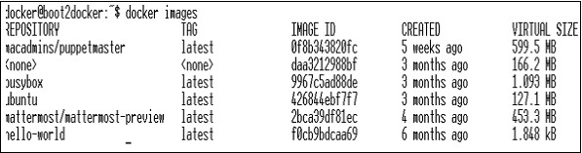

The above screenshot shows a set of images which are stored in our local Docker registry.

If we want to build a container from the image which consists of an application to test, we can do it using the Docker run command.

$ docker run –i –t unbunt /bin/bash

## **From Docker File**

In order to create an application from the Docker file, we need to first create a Docker file.

Following is an example of Jenkins Docker file.

FROM ubuntu:14.04

MAINTAINER vipinkumarmishra@virtusapolaris.com

ENV REFRESHED_AT 2017-01-15

RUN apt-get update -qq && apt-get install -qqy curl

RUN curl https://get.docker.io/gpg | apt-key add -

RUN echo deb http://get.docker.io/ubuntu docker main > /etc/apt/↩

sources.list.d/docker.list

RUN apt-get update -qq && apt-get install -qqy iptables ca-↩

certificates lxc openjdk-6-jdk git-core lxc-docker

ENV JENKINS_HOME /opt/jenkins/data

ENV JENKINS_MIRROR http://mirrors.jenkins-ci.org

RUN mkdir -p $JENKINS_HOME/plugins

RUN curl -sf -o /opt/jenkins/jenkins.war -L $JENKINS_MIRROR/war-↩

stable/latest/jenkins.war

RUN for plugin in chucknorris greenballs scm-api git-client git ↩

ws-cleanup ;\

do curl -sf -o $JENKINS_HOME/plugins/${plugin}.hpi \

-L $JENKINS_MIRROR/plugins/${plugin}/latest/${plugin}.hpi ↩

; done

ADD ./dockerjenkins.sh /usr/local/bin/dockerjenkins.sh

RUN chmod +x /usr/local/bin/dockerjenkins.sh

VOLUME /var/lib/docker

EXPOSE 8080

ENTRYPOINT [ "/usr/local/bin/dockerjenkins.sh" ]

Once the above file is created, save it with the name of Dockerfile and cd to the file path. Then, run the following command.

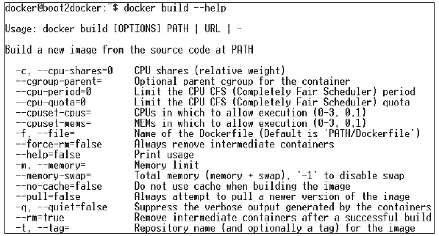

$ sudo docker build -t jamtur01/Jenkins .

Once the image is built, we can test if the image is working fine and can be converted to a container.

$ docker run –i –t jamtur01/Jenkins /bin/bash

# Kubernetes - App Deployment

Deployment is a method of converting images to containers and then allocating those images to pods in the Kubernetes cluster. This also helps in setting up the application cluster which includes deployment of service, pod, replication controller and replica set. The cluster can be set up in such a way that the applications deployed on the pod can communicate with each other.

In this setup, we can have a load balancer setting on top of one application diverting traffic to a set of pods and later they communicate to backend pods. The communication between pods happen via the service object built in Kubernetes.

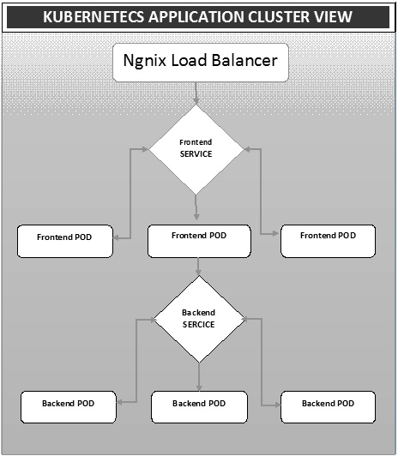

## **Ngnix Load Balancer Yaml File**

apiVersion: v1

kind: Service

metadata:

name: oppv-dev-nginx

labels:

k8s-app: omni-ppv-api

spec:

type: NodePort

ports:

- port: 8080

nodePort: 31999

name: omninginx

selector:

k8s-app: appname

component: nginx

env: dev

## **Ngnix Replication Controller Yaml**

apiVersion: v1

kind: ReplicationController

metadata:

name: appname

spec:

replicas: replica_count

template:

metadata:

name: appname

labels:

k8s-app: appname

component: nginx

env: env_name

spec:

nodeSelector:

resource-group: oppv

containers:

- name: appname

image: IMAGE_TEMPLATE

imagePullPolicy: Always

ports:

- containerPort: 8080

resources:

requests:

memory: "request_mem"

cpu: "request_cpu"

limits:

memory: "limit_mem"

cpu: "limit_cpu"

env:

- name: BACKEND_HOST

value: oppv-env_name-node:3000

## **Frontend Service Yaml File**

apiVersion: v1

kind: Service

metadata:

name: appname

labels:

k8s-app: appname

spec:

type: NodePort

ports:

- name: http

port: 3000

protocol: TCP

targetPort: 3000

selector:

k8s-app: appname

component: nodejs

env: dev

## **Frontend Replication Controller Yaml File**

apiVersion: v1

kind: ReplicationController

metadata:

name: Frontend

spec:

replicas: 3

template:

metadata:

name: frontend

labels:

k8s-app: Frontend

component: nodejs

env: Dev

spec:

nodeSelector:

resource-group: oppv

containers:

- name: appname

image: IMAGE_TEMPLATE

imagePullPolicy: Always

ports:

- containerPort: 3000

resources:

requests:

memory: "request_mem"

cpu: "limit_cpu"

limits:

memory: "limit_mem"

cpu: "limit_cpu"

env:

- name: ENV

valueFrom:

configMapKeyRef:

name: appname

key: config-env

## **Backend Service Yaml File**

apiVersion: v1

kind: Service

metadata:

name: backend

labels:

k8s-app: backend

spec:

type: NodePort

ports:

- name: http

port: 9010

protocol: TCP

targetPort: 9000

selector:

k8s-app: appname

component: play

env: dev

## **Backed Replication Controller Yaml File**

apiVersion: v1

kind: ReplicationController

metadata:

name: backend

spec:

replicas: 3

template:

metadata:

name: backend

labels:

k8s-app: beckend

component: play

env: dev

spec:

nodeSelector:

resource-group: oppv

containers:

- name: appname

image: IMAGE_TEMPLATE

imagePullPolicy: Always

ports:

- containerPort: 9000

command: [ "./docker-entrypoint.sh" ]

resources:

requests:

memory: "request_mem"

cpu: "request_cpu"

limits:

memory: "limit_mem"

cpu: "limit_cpu"

volumeMounts:

- name: config-volume

mountPath: /app/vipin/play/conf

volumes:

- name: config-volume

configMap:

name: appname

# Kubernetes - Autoscaling

**Autoscaling** is one of the key features in Kubernetes cluster. It is a feature in which the cluster is capable of increasing the number of nodes as the demand for service response increases and decrease the number of nodes as the requirement decreases. This feature of auto scaling is currently supported in Google Cloud Engine (GCE) and Google Container Engine (GKE) and will start with AWS pretty soon.

In order to set up scalable infrastructure in GCE, we need to first have an active GCE project with features of Google cloud monitoring, google cloud logging, and stackdriver enabled.

First, we will set up the cluster with few nodes running in it. Once done, we need to set up the following environment variable.

## **Environment Variable**

export NUM_NODES = 2

export KUBE_AUTOSCALER_MIN_NODES = 2

export KUBE_AUTOSCALER_MAX_NODES = 5

export KUBE_ENABLE_CLUSTER_AUTOSCALER = true

Once done, we will start the cluster by running **kube-up.sh**. This will create a cluster together with cluster auto-scalar add on.

./cluster/kube-up.sh

On creation of the cluster, we can check our cluster using the following kubectl command.

$ kubectl get nodes

NAME STATUS AGE

kubernetes-master Ready,SchedulingDisabled 10m

kubernetes-minion-group-de5q Ready 10m

kubernetes-minion-group-yhdx Ready 8m

Now, we can deploy an application on the cluster and then enable the horizontal pod autoscaler. This can be done using the following command.

$ kubectl autoscale deployment <Application Name> --cpu-percent = 50 --min = 1 --

max = 10

The above command shows that we will maintain at least one and maximum 10 replica of the POD as the load on the application increases.

We can check the status of autoscaler by running the **$kubclt get hpa** command. We will increase the load on the pods using the following command.

$ kubectl run -i --tty load-generator --image = busybox /bin/sh

$ while true; do wget -q -O- http://php-apache.default.svc.cluster.local; done

We can check the **hpa** by running **$ kubectl get hpa** command.

$ kubectl get hpa

NAME REFERENCE TARGET CURRENT

php-apache Deployment/php-apache/scale 50% 310%

MINPODS MAXPODS AGE

1 20 2m

$ kubectl get deployment php-apache

NAME DESIRED CURRENT UP-TO-DATE AVAILABLE AGE

php-apache 7 7 7 3 4m

We can check the number of pods running using the following command.

jsz@jsz-desk2:~/k8s-src$ kubectl get pods

php-apache-2046965998-3ewo6 0/1 Pending 0 1m

php-apache-2046965998-8m03k 1/1 Running 0 1m

php-apache-2046965998-ddpgp 1/1 Running 0 5m

php-apache-2046965998-lrik6 1/1 Running 0 1m

php-apache-2046965998-nj465 0/1 Pending 0 1m

php-apache-2046965998-tmwg1 1/1 Running 0 1m

php-apache-2046965998-xkbw1 0/1 Pending 0 1m

And finally, we can get the node status.

$ kubectl get nodes

NAME STATUS AGE

kubernetes-master Ready,SchedulingDisabled 9m

kubernetes-minion-group-6z5i Ready 43s

kubernetes-minion-group-de5q Ready 9m

kubernetes-minion-group-yhdx Ready 9m

# Kubernetes - Dashboard Setup

Setting up Kubernetes dashboard involves several steps with a set of tools required as the prerequisites to set it up.

* Docker (1.3+)
* go (1.5+)
* nodejs (4.2.2+)
* npm (1.3+)
* java (7+)
* gulp (3.9+)
* Kubernetes (1.1.2+)

## **Setting Up the Dashboard**

$ sudo apt-get update && sudo apt-get upgrade

Installing Python

$ sudo apt-get install python

$ sudo apt-get install python3

Installing GCC

$ sudo apt-get install gcc-4.8 g++-4.8

Installing make

$ sudo apt-get install make

Installing Java

$ sudo apt-get install openjdk-7-jdk

Installing Node.js

$ wget https://nodejs.org/dist/v4.2.2/node-v4.2.2.tar.gz

$ tar -xzf node-v4.2.2.tar.gz

$ cd node-v4.2.2

$ ./configure

$ make

$ sudo make install

Installing gulp

$ npm install -g gulp

$ npm install gulp

## **Verifying Versions**

Java Version

$ java –version

java version "1.7.0_91"

OpenJDK Runtime Environment (IcedTea 2.6.3) (7u91-2.6.3-1~deb8u1+rpi1)

OpenJDK Zero VM (build 24.91-b01, mixed mode)

$ node –v

V4.2.2

$ npn -v

2.14.7

$ gulp -v

[09:51:28] CLI version 3.9.0

$ sudo gcc --version

gcc (Raspbian 4.8.4-1) 4.8.4

Copyright (C) 2013 Free Software Foundation, Inc. This is free software;

see the source for copying conditions. There is NO warranty; not even for

MERCHANTABILITY or FITNESS FOR A PARTICULAR PURPOSE.

## **Installing GO**

$ git clone https://go.googlesource.com/go

$ cd go

$ git checkout go1.4.3

$ cd src

Building GO

$ ./all.bash

$ vi /root/.bashrc

In the .bashrc

export GOROOT = $HOME/go

export PATH = $PATH:$GOROOT/bin

$ go version

go version go1.4.3 linux/arm

## **Installing Kubernetes Dashboard**

$ git clone https://github.com/kubernetes/dashboard.git

$ cd dashboard

$ npm install -g bower

## **Running the Dashboard**

$ git clone https://github.com/kubernetes/dashboard.git

$ cd dashboard

$ npm install -g bower

$ gulp serve

[11:19:12] Requiring external module babel-core/register

[11:20:50] Using gulpfile ~/dashboard/gulpfile.babel.js

[11:20:50] Starting 'package-backend-source'...

[11:20:50] Starting 'kill-backend'...

[11:20:50] Finished 'kill-backend' after 1.39 ms

[11:20:50] Starting 'scripts'...

[11:20:53] Starting 'styles'...

[11:21:41] Finished 'scripts' after 50 s

[11:21:42] Finished 'package-backend-source' after 52 s

[11:21:42] Starting 'backend'...

[11:21:43] Finished 'styles' after 49 s

[11:21:43] Starting 'index'...

[11:21:44] Finished 'index' after 1.43 s

[11:21:44] Starting 'watch'...

[11:21:45] Finished 'watch' after 1.41 s

[11:23:27] Finished 'backend' after 1.73 min

[11:23:27] Starting 'spawn-backend'...

[11:23:27] Finished 'spawn-backend' after 88 ms

[11:23:27] Starting 'serve'...

2016/02/01 11:23:27 Starting HTTP server on port 9091

2016/02/01 11:23:27 Creating API client for

2016/02/01 11:23:27 Creating Heapster REST client for http://localhost:8082

[11:23:27] Finished 'serve' after 312 ms

[BS] [BrowserSync SPA] Running...

[BS] Access URLs:

--------------------------------------

Local: http://localhost:9090/

External: http://192.168.1.21:9090/

--------------------------------------

UI: http://localhost:3001

UI External: http://192.168.1.21:3001

--------------------------------------

[BS] Serving files from: /root/dashboard/.tmp/serve

[BS] Serving files from: /root/dashboard/src/app/frontend

[BS] Serving files from: /root/dashboard/src/app

## **The Kubernetes Dashboard**

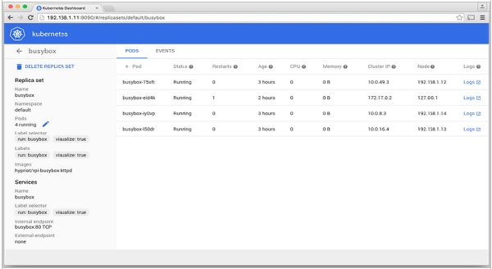

# Kubernetes - Monitoring

Monitoring is one of the key component for managing large clusters. For this, we have a number of tools.

## **Monitoring with Prometheus**

It is a monitoring and alerting system. It was built at SoundCloud and was open sourced in 2012. It handles the multi-dimensional data very well.

Prometheus has multiple components to participate in monitoring −

* **Prometheus** − It is the core component that scraps and stores data.
* **Prometheus node explore** − Gets the host level matrices and exposes them to Prometheus.
* **Ranch-eye** − is an **haproxy** and exposes **cAdvisor** stats to Prometheus.
* **Grafana** − Visualization of data.
* **InfuxDB** − Time series database specifically used to store data from rancher.
* **Prom-ranch-exporter** − It is a simple node.js application, which helps in querying Rancher server for the status of stack of service.

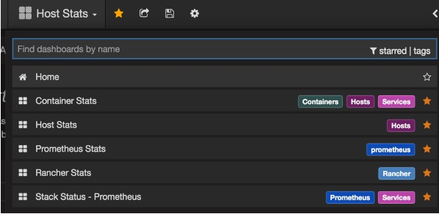

## **Sematext Docker Agent**

It is a modern Docker-aware metrics, events, and log collection agent. It runs as a tiny container on every Docker host and collects logs, metrics, and events for all cluster node and containers. It discovers all containers (one pod might contain multiple containers) including containers for Kubernetes core services, if the core services are deployed in Docker containers. After its deployment, all logs and metrics are immediately available out of the box.

## **Deploying Agents to Nodes**

Kubernetes provides DeamonSets which ensures pods are added to the cluster.

## **Configuring SemaText Docker Agent**

It is configured via environment variables.

* Get a free account at [apps.sematext.com](https://apps.sematext.com/ui/registration), if you don’t have one already.
* Create an SPM App of type “Docker” to obtain the SPM App Token. SPM App will hold your Kubernetes performance metrics and event.
* Create a Logsene App to obtain the Logsene App Token. Logsene App will hold your Kubernetes logs.
* Edit values of LOGSENE_TOKEN and SPM_TOKEN in the DaemonSet definition as shown below.
  + Grab the latest sematext-agent-daemonset.yml (raw plain-text) template (also shown below).
  + Store it somewhere on the disk.
  + Replace the SPM_TOKEN and LOGSENE_TOKEN placeholders with your SPM and Logsene App tokens.

## **Create DaemonSet Object**

apiVersion: extensions/v1beta1

kind: DaemonSet

metadata:

name: sematext-agent

spec:

template:

metadata:

labels:

app: sematext-agent

spec:

selector: {}

dnsPolicy: "ClusterFirst"

restartPolicy: "Always"

containers:

- name: sematext-agent

image: sematext/sematext-agent-docker:latest

imagePullPolicy: "Always"

env:

- name: SPM_TOKEN

value: "REPLACE THIS WITH YOUR SPM TOKEN"

- name: LOGSENE_TOKEN

value: "REPLACE THIS WITH YOUR LOGSENE TOKEN"

- name: KUBERNETES

value: "1"

volumeMounts:

- mountPath: /var/run/docker.sock

name: docker-sock

- mountPath: /etc/localtime

name: localtime

volumes:

- name: docker-sock

hostPath:

path: /var/run/docker.sock

- name: localtime

hostPath:

path: /etc/localtime

## **Running the Sematext Agent Docker with kubectl**

$ kubectl create -f sematext-agent-daemonset.yml

daemonset "sematext-agent-daemonset" created

## **Kubernetes Log**

Kubernetes containers’ logs are not much different from Docker container logs. However, Kubernetes users need to view logs for the deployed pods. Hence, it is very useful to have Kubernetes-specific information available for log search, such as −

* Kubernetes namespace
* Kubernetes pod name
* Kubernetes container name
* Docker image name
* Kubernetes UID

## **Using ELK Stack and LogSpout**

ELK stack includes Elasticsearch, Logstash, and Kibana. To collect and forward the logs to the logging platform, we will use LogSpout (though there are other options such as FluentD).

The following code shows how to set up ELK cluster on Kubernetes and create service for ElasticSearch −

apiVersion: v1

kind: Service

metadata:

name: elasticsearch

namespace: elk

labels:

component: elasticsearch

spec:

type: LoadBalancer

selector:

component: elasticsearch

ports:

- name: http

port: 9200

protocol: TCP

- name: transport

port: 9300

protocol: TCP

## **Creating Replication Controller**

apiVersion: v1

kind: ReplicationController

metadata:

name: es

namespace: elk

labels:

component: elasticsearch

spec:

replicas: 1

template:

metadata:

labels:

component: elasticsearch

spec:

serviceAccount: elasticsearch

containers:

- name: es

securityContext:

capabilities:

add:

- IPC_LOCK

image: quay.io/pires/docker-elasticsearch-kubernetes:1.7.1-4

env:

- name: KUBERNETES_CA_CERTIFICATE_FILE

value: /var/run/secrets/kubernetes.io/serviceaccount/ca.crt

- name: NAMESPACE

valueFrom:

fieldRef:

fieldPath: metadata.namespace

- name: "CLUSTER_NAME"

value: "myesdb"

- name: "DISCOVERY_SERVICE"

value: "elasticsearch"

- name: NODE_MASTER

value: "true"

- name: NODE_DATA

value: "true"

- name: HTTP_ENABLE

value: "true"

ports:

- containerPort: 9200

name: http

protocol: TCP

- containerPort: 9300

volumeMounts:

- mountPath: /data

name: storage

volumes:

- name: storage

emptyDir: {}

## **Kibana URL**

For Kibana, we provide the Elasticsearch URL as an environment variable.

- name: KIBANA_ES_URL

value: "http://elasticsearch.elk.svc.cluster.local:9200"

- name: KUBERNETES_TRUST_CERT

value: "true"

Kibana UI will be reachable at container port 5601 and corresponding host/Node Port combination. When you begin, there won’t be any data in Kibana (which is expected as you have not pushed any data).